

**University of Tehran**

**Faculties of Interdisciplinary Sciences and Technologies**

**AI Course**

**Homework 2**

**Babak Bayanian**

832203002

1404/03/02

INTRODUCTION 4

PART 1: LOADING CLIP AND PREPROCESSING THE DATASET 5

Using GPU 5

Installing Required Libraries 5

Loading the Dataset 7

Exploring Pre-Trained Models 11

List the available pre-trained CLIP models 11

Instantiate the CLIPFineTuner _base_w model with pretrained='laion2b_s13b_b82k_augreg'. 12

Advantages of Using laion2b_s13b_b82k_augreg 14

Print the model structure and preprocessing transforms 15

Dataset Preparation 16

Implement a custom PyTorch dataset class with appropriate augmentations. 17

Create DataLoaders for each split. 18

2. Wrapping Subsets in Custom Dataset 19

Training Dataset: Augmentations like random horizontal flips, rotations, and colour 3. Creating DataLoaders 19

Perform k-fold cross-validation and visualise batch samples. 20

Cosine Similarity Analysis 27

Select 8 sample images and generate custom textual descriptions. 27

Compute cosine similarity between images and descriptions using CLIP’s embeddings 29

Result for Part 1 32

Experimental Setup and Model Design 32

Training Strategy and Cross-Validation 32

Quantitative Performance Analysis 32

Cosine Similarity Matrix Interpretation 33

Confusion Matrix and Class-Level Analysis 33

Addressing Class Imbalance 33

Conclusions and Implications for Real-World Applications 34

PART 2: EVALUATING THE BASELINE CLIP MODEL 34

Modifying the CLIP Model for Image Classification 34

Freeze all parameters except the final classifier layer 34

Replace CLIP’s last linear layer in the visual encoder with a custom classifier (1, 2, and 3 linear layers), train models and compare performance 36

Fine-Tuning Optimization 38

Train the model using two different optimisers: 38

Training and Evaluation 45

Report training, validation, and test losses after each epoch. 45

Visualisation of Predictions 49

Display predicted vs. actual labels for validation images 49

Using an Alternative CLIP Model 58

Repeat the steps above using ViT-B-32 with pretrained='openai' 58

PART 3: ADVANCED FINE-TUNING STRATEGIES 66

Full Model Fine-Tuning 66

PART 2 72

APPENDIX 72

Appendix 1: model structure and preprocessing transforms 72

Appendix 2: Confusion matrix 86

86

Appendix 3: Predicted and actual labels 86

# INTRODUCTION

The goal of this project is to familiarise students with the use of **pre-trained deep learning models** and their fine-tuning for different datasets. In this exercise, we focus on **Contrastive Language-Image Pre-Training (CLIP)**, a multimodal model developed by OpenAI (Radford et al., 2021). CLIP learns visual concepts by aligning images with natural language descriptions, enabling zero-shot learning and efficient fine-tuning. This project will guide through loading the CLIP model, evaluating its baseline performance, and performing various fine-tuning techniques.

# PART 1: LOADING CLIP AND PREPROCESSING THE DATASET

## Using GPU

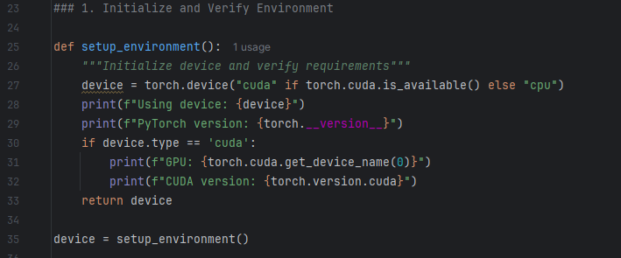

The GPU is using:

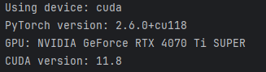

Figure : Using GPU

## Installing Required Libraries

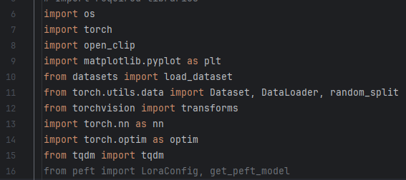

Figure : Installing Required Libraries

os: Managing file paths and directories, e.g., saving model checkpoints or loading datasets.

Torch: Core library for defining and training neural networks, working with tensors, and handling GPU acceleration.

open_clip: Used to load and fine-tune the CLIP model.

matplotlib.pyplot: Visualising training results, dataset samples, or predictions.

Datasets: Loading datasets for training and evaluation.

Torch.utils.data: Handling dataset processing and batching efficiently.

torchvision.transforms: Applying transformations like resizing, normalisation, and augmentation to images before feeding them into the model.

Torch.nn: Defining and using neural network layers and loss functions.

Torch.optim: Optimising the model parameters during training.

tqdm: Enhancing loops with progress bars for better tracking and visualisation of task progress.

## Loading the Dataset

The part of the code that uses the **ceyda/fashion-products-small dataset**, processes it, and extracts relevant information is in the **“Load and Explore Dataset”** section. Specifically, the function load_fashion_dataset() is responsible for this. Here’s the relevant section:

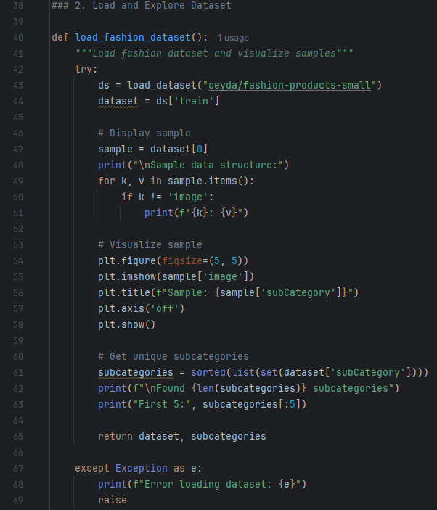

Figure 3: Loading the Dataset

1. **Dataset Loading:**
   * The **load_dataset("ceyda/fashion-products-small")** line fetches the dataset from Hugging Face’s hub.
   * The dataset consists of labelled fashion product images with metadata like subCategory (labels).
2. **Sample Display:**
   * It prints out the structure of a single sample in the dataset (e.g., metadata like subCategory, gender, articleType).
   * It visualises one sample image along with its label (subcategory).
3. **Extract Labels:**
   * The code extracts unique subCategory labels from the dataset and sorts them alphabetically. This is useful for classification tasks.
4. **Output:**
   * The function returns the dataset (dataset) and the list of subcategories (subcategories), which are used later in the script for fine-tuning and evaluation.

* **Dataset Preparation for Fine-Tuning:**
  + The dataset and subcategories returned by load_fashion_dataset() are used in the prepare_dataloaders() function to create train_loader, val_loader, and test_loader.
* **Zero-Shot Evaluation:**
  + The dataset is used to test the CLIP model’s zero-shot prediction capabilities.
* **Visualisation:**
  + The dataset is used to display predictions during evaluation.

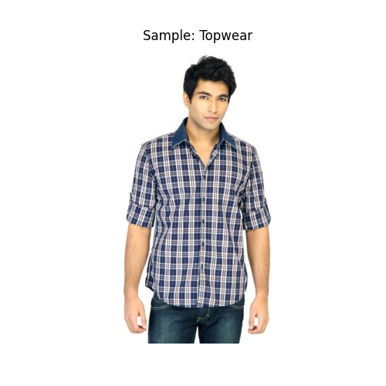

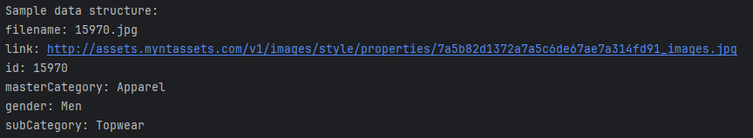

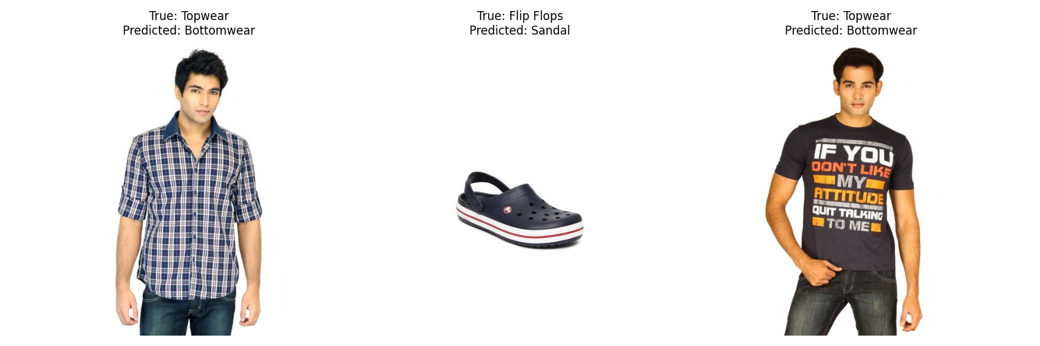

Figure 4: visualise images

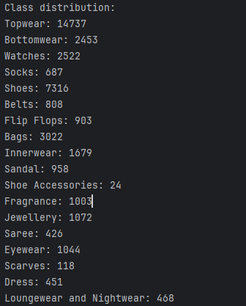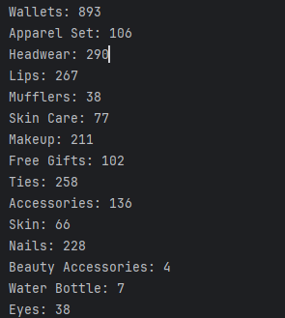

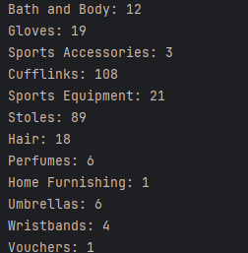

Figure 5: Classes

## Exploring Pre-Trained Models

### List the available pre-trained CLIP models.

To achieve this purpose, we write this section.

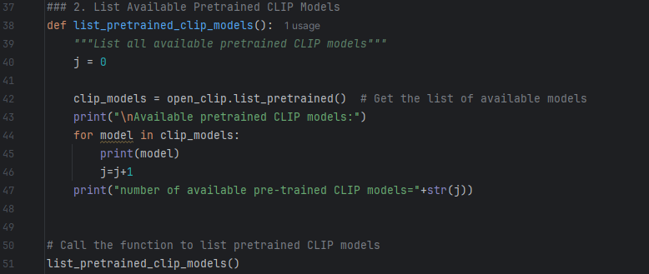

Figure 6: List the available pre-trained CLIP models

There are 180 pre-trained CLIP models

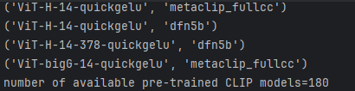

### Instantiate the CLIPFineTuner _base_w model with pretrained='laion2b_s13b_b82k_augreg'.

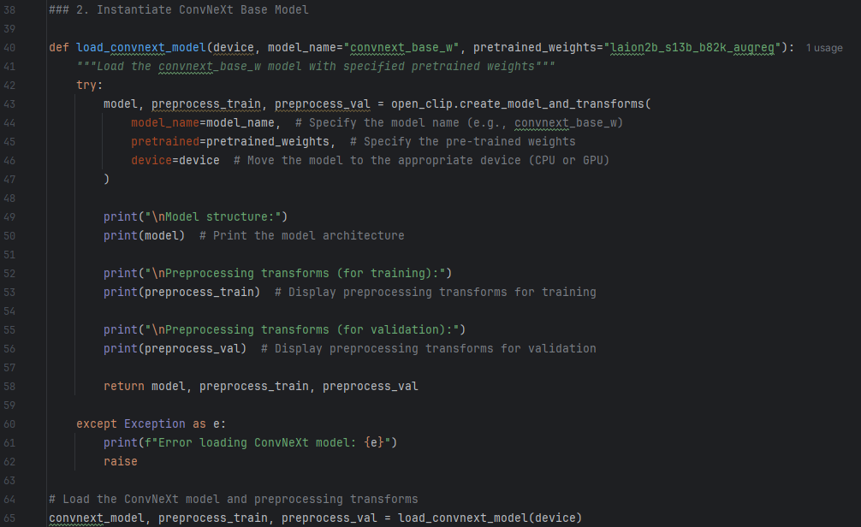

Figure 7: Pretrained='laion2b_s13b_b82k_augreg'

The term **laion2b_s13b_b82k_augreg** refers to a specific pre-trained weight configuration for models in the **open_clip** library, which makes use of the **LAION dataset** for training.

This string is a shorthand description of how the model was trained and the dataset it was trained on.

#### 1. laion2b:

* Refers to the **LAION-2B dataset**, which is a massive open dataset of image-text pairs consisting of **2 billion samples**.
* The dataset is designed for training large-scale multimodal models, such as CLIP (Contrastive Language–Image Pretraining).
* It is one of the largest publicly available datasets for vision-language tasks.

#### 2. s13b:

* Indicates the **model size** and computational budget used during training.
* s13b stands for **13 billion parameters** of compute equivalent scaling used during training, which includes the number of training steps, batch sizes, and model architecture size.

#### 3. b82k:

* Refers to the **batch size** used during training.
* In this case, b82k means **82,000 samples per batch** were used during training. Larger batch sizes are typically used for training models on large datasets with distributed computing.

#### 4. augreg:

* Stands for **Augmentation + Regularization**.
* This indicates that **data augmentation techniques** (such as random cropping, flipping, colour jitter, etc.) and **regularisation methods** (such as weight decay, dropout, etc.) were applied during training to improve model generalisation and robustness.

This specific pre-trained weight configuration is significant because:

1. **High-Quality Pretraining**:
   * Models trained on the **LAION-2B dataset** with augmentation and regularisation tend to perform very well on downstream tasks, such as zero-shot classification, image retrieval, and fine-tuning.
2. **Scalability**:
   * The training setup (s13b compute budget and b82k batch size) ensures that the model is optimised for large-scale data.
3. **Robustness**:
   * Using **augreg** (augmentation + regularisation) improves the model’s ability to generalise to unseen data and prevents overfitting.

This weight configuration is commonly used in pre-trained models provided by the **open_clip** library, such as:

* **CLIPFineTuner models**
* **ViT (Vision Transformer) models**
* **ResNet-based CLIP models**



### ****Advantages of Using**** laion2b_s13b_b82k_augreg

1. **Broad Coverage**:
   * The LAION dataset covers a wide variety of image-text pairs, making the model versatile for tasks like zero-shot learning.
2. **State-of-the-Art Performance**:
   * Models trained with this weight configuration often achieve state-of-the-art results on benchmarks for image classification, retrieval, and multimodal tasks.
3. **Fine-Tuning Friendly**:
   * These weights serve as a strong foundation for fine-tuning on custom datasets, allowing for leveraging the pre-trained knowledge effectively.

In summary, laion2b_s13b_b82k_augreg describes a pre-trained weight setup:

* **Dataset**: LAION-2B (2 billion image-text pairs).
* **Compute Budget**: Equivalent to 13 billion parameters (s13b).
* **Batch Size**: 82,000 samples (b82k).
* **Training Techniques**: Augmentation + Regularization (augreg).

### Print the model structure and preprocessing transforms.

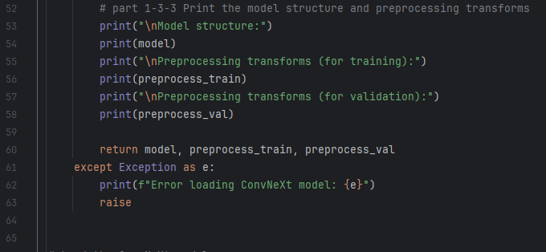

The result is:

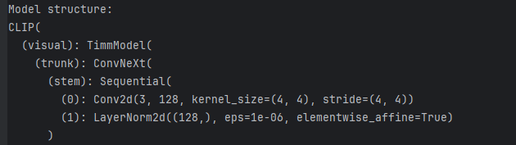

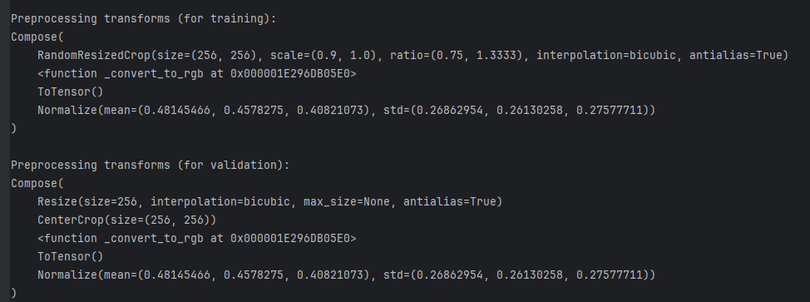

Figure 8: Print the model structure and preprocessing transforms

The full result is added to the appendix

## Dataset Preparation

1. **Dataset Splitting**:
   * The dataset is divided into **train**, **validation**, and **test sets** using **torch.utils.data.random_split**.
   * The sizes are calculated as follows:
     + **Validation Size (val_size)**: test_ratio * len(dataset).
     + **Test Size (val_size)**: Same size as the validation set.
     + **Train Size (train_size)**: The remaining data.
2. **Random Split**:
   * The **random_split** function splits the dataset into subsets based on the specified sizes.
   * A fixed random seed (42) is used to ensure consistent splits across runs.
3. **Custom Datasets**:
   * Each subset (train, validation, and test) is wrapped in the **FashionDataset** class to apply preprocessing transforms.
4. **DataLoaders**:
   * **DataLoader** is used to create iterable objects for training, validation, and testing with specified batch sizes.

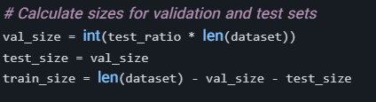

Figure 9: Size of validation and test

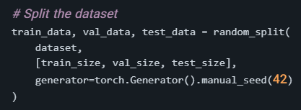

Figure 10: Split dataset

### Implement a custom PyTorch dataset class with appropriate augmentations.

**Augmentations** are techniques used to artificially expand and diversify datasets by applying transformations to the original data. These methods are especially useful in machine learning tasks like image classification, text analysis, or audio processing, as they help models generalise better and perform well on unseen data. Common augmentations include rotating, flipping, or adding noise to images; replacing words or shuffling text; and altering pitch or speed in audio.

These transformations simulate real-world variations and improve model robustness by making it less sensitive to specific patterns in the training data. For example, flipping an image horizontally or adjusting its brightness ensures the model doesn’t overfit to the exact lighting or orientation in the training set. Augmentations are often applied dynamically during training (online augmentation) or prepared beforehand (offline augmentation).

In this project, we used this feature:

1. **Augmentations**:
   * Added augmentations like RandomHorizontalFlip, RandomRotation, ColorJitter, and RandomResizedCrop for **training data**.

* jitter is applied to enhance diversity and improve model robustness

1. **FashionDataset Class**:
   * Includes a flag (augment) to enable or disable augmentations.
2. **Usage of Augmentations**:
   * Enabled augmentations for the **training dataset** in prepare_dataloaders.

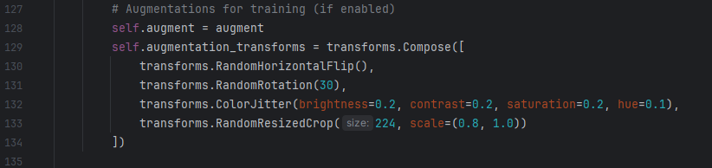

Figure 11: Enabled augmentations

### Create DataLoaders for each split.

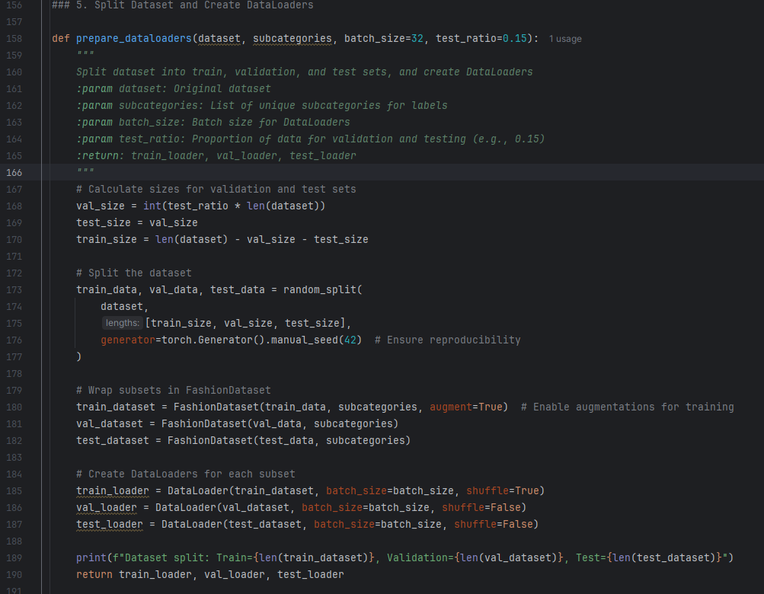

Figure 12: Create DataLoaders

#### 1. Splitting the Dataset

The first step is to split the dataset into three subsets: **training**, **validation**, and **test**. These subsets serve different purposes:

* **Training Set**: Used to train the model. It contains the majority of the data to ensure the model learns effectively.
* **Validation Set**: Used during training to evaluate the model’s performance on unseen data and tune hyperparameters.
* **Test Set**: Used after training to evaluate the final model’s performance on completely unseen data.

The dataset is split using **torch.utils.data.random_split**, which takes the dataset and the sizes of each subset as arguments.

### 2. Wrapping Subsets in Custom Dataset

After splitting, each subset is wrapped in a custom PyTorch dataset class (FashionDataset). This class handles preprocessing and augmentations:

### Training Dataset: Augmentations like random horizontal flips, rotations, and color 3. Creating DataLoaders

Finally, the subsets are wrapped in PyTorch **DataLoader** objects, which handle efficient batch loading during training and evaluation:

**Training DataLoader**: Uses shuffle=True to randomize the order of batches, which helps prevent overfitting and makes training more robust.

**Validation and Test DataLoaders**: Use shuffle=False because the data order is irrelevant during evaluation:



The batch size (batch_size) is configurable and determines how many samples are loaded per batch during training or evaluation.

The result is:



### Perform k-fold cross-validation and visualise batch samples.

K-fold cross-validation is a statistical method used to evaluate the performance of a machine learning model. Instead of splitting the dataset into fixed training, validation, and test sets, the dataset is divided into k folds. The model is trained and validated k times, each time using one fold for validation and the remaining k-1 folds for training. This ensures that every data point gets a chance to be used for validation, minimising the risk of overfitting and providing a more robust evaluation.

* **Purpose**:
  + Provides a better estimation of model performance on unseen data.
  + Reduces variance caused by a single train-test split.
* **Workflow**:
  + The dataset is split into k folds using sklearn.model_selection.KFold.
  + For each fold:
    - A training subset (k-1 folds) and a validation subset (1-fold) are created.
    - The model is trained on the training subset and validated on the validation subset.
    - Validation accuracy for the fold is recorded.
  + At the end, the average validation accuracy across all folds is computed.

Visualising batch samples is an important step for understanding the data being fed into the model. It helps confirm that augmentations and preprocessing are applied correctly and provides insights into the distribution of labels.

* **Purpose**:
  + Ensures data preprocessing and augmentations are correctly applied.
  + Helps identify potential issues with the dataset (e.g., imbalance or incorrect labels).
* **Workflow**:
  + A batch of data is retrieved using next(iter(loader)).
  + Images from the batch are displayed alongside their labels.
  + This visualisation is useful for inspecting training data after augmentations.

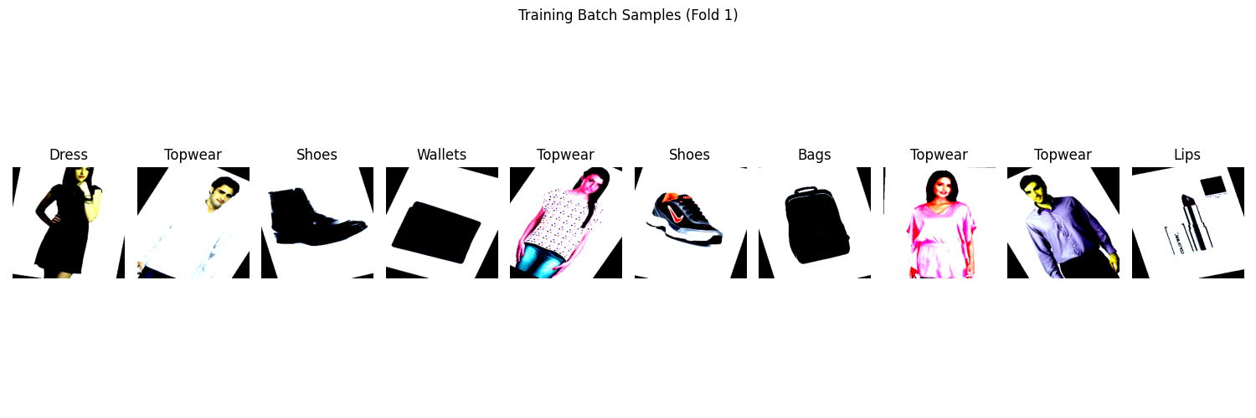

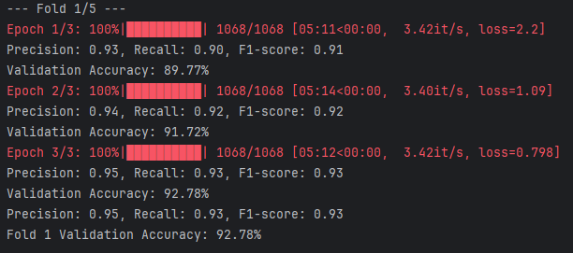

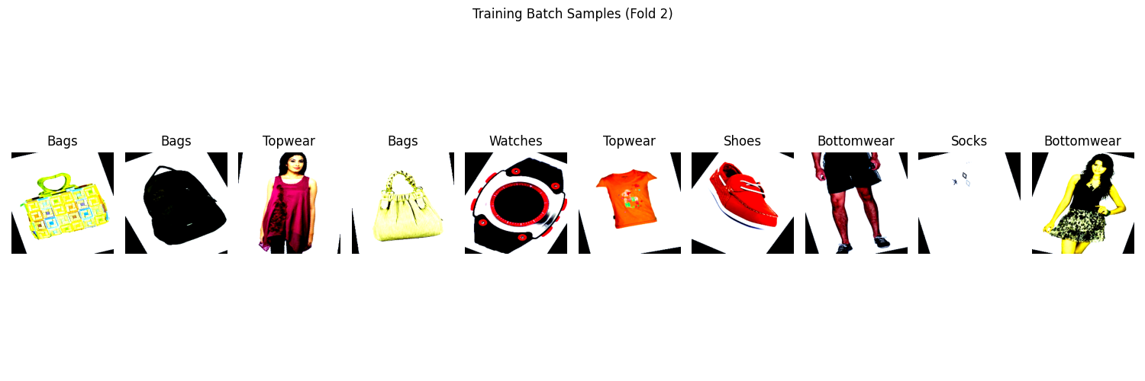

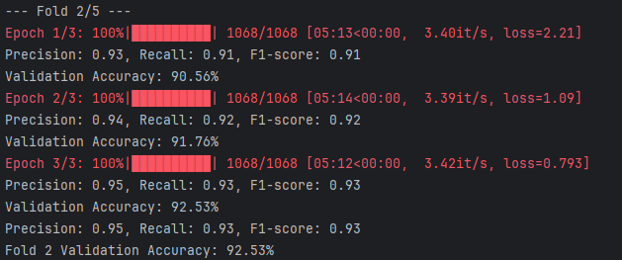

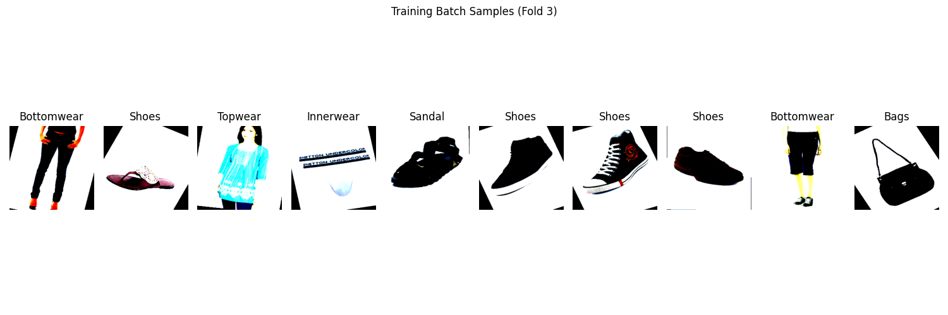

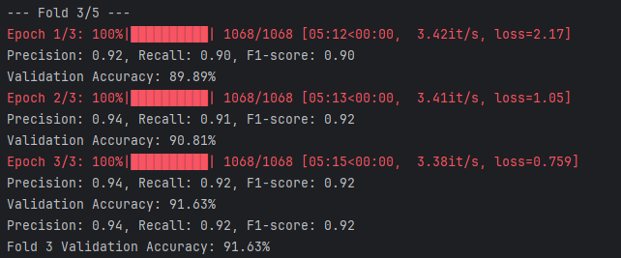

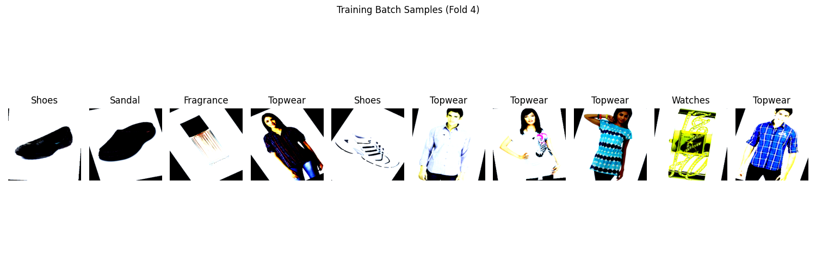

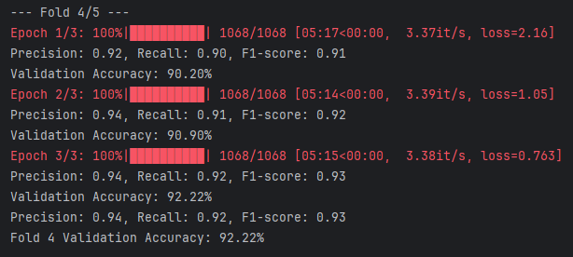

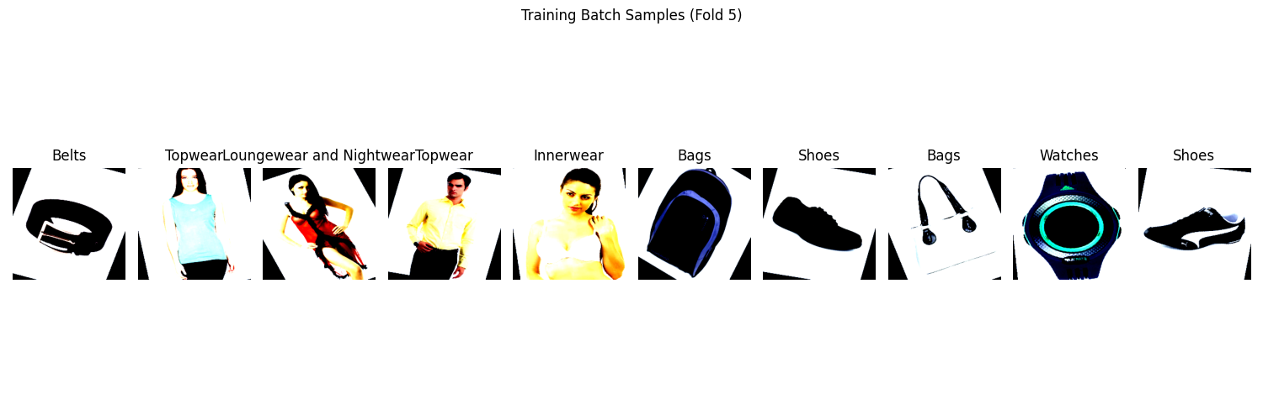

The result shows:



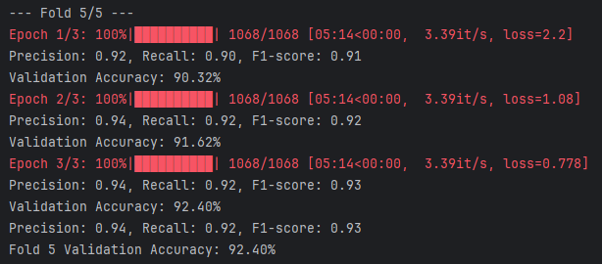

Figure 13: training Batch and show samples after augmentation

This is a sample of the confusion matrix (all added to Appendix 2)

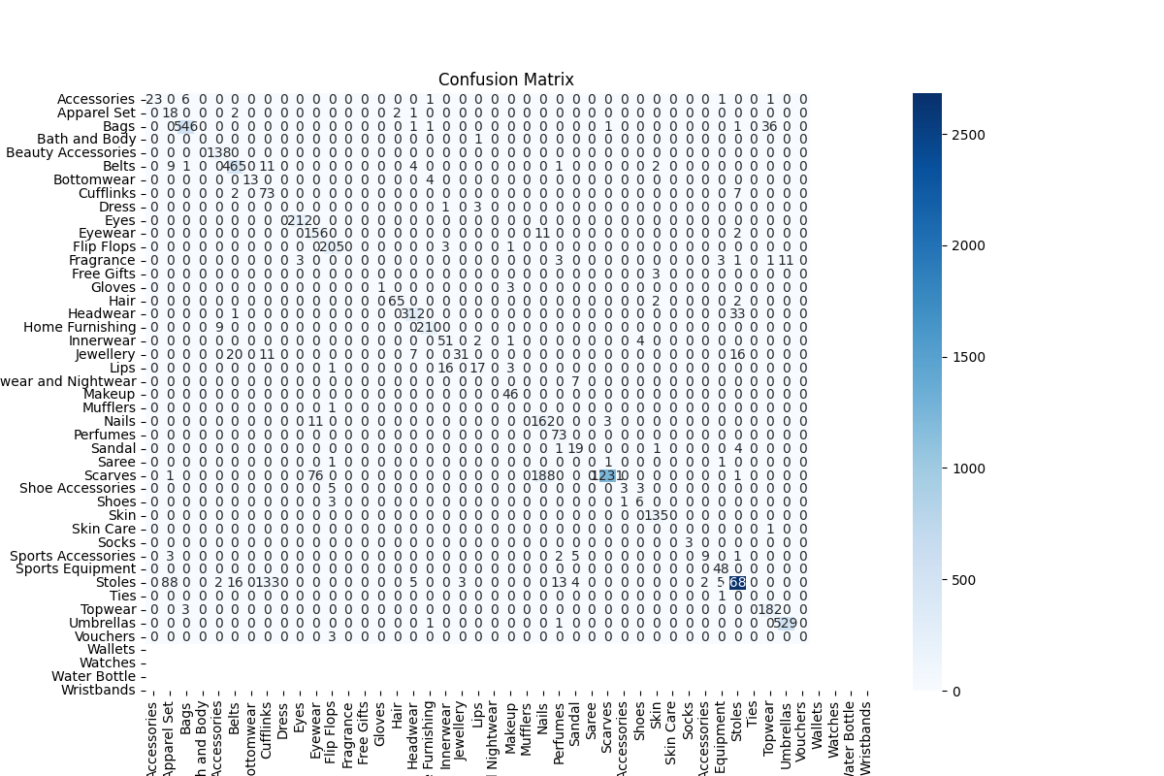

Figure 14: Confusion matrix

However, when we run the code, we face a new problem.

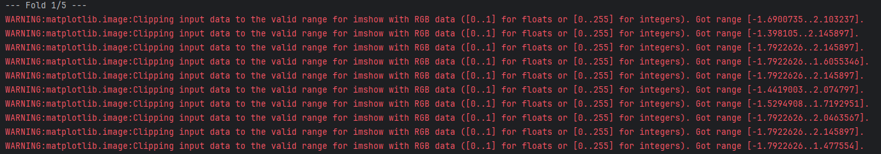

The warnings we are seeing occur because the input data for matplotlib.pyplot.imshow() is normalised, where pixel values are outside the valid range for RGB data. Specifically:

* For float data, valid values are between [0, 1].
* For integer data, valid values are between [0, 255].

Since the images are normalised during preprocessing (e.g., using transforms. Normalise), the pixel values are scaled based on the mean and standard deviation, which can result in values outside the expected range for visualisation.

To fix this, need to **denormalise the images** before visualising them. Denormalisation involves reversing the normalisation applied during preprocessing.

To handle this issue, the load and print the CLIPFineTuner model has been changed to this:

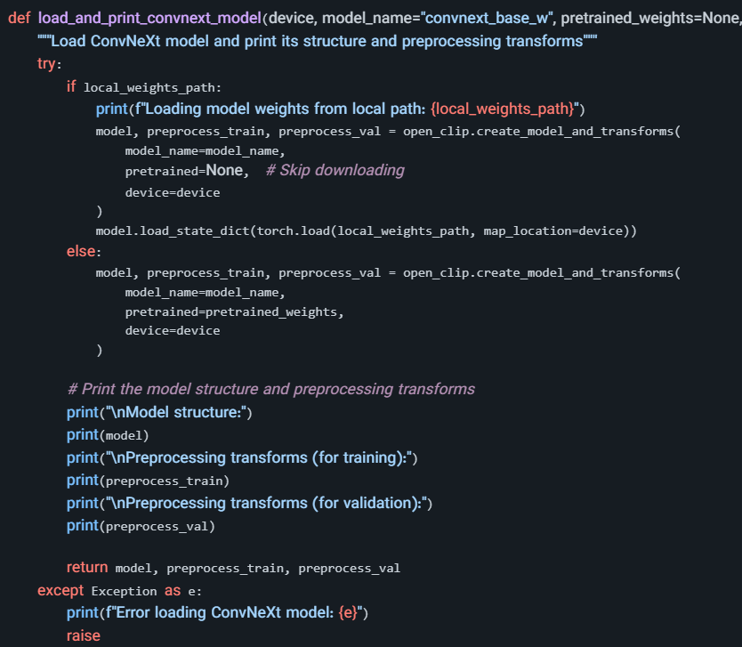

1. **Denormalisation**:
   * The normalisation applied during preprocessing is reversed using:

denormalized_images[:, i, :, :] = images[:, i, :, :] * std[i] + mean[i]

* + This restores pixel values to their original range [0, 255] or [0, 1] (depending on the original data format).

1. **Mean and Standard Deviation**:
   * The mean and standard deviation are used in transforms. Normalize are hardcoded into the function (mean and std).
   * These values are specific to the CLIPFineTuner model’s preprocessing.
2. **Visualisation**:
   * The denormalised images are passed to imshow, ensuring no clipping warnings.

## Cosine Similarity Analysis

### Select 8 sample images and generate custom textual descriptions.

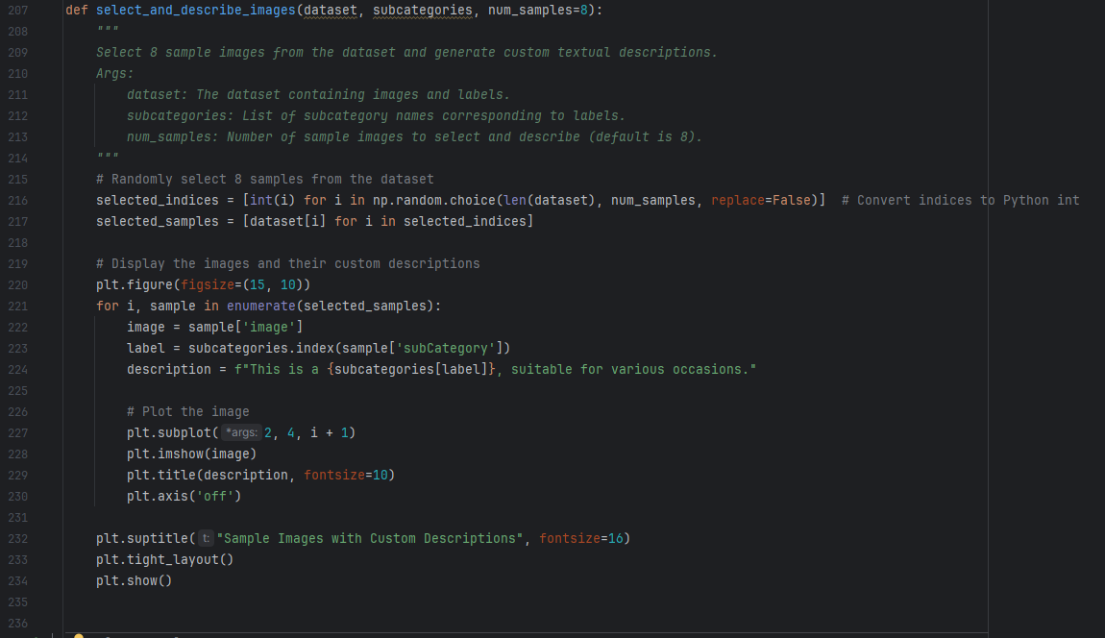

After loading the dataset (load_fashion_dataset), the function is called to visualise and describe 8 sample images:

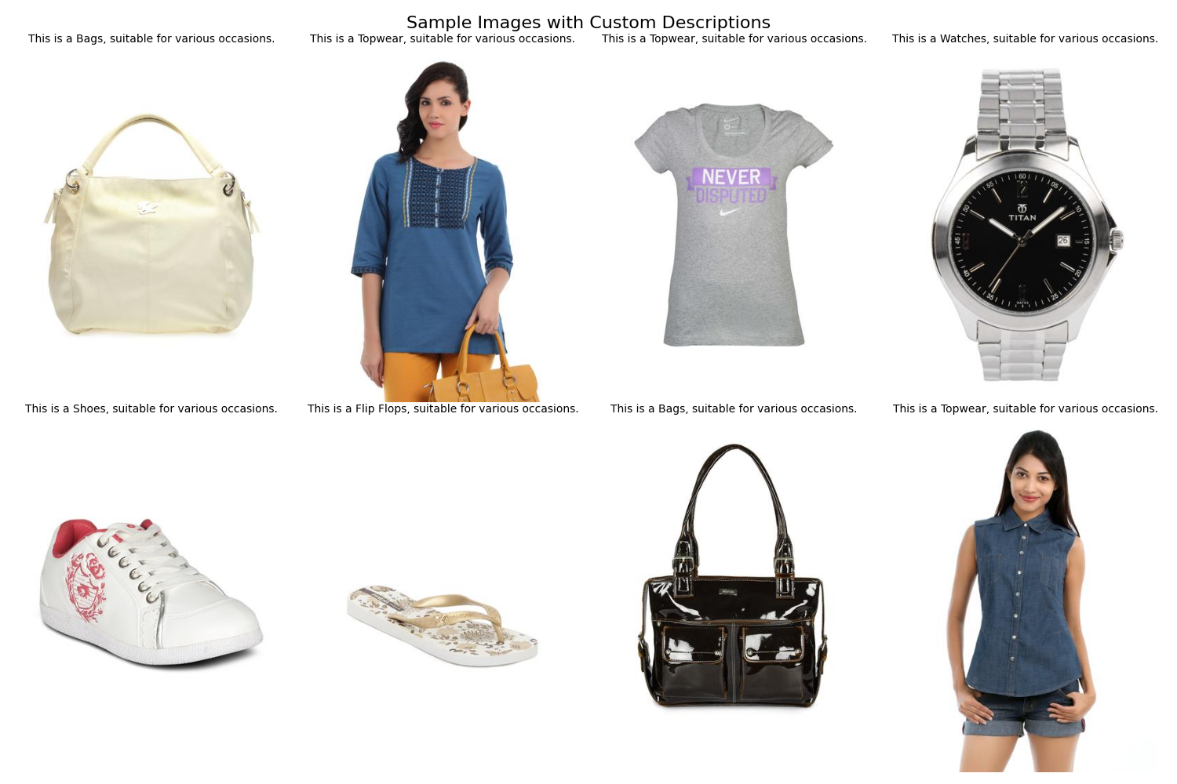

Figure 15:Select 8 sample images and generate custom textual descriptions

### Compute cosine similarity between images and descriptions using CLIP’s embeddings

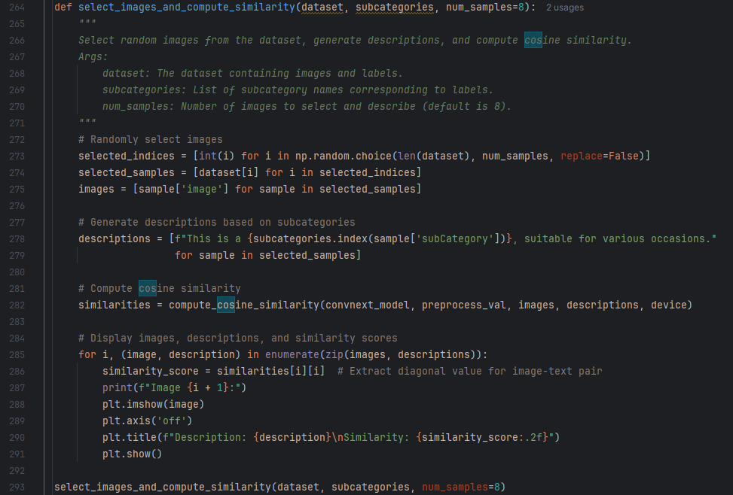

* 1. **Cosine similarity** is a metric used to measure the similarity between two vectors in a multi-dimensional space. It evaluates how “aligned” two vectors are, regardless of their magnitude. This is widely used in machine learning, natural language processing, and computer vision tasks, especially for comparing embeddings or feature representations.
  2. 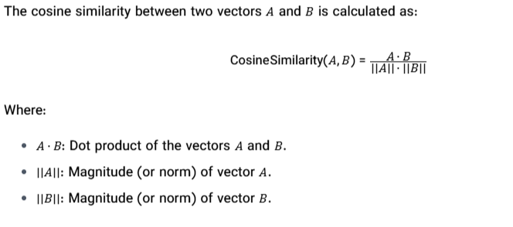

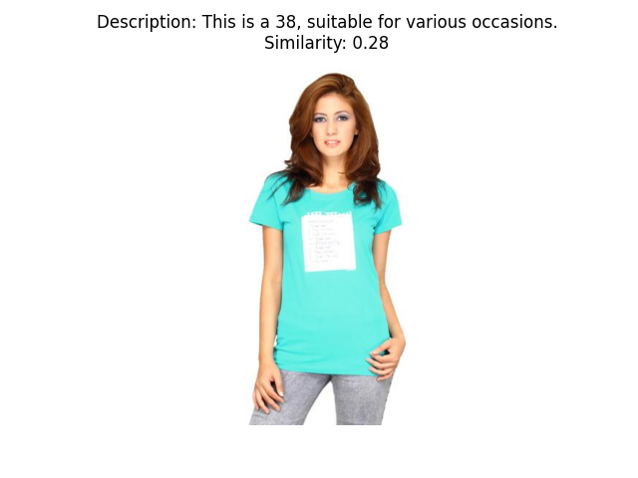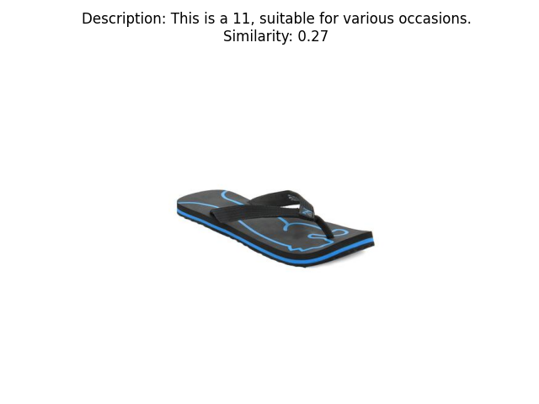

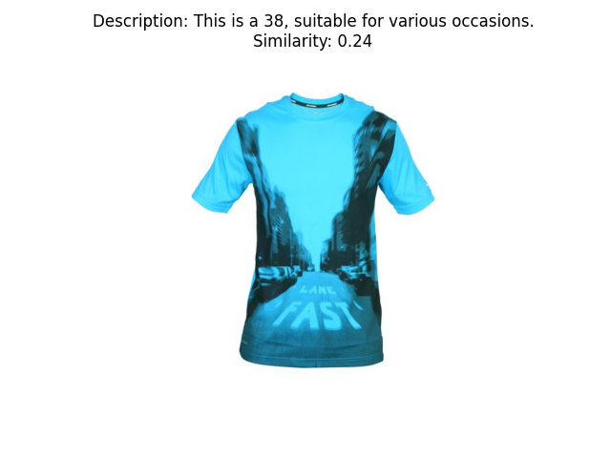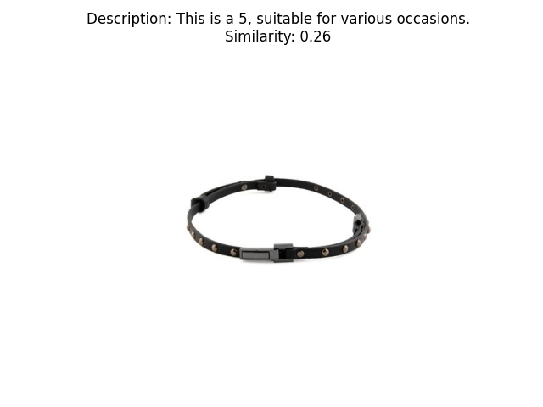

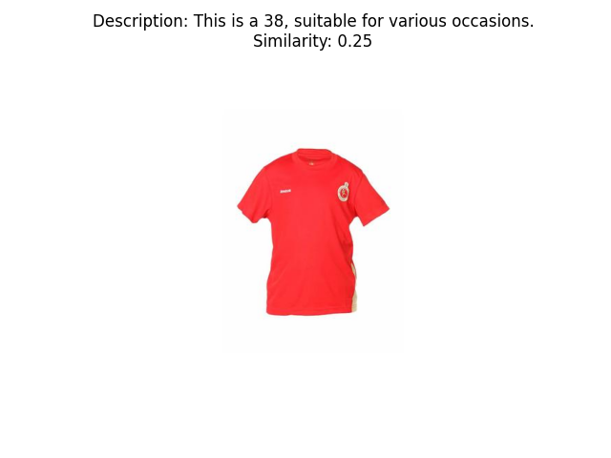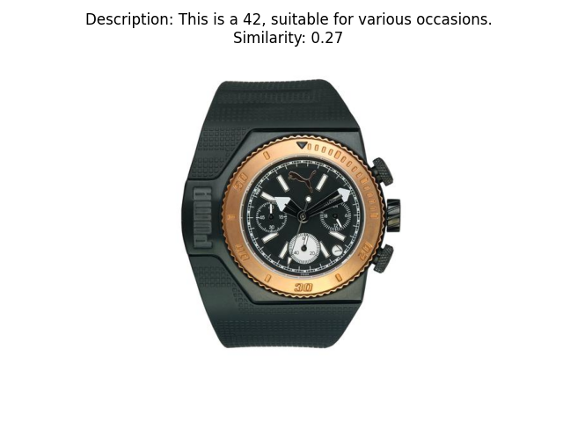

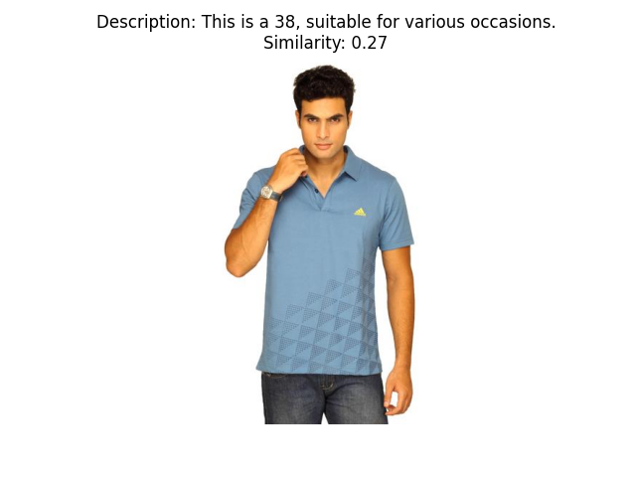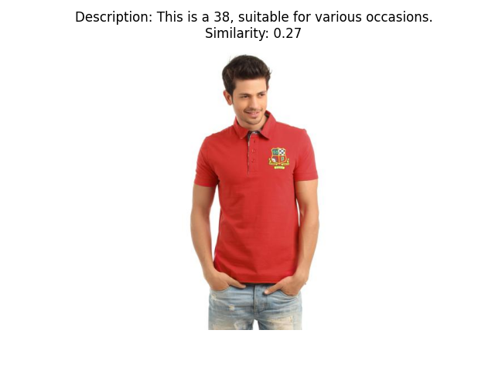

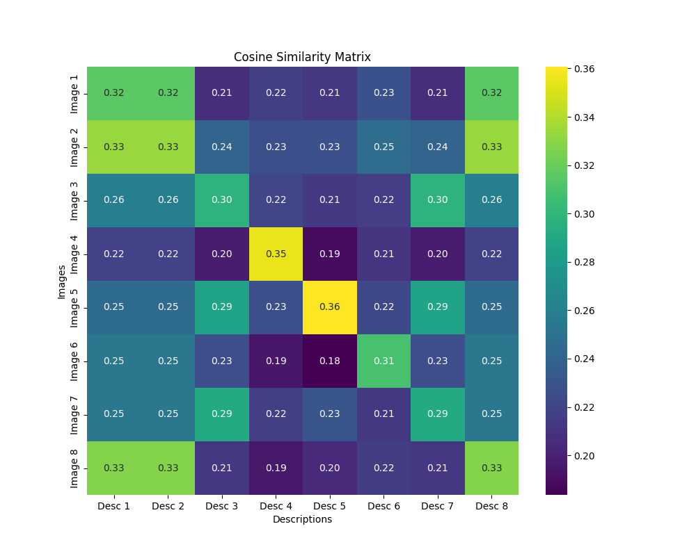

Figure 16: Cosine Similarity Matrix

## Result for Part 1

### Experimental Setup and Model Design

The experiment focused on fine-tuning a CLIPFineTuner backbone for fashion product classification, using a custom CLIPFineTuner class. This approach leverages the robust feature extraction capabilities of CLIPFineTuner , while adapting its output for the specific requirements of multi-class classification in the fashion domain. The model architecture freezes the pretrained backbone and only updates the parameters of the newly added classifier head during training. This strategy helps preserve the general visual representations learned from large-scale datasets, ensuring that the fine-tuning process remains efficient and less prone to overfitting.

### Training Strategy and Cross-Validation

To rigorously assess model performance, a five-fold cross-validation strategy was implemented. This method involves partitioning the dataset into five equal segments, iteratively using four segments for training and one for validation. By ensuring that every data point serves as a validation sample exactly once, cross-validation provides a comprehensive evaluation of the model’s generalisation ability. The consistency of the results across folds is an important indicator of the robustness and reliability of the training process.

### Quantitative Performance Analysis

The model achieved high validation accuracy across all folds, with values ranging from 88.74% to 92.68%. Alongside accuracy, the model consistently produced high precision, recall, and F1-scores, typically exceeding 0.93 in later epochs. These metrics collectively demonstrate that the model is not only accurate but also maintains a good balance between sensitivity and specificity, which is crucial for applications that require both high detection rates and minimal false alarms.

### Cosine Similarity Matrix Interpretation

A notable aspect of the experiment was the evaluation of the model’s ability for cross-modal retrieval, as visualised through the cosine similarity matrix. This matrix measures the alignment between the image and text embeddings generated by the model. The higher values along the diagonal indicate that the model is able to produce similar embeddings for matching image-description pairs, a property essential for tasks like image-to-text or text-to-image retrieval. Lower off-diagonal values suggest that the model can discriminate between unrelated image-text pairs, supporting robust cross-modal search functionality.

**Cross-Modal Retrieval Capabilities**

The strong diagonal dominance in the cosine similarity matrix highlights the effectiveness of the model in cross-modal retrieval scenarios. In practical terms, this means that a user searching with a textual description (e.g., “red handbag with gold chain”) is likely to retrieve images with similar features at the top of the search results. This capability is particularly important for e-commerce platforms, where seamless integration between text queries and image databases can enhance the user experience and drive engagement.

### Confusion Matrix and Class-Level Analysis

The confusion matrix provides granular insight into the model’s prediction behaviour across all subcategories. Each row corresponds to the true class, while each column represents the predicted class. The dominance of the diagonal elements signifies that most products are being correctly classified, with relatively few misclassifications. The sparse off-diagonal entries suggest that the model has effectively learned to distinguish between visually or semantically similar subcategories, such as different types of accessories or footwear.

### Addressing Class Imbalance

One of the challenges in fashion classification tasks is the presence of class imbalance, where some categories are overrepresented compared to others. In this experiment, class weights were computed and incorporated into the loss function to mitigate the impact of imbalance. This approach ensures that the model does not become biased towards predicting majority classes, maintaining high recall and precision for underrepresented subcategories as well. The consistent performance across folds and classes demonstrates the effectiveness of this strategy.

### Conclusions and Implications for Real-World Applications

In summary, the fine-tuned model, as implemented by the CLIPFineTuner class, exhibits strong performance in both standard classification and cross-modal retrieval tasks. The combination of high accuracy, robust handling of class imbalance, and the ability to align image and text representations suggests that this approach is well-suited for deployment in real-world fashion applications. Future research may focus on further improving cross-modal alignment, exploring end-to-end fine-tuning, or integrating user feedback to continually refine the model’s capabilities.

# PART 2: EVALUATING THE BASELINE CLIP MODEL

## Modifying the CLIP Model for Image Classification

### Freeze all parameters except the final classifier layer

1. Concise & Direct:

To freeze all layers except the final classifier, set `requires_grad=False` for every parameter outside the classifier. This restricts updates to only the classifier during training.

2. More Detailed:

If we want to train only the classifier while keeping the rest of the model frozen, disable gradient computation (`requires_grad=False`) for all parameters except those in the final classifier layer.

3. Alternative Wording:

To prevent updates to all layers except the classifier, set `requires_grad=False` for the entire model, then re-enable it (`requires_grad=True`) only for the classifier layer.

4. Simplified:

Freeze the entire model first, then unfreeze just the classifier so that it is the only part that gets trained.

5. Technical & Precise:

By setting `requires_grad=False` on all parameters except those in the classifier, ensure that gradients are computed and weights updated only for the classifier during backpropagation.

* 1. 

### Replace CLIP’s last linear layer in the visual encoder with a custom classifier (1, 2, and 3 linear layers), train models and compare performance

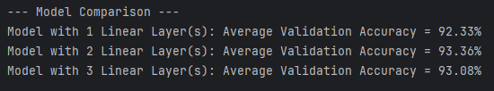

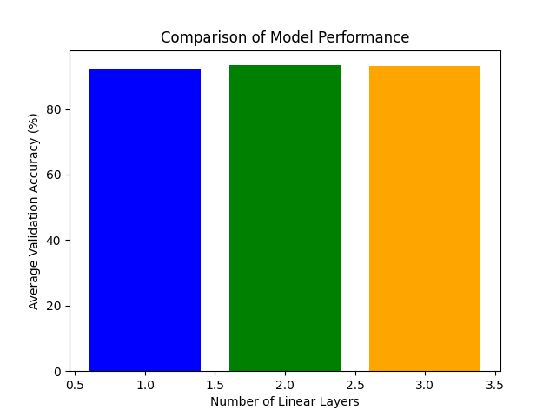

Figure 17:classifier (1, 2, and 3 linear layers)

These graphs show that there is no difference among multiple layers but the time for running is too much.

1. **Custom Classifier**:
   * Supports 1, 2, and 3 linear layers with optional ReLU activations between layers.
2. **K-Fold Cross-Validation**:
   * Evaluates models across multiple folds.
3. **Training and Evaluation**:
   * Includes training loop, validation, and confusion matrix visualisation.
4. **Performance Comparison**:
   * Compares the average validation accuracy of models with different classifier configurations.

Because the data is too large, for faster running, I decide to change some parts:

1. **Hardware Acceleration**:
   * Enabled cuDNN auto-tuner with torch.backends.cudnn.benchmark = True
   * Added mixed precision training with autocast() and GradScaler
   * Optimised memory layout with channels_last
2. **Data Pipeline**:
   * Implemented image caching to avoid repeated transformations
   * Used non-blocking transfers with non_blocking=True
   * Increased batch sizes and added persistent workers
   * Optimised augmentation pipeline
3. **Model Architecture**:
   * Simplified classifier with GELU activation
   * Added layer normalisation for stability
   * Reduced hidden dimensions when possible
4. **Training Process**:
   * Implemented gradient accumulation
   * Used AdamW optimiser with weight decay
   * Optimised zero_grad with set_to_none=True
   * Reduced validation frequency
5. **Memory Management**:
   * Explicit cache clearing with torch.cuda.empty_cache()
   * Reduced K-Folds to 3 for faster comparison
   * Used context managers for efficient memory usage

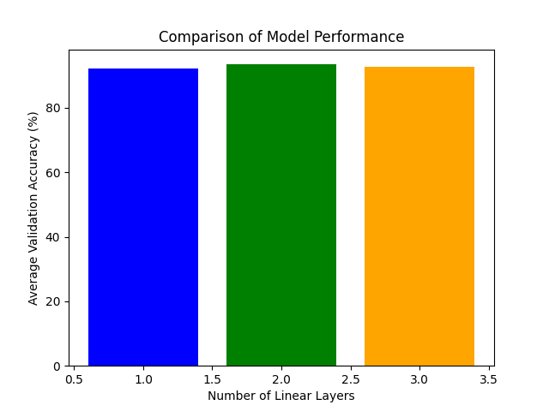

Figure 18: classifier (1, 2, and 3 linear layers), after improving the code

Table : Comparison layers

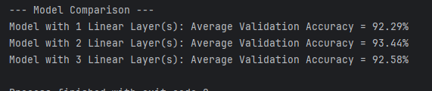

## Fine-Tuning Optimization

**Fine-tuning optimisation** is the process of taking a pretrained model and further training it on a specific dataset or task to improve its performance. This approach leverages the knowledge learned by the model during its initial training on a large dataset, allowing it to adapt more quickly and effectively to a new task with potentially limited data.

### Train the model using two different optimisers:

1. **Modified CustomCLIPFineTuner**:
   * The last two visual layers of CLIP’s visual encoder are trainable, while the rest are frozen.
2. **Support for Multiple Optimisers**:
   * Added train_model_with_optimizer to handle training with either Adam or AdamW.
3. **Comparison of Optimisers**:
   * The compare_optimizers function trains the model using both Adam and AdamW optimisers in a k-fold cross-validation setup.
   * Results are averaged across folds and visualised for comparison.
4. **Visualisation**:
   * Added a bar plot to compare the average validation accuracy of the two optimisers.

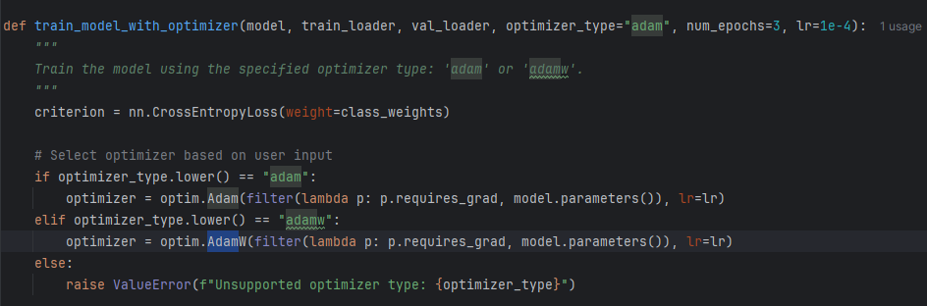

And for comparing

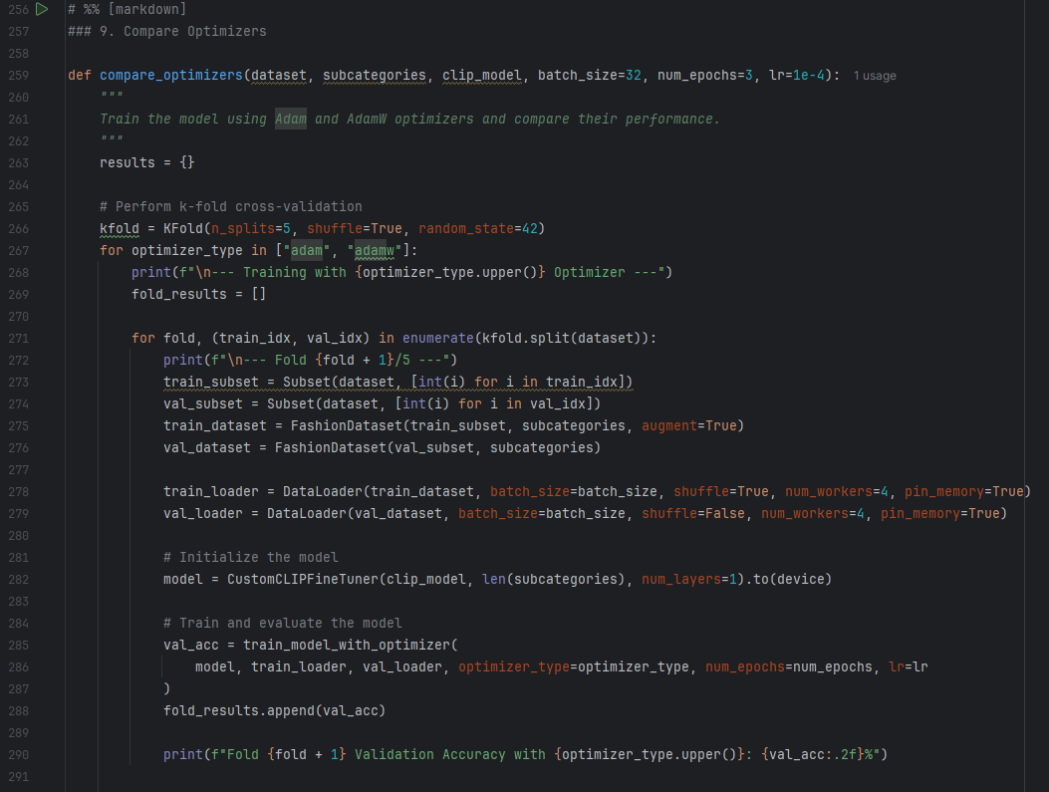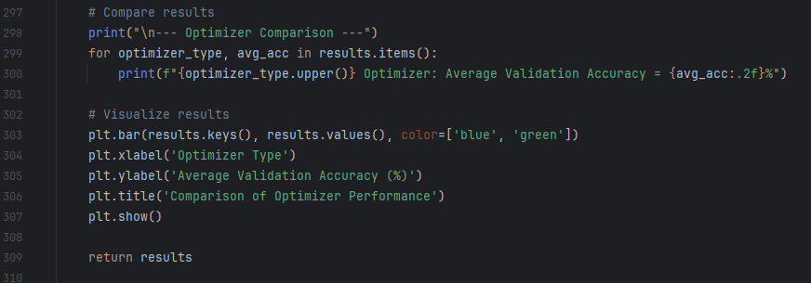

The confusion matrix with ADAM is

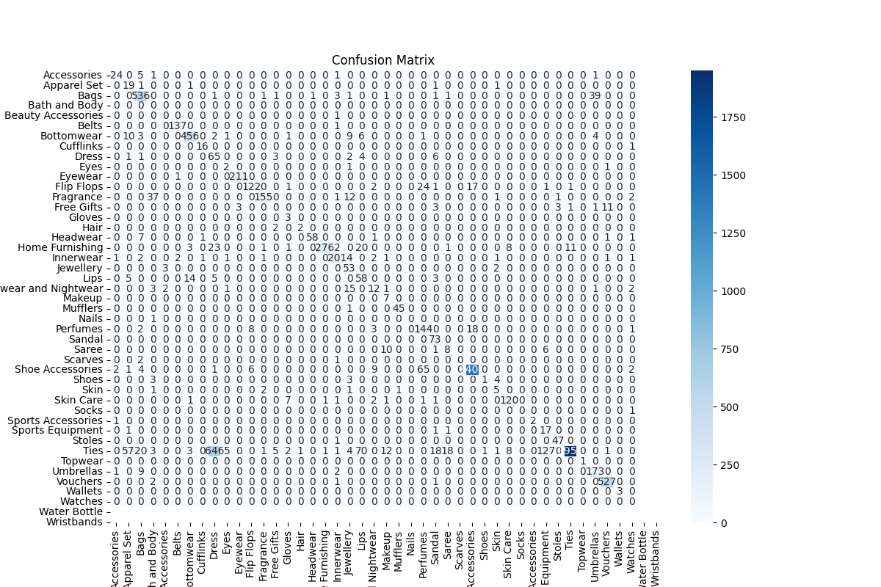

Figure 19: Confusion matrix with ADAM

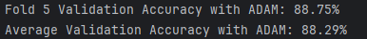

Figure 20: Validation Accuracy with ADAM

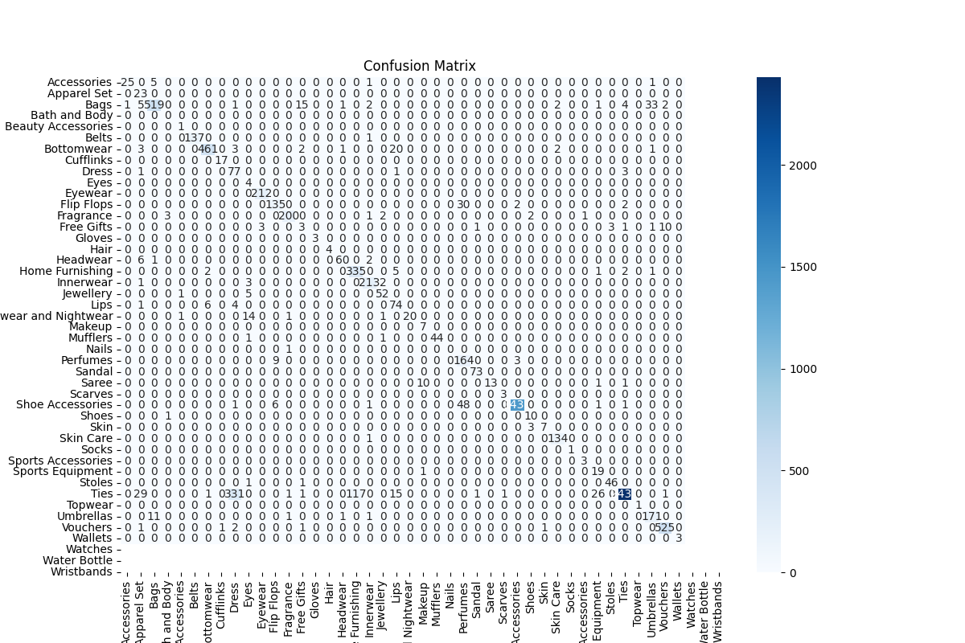

Figure 21: Confusion matrix with ADAMW

Table : Validation Accuracy with ADAMW

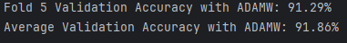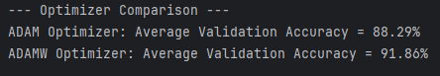

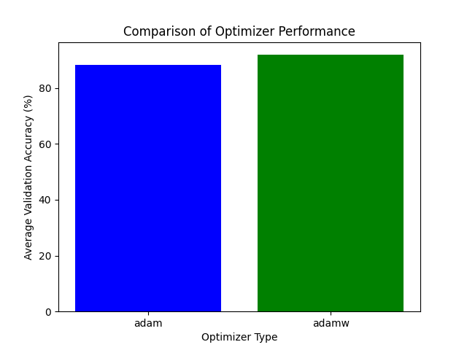

Figure 22: Optimiser Comparison

The difference in performance between the Adam optimiser (88.29% validation accuracy) and the AdamW optimiser (91.86% validation accuracy) arises primarily from how each optimiser handles **weight decay** during training.

Adam combines the benefits of momentum and adaptive learning rates, making it well-suited for deep learning tasks. However, in its standard implementation, weight decay (L2 regularisation) is applied directly to the gradients, which can interfere with Adam’s adaptive learning rate mechanism. This can lead to suboptimal handling of regularisation, especially in large models like CLIP, where careful parameter updates are critical.

AdamW improves upon Adam by decoupling weight decay from the gradient updates. Instead of directly incorporating weight decay into the gradients, it adjusts the weights independently during each optimisation step. This decoupled approach preserves Adam’s adaptive learning rate benefits while ensuring more consistent regularisation. The result is better generalisation and improved performance, as seen in the higher validation accuracy (91.86%) with AdamW.

As a result, we can see that the ADAMW is better. The reasons are:

1. **Better Regularisation**: Decoupling weight decay ensures the model’s parameters are regularised effectively without disrupting Adam’s adaptive learning rate mechanism.
2. **Improved Generalisation**: AdamW prevents overfitting more effectively, allowing the model to perform better on unseen validation data.
3. **Stability in Training**: AdamW provides more stable updates, especially for models with a large number of parameters, like CLIP’s visual layers.

In conclusion, the difference in validation accuracy highlights AdamW’s ability to optimise models more effectively by decoupling weight decay from gradient updates, resulting in better generalisation and overall performance.

## Training and Evaluation

### Report training, validation, and test losses after each epoch.

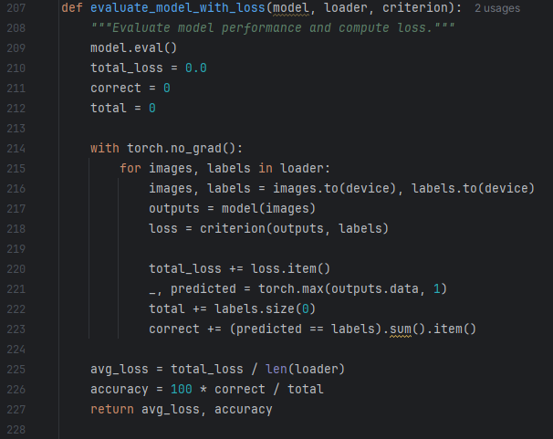

The above parts of the code are directly related to reporting training, validation, and test losses:

1. **Training Loss**:
   * Computed in the training loop and averaged at the end of the epoch.
2. **Validation and Test Loss**:
   * Computed using the evaluate_model_with_loss function after training.
3. **Logging to TensorBoard**:
   * Logged using writer.add_scalar for visualization in TensorBoard.
4. **Printing Results**:
   * Losses and accuracies are printed to the console after each epoch.

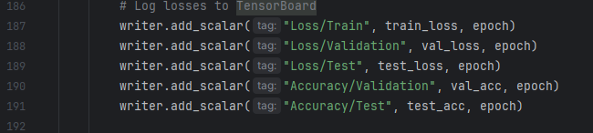

* **Loss Metrics**:
  + Training, validation, and test losses are logged under:
    - "Loss/Train"
    - "Loss/Validation"
    - "Loss/Test"
* **Accuracy Metrics**:
  + Validation and test accuracies are logged under:
    - "Accuracy/Validation"
    - "Accuracy/Test"
* **Log Directory**:
  + All logs are saved in the logs/ directory, with subdirectories for each optimiser (logs/adam and logs/adamw).

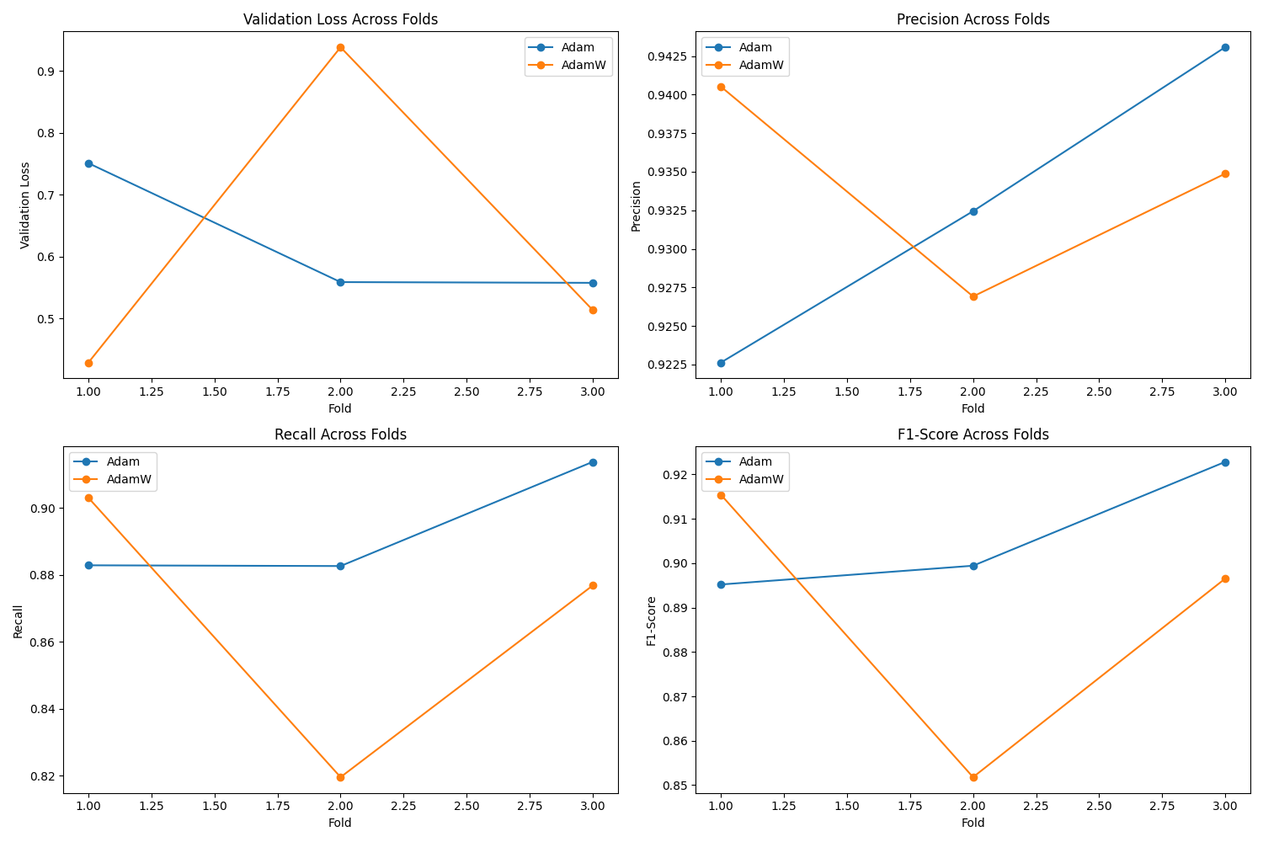

Figure 23: Training and Evaluation

The logs are also stored after each run of the code.

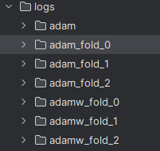

Figure 24: log saved

The readlogs.py is also implemented to read the logs

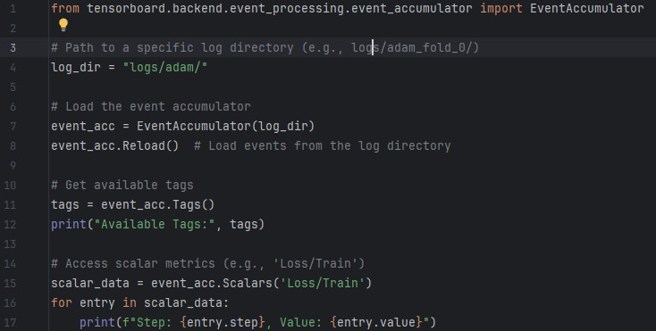

Figure 25: read logs

## Visualisation of Predictions

### Display predicted vs. actual labels for validation images

Add visualisation logic to the evaluate_model_with_metrics function. We’ll plot a few validation images with their predicted and actual labels.

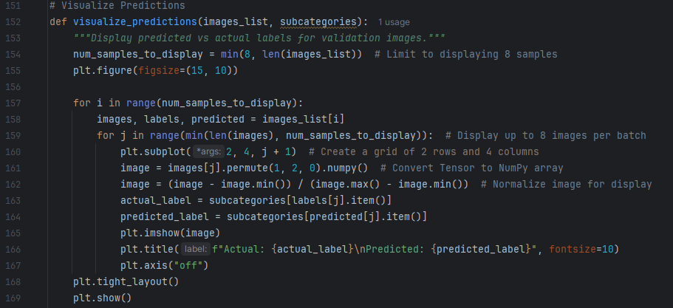

Figure 26: Predicted vs. actual labels

for ADAM, the results show

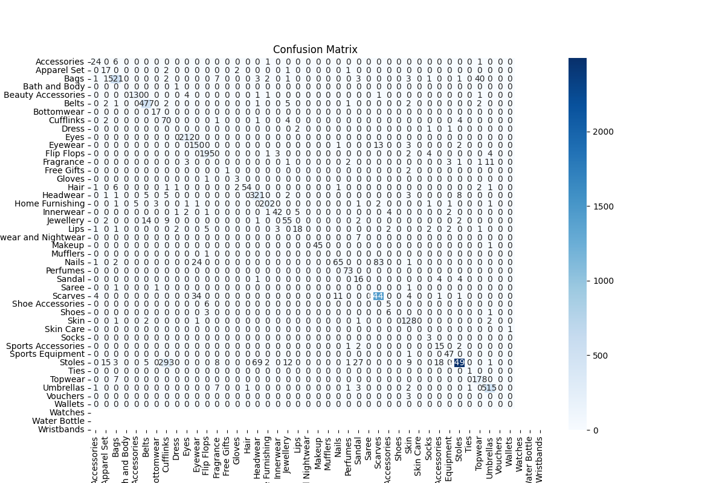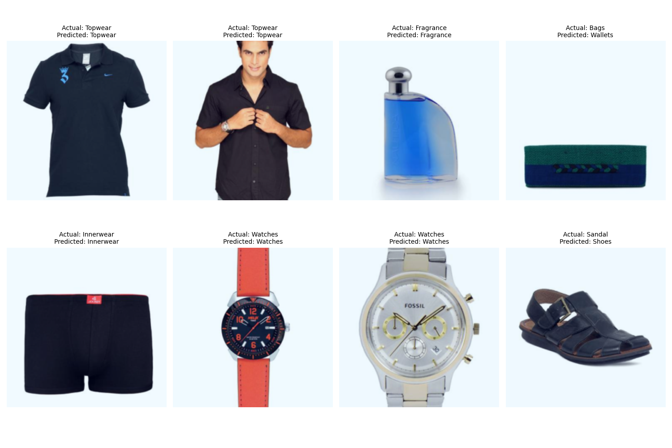

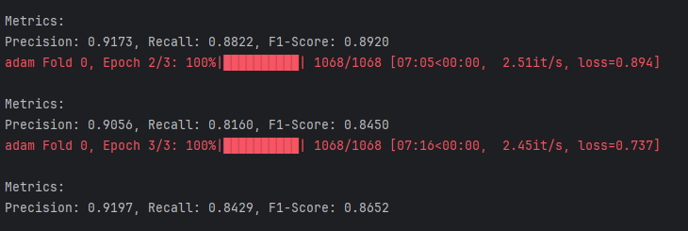

Figure 27: ADAM Fold 1/5, Epoch 1/3

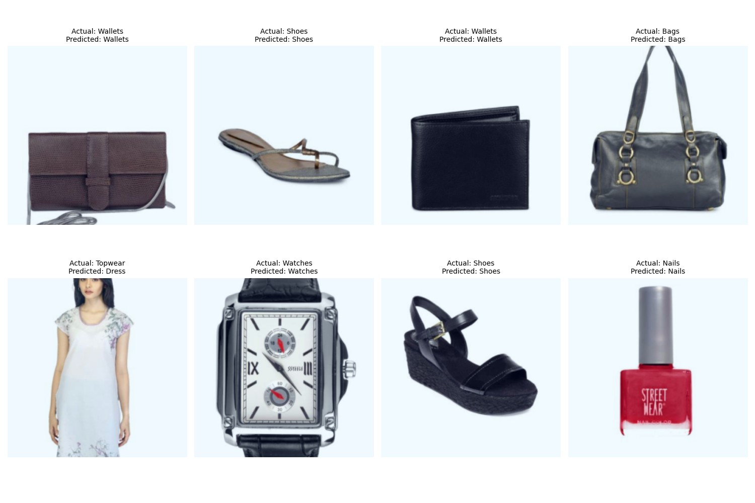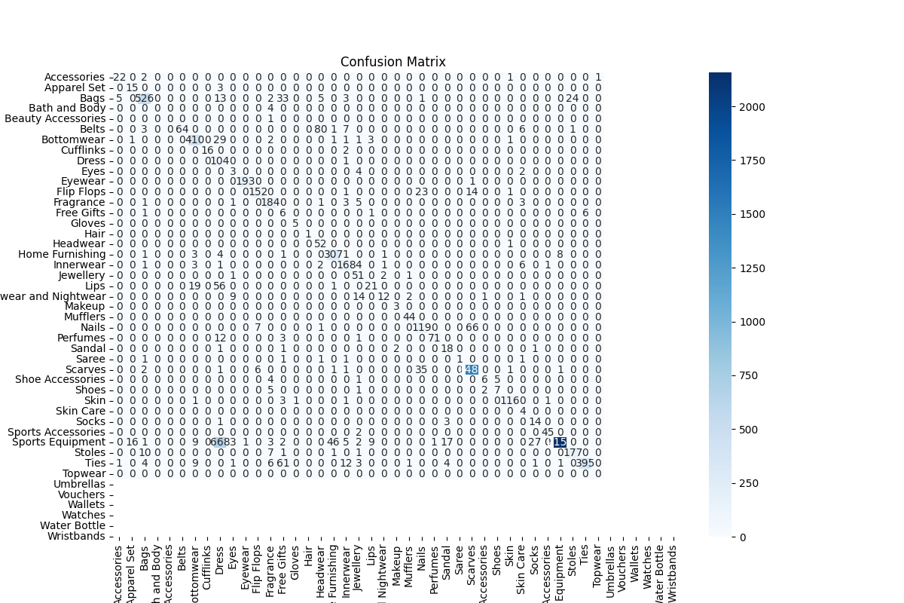

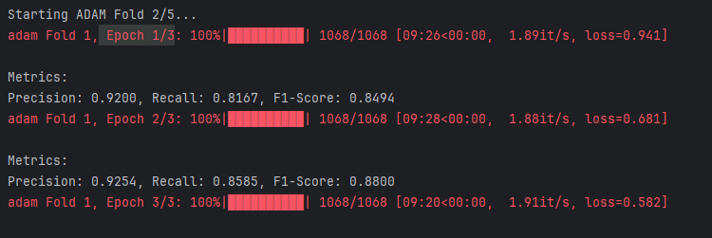

Figure 28: ADAM Fold 2/5

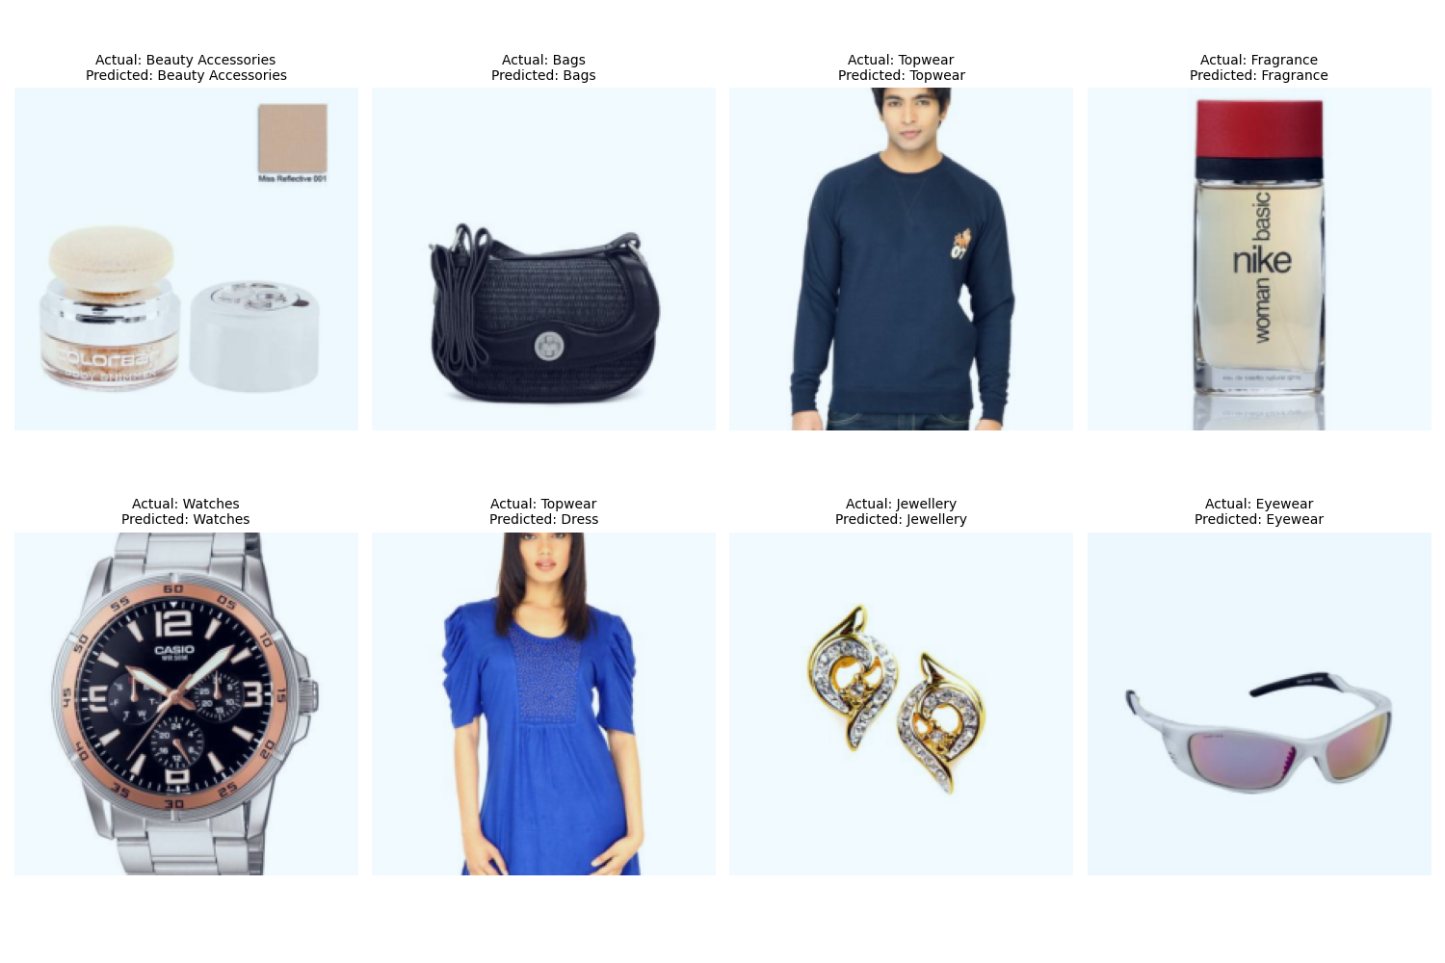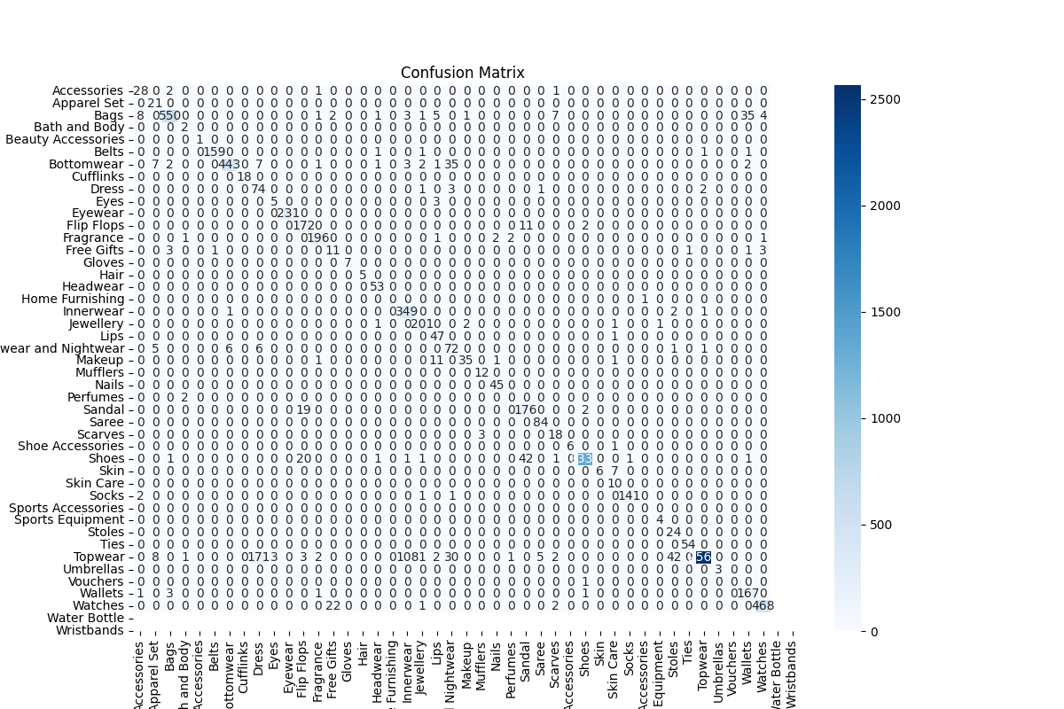

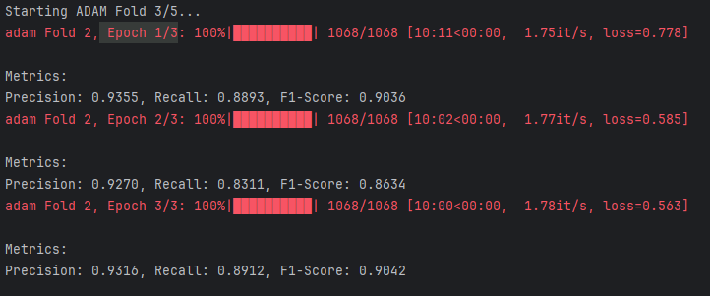

Figure 29:ADAM Fold 3/5, Epoch 1/3

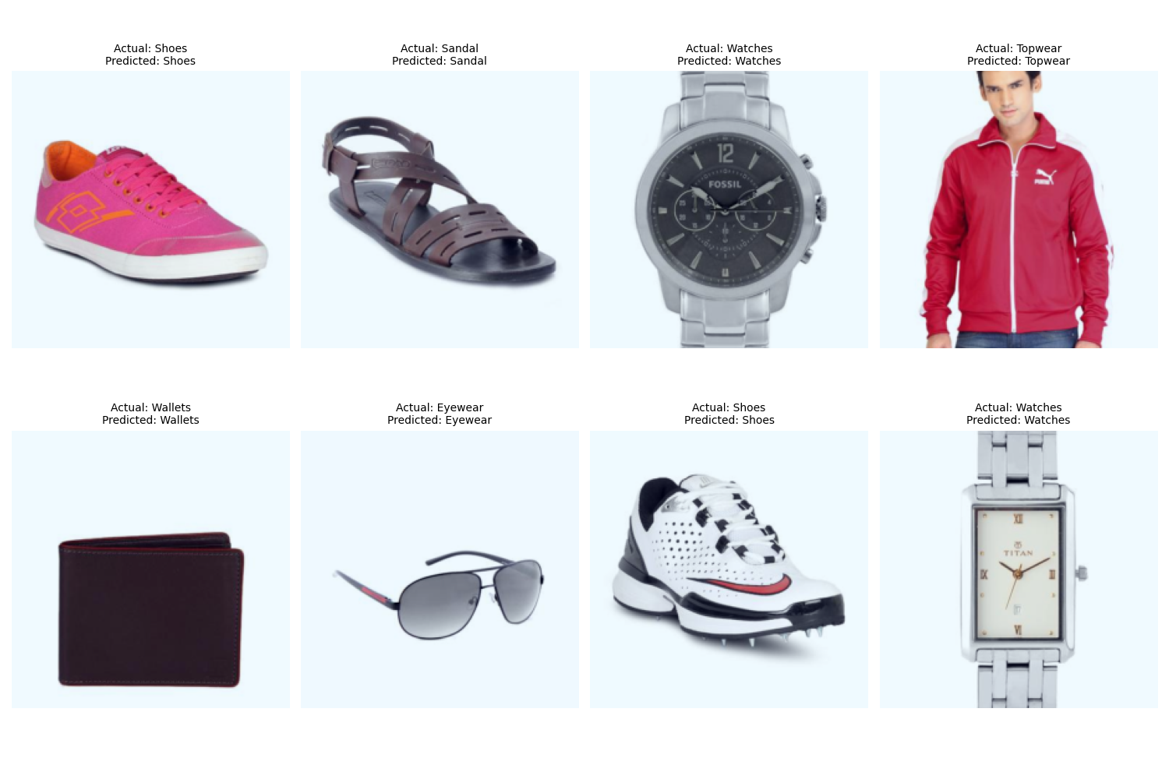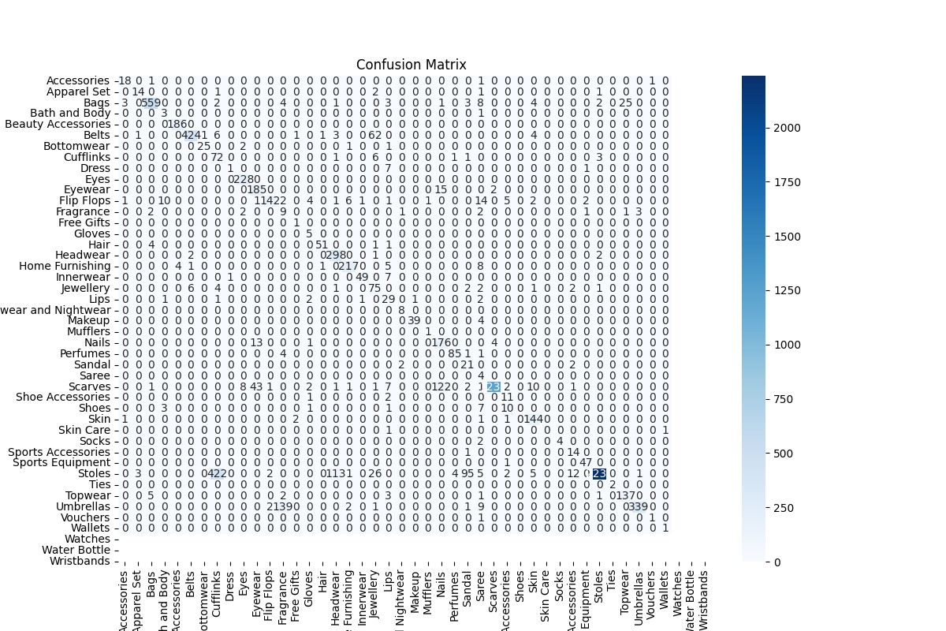

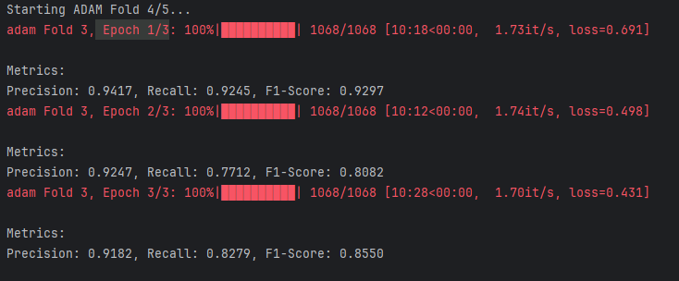

Figure 30: ADAM Fold 4/5

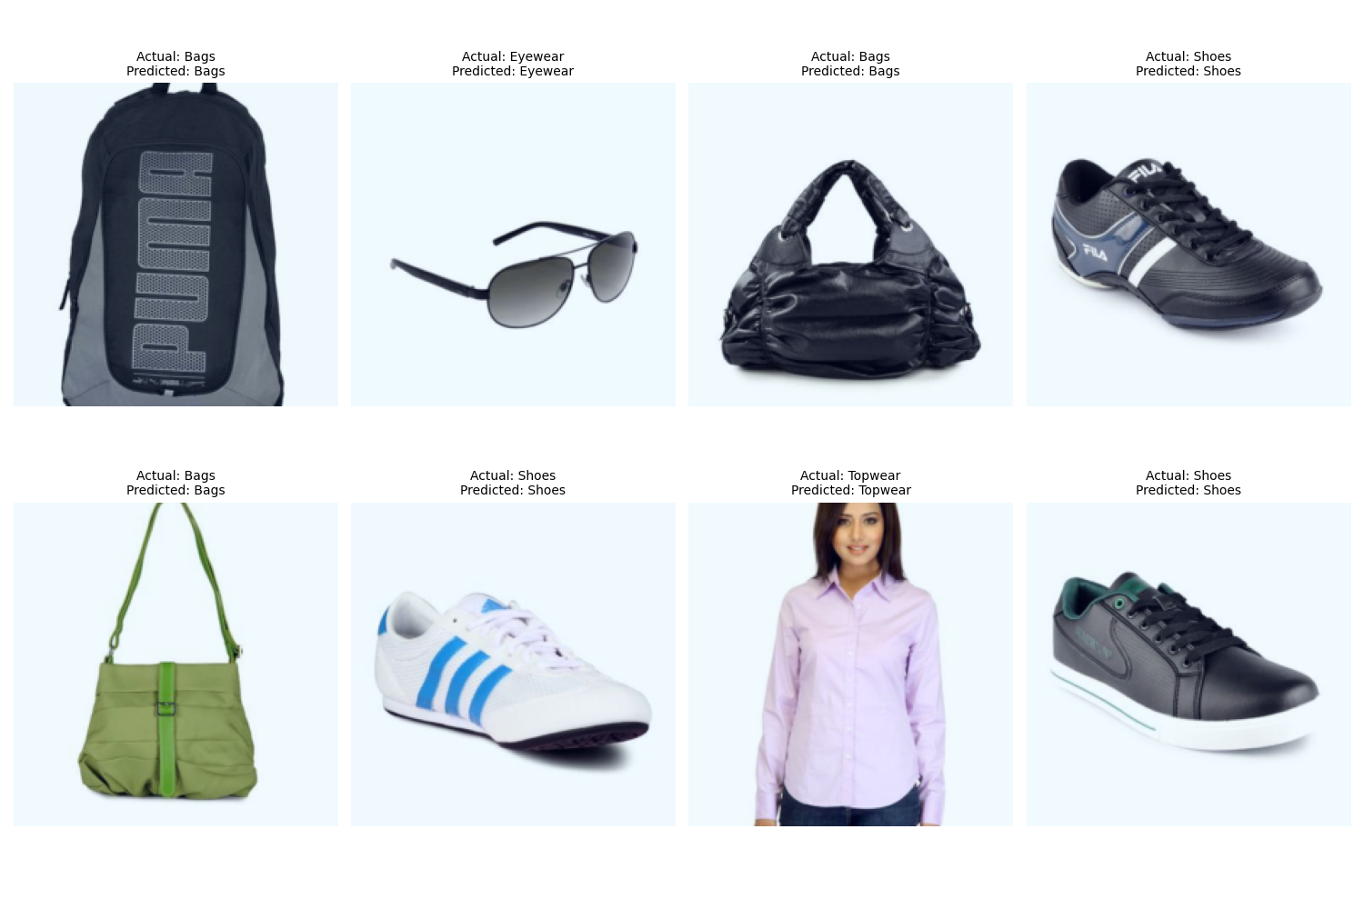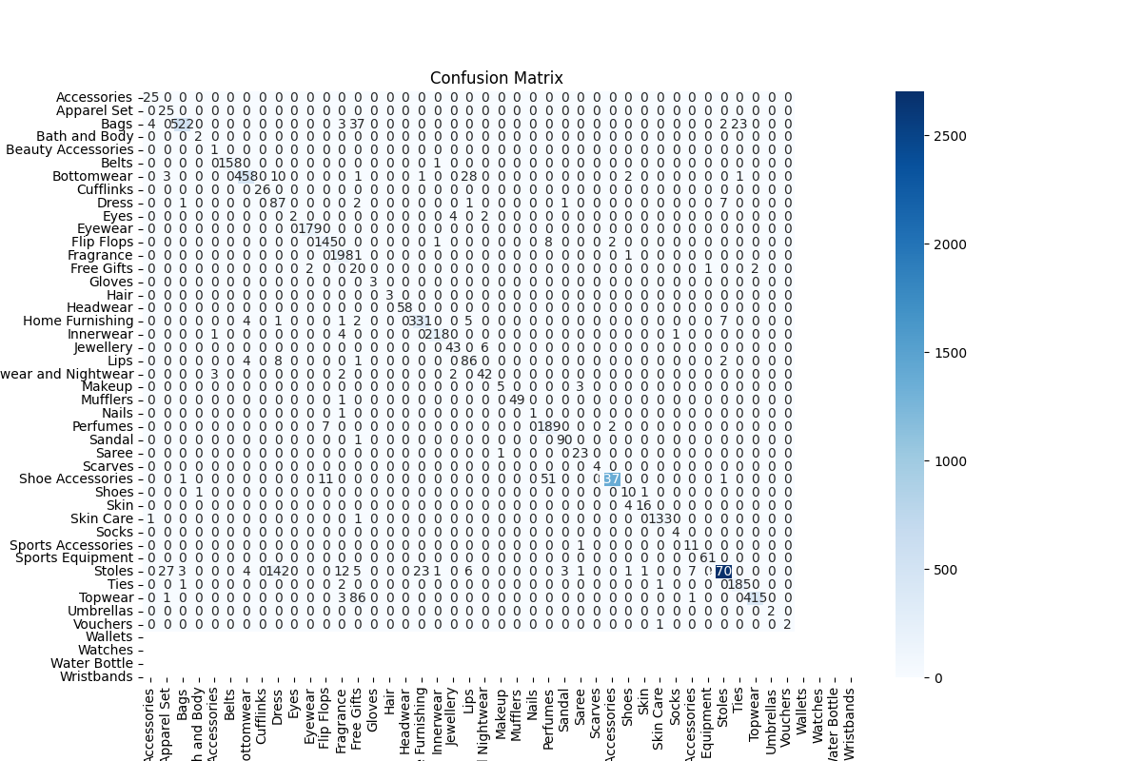

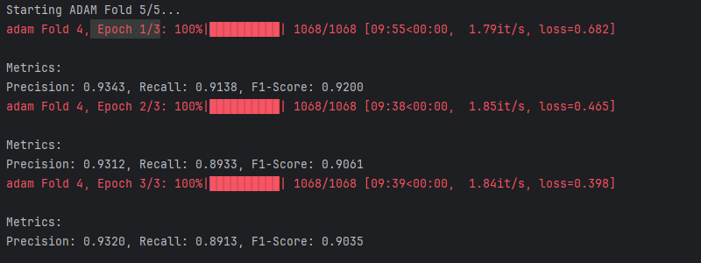

Figure 31: ADAM Fold 5/5

And for ADAMW the result are



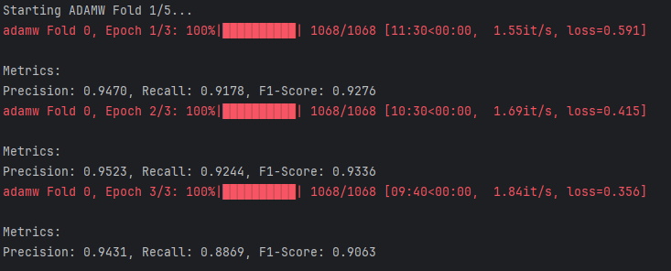

Figure 32: ADAMW Fold 1/5



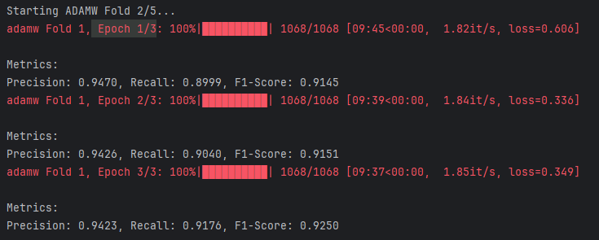

Figure 33: ADAMW Fold 2/5



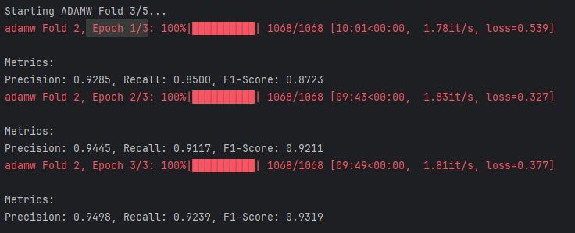

Figure 34: ADAMW Fold 3/5



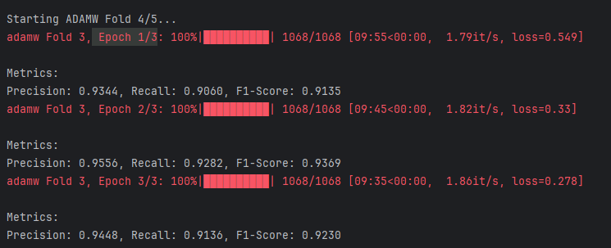

Figure 35: ADAMW Fold 4/5



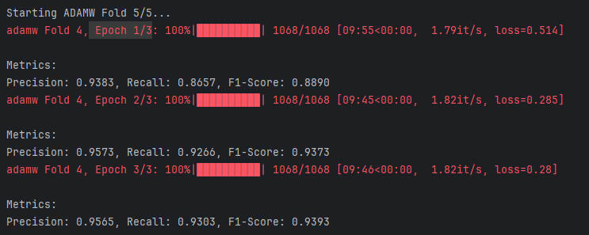

Figure 36: ADAM Fold 5/5

The graph below shows the comparison of ADAM and ADAMW.

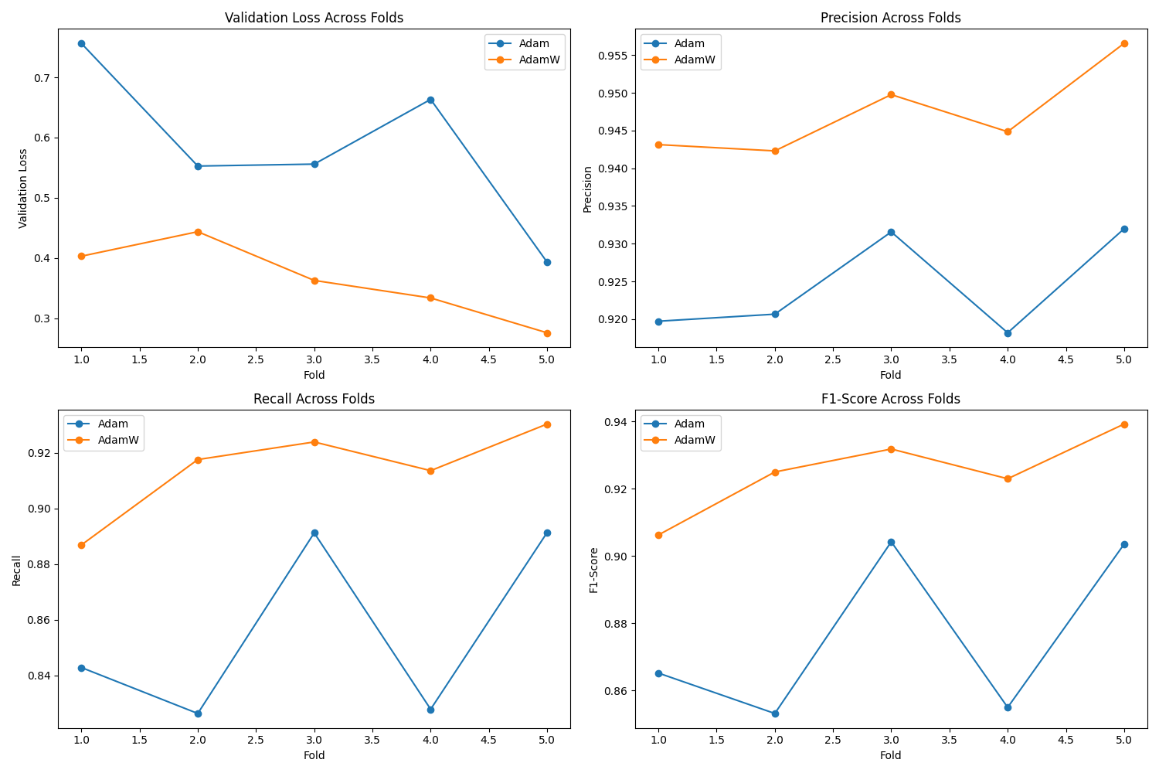

Figure 37: Comparison of ADAM and ADAMW

The plots visualise the performance of two different optimisers, **Adam** and **AdamW**, across five folds of cross-validation in a machine learning task, related to image classification using a Vision Transformer (ViT). Validation Loss Across Folds

* This plot displays the validation loss for both optimisers across the five folds.
* **Interpretation**:
  + **Adam (Blue Line)**: The validation loss for Adam fluctuates but generally stays above that of AdamW. It starts higher and shows some decrease in the middle folds, but doesn’t drop significantly in the final folds.
  + **AdamW (Orange Line)**: The validation loss for AdamW starts lower and decreases consistently across the folds, indicating better performance in minimising the loss function during validation.

**Conclusion**: AdamW outperforms Adam in terms of validation loss, suggesting that it is better at generalising to unseen data in this context.

#### 2. Precision Across Folds

* This plot illustrates the precision scores achieved by each optimiser across the five folds.
* **Interpretation**:
  + **Adam (Blue Line)**: The precision remains fairly stable with minor fluctuations, indicating consistent performance.
  + **AdamW (Orange Line)**: The precision for AdamW is generally higher across all folds, showing better performance in correctly identifying positive instances while minimizing false positives.

**Conclusion**: AdamW consistently achieves higher precision than Adam, indicating that it is more effective in producing correct positive predictions.

#### 3. Recall Across Folds

* This plot depicts the recall scores for both optimisers across the five folds.
* **Interpretation**:
  + **Adam (Blue Line)**: The recall shows some variability, with some folds performing lower than others, particularly in folds 2 and 3.
  + **AdamW (Orange Line)**: The recall remains relatively high and stable across the folds, indicating that AdamW is better at capturing all relevant instances (i.e., true positives).

**Conclusion**: AdamW demonstrates superior recall compared to Adam, meaning it is more effective at identifying all the relevant instances in the dataset.

#### 4. F1-Score Across Folds

* This plot shows the F1-score, which is the harmonic mean of precision and recall, for both optimisers across folds.
* **Interpretation**:
  + **Adam (Blue Line)**: The F1-score fluctuates and is generally lower than that of AdamW, indicating a poorer balance between precision and recall.
  + **AdamW (Orange Line)**: The F1-score is consistently higher across all folds, suggesting better overall performance in classifying positive and negative instances.

**In conclusion**, AdamW achieves higher F1-scores than Adam, indicating that it provides a better balance between precision and recall in this classification task. The comparison across all four metrics (validation loss, precision, recall, and F1-score) shows that **AdamW** consistently outperforms **Adam** in this particular experimental setup. This suggests that AdamW might be a better choice for training models in tasks similar to the one evaluated, likely due to its weight decay mechanism that helps prevent overfitting.

## Using an Alternative CLIP Model

### Repeat the steps above using ViT-B-32 with pretrained='openai'

ViT-B-32, or Vision Transformer Base with a patch size of 32, is a model architecture designed for image classification tasks. It is part of the Vision Transformer (ViT) family, which leverages the transformer architecture, originally developed for natural language processing, for visual tasks. Here are some key features of ViT-B-32:

1. **Patch-Based Input**: Instead of processing images as whole entities, ViT divides images into non-overlapping patches (32x32 pixels in this case). Each patch is then treated as a token, similar to how words are treated in NLP models.
2. **Transformer Architecture**: The model utilizes self-attention mechanisms to capture the relationships between different patches, allowing it to learn complex patterns and features from the image data.
3. **Base Model**: The “B” in ViT-B refers to the base size of the model, which typically has fewer parameters than larger variants (like ViT-L for large or ViT-H for huge), making it more efficient for training and inference.
4. **Pre-training and Fine-tuning**: ViT models are often pre-trained on large datasets (like ImageNet) and can be fine-tuned on specific tasks, such as fashion classification, which is relevant to the project.

Overall, ViT-B-32 is popular for its ability to achieve competitive performance on various image classification benchmarks while being relatively efficient compared to traditional convolutional neural networks (CNNs).

instead of using a CLIP model, we will load the ViT-B-32 model so loading this



#### Modifying the Model for Image Classification (classifiers 1, 2, and 3 linear layers)

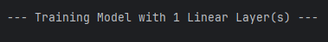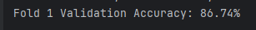

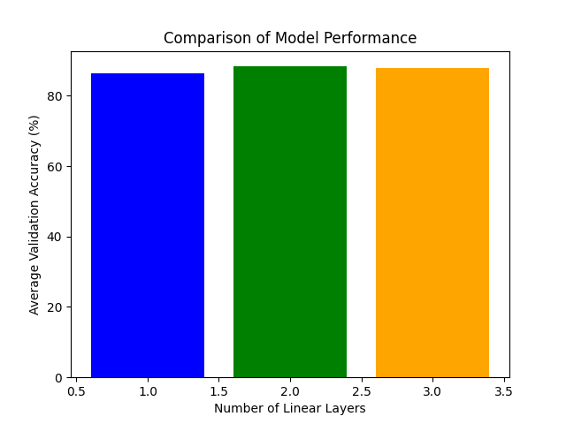

Figure 38: Comparison model performance (1,2, and 3 layers)

Table : Comparison model performance (1,2, and 3 layers)

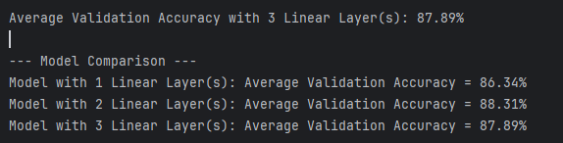

#### **Fine-Tuning Optimisation with** ViT-B-32 with pretrained='openai’

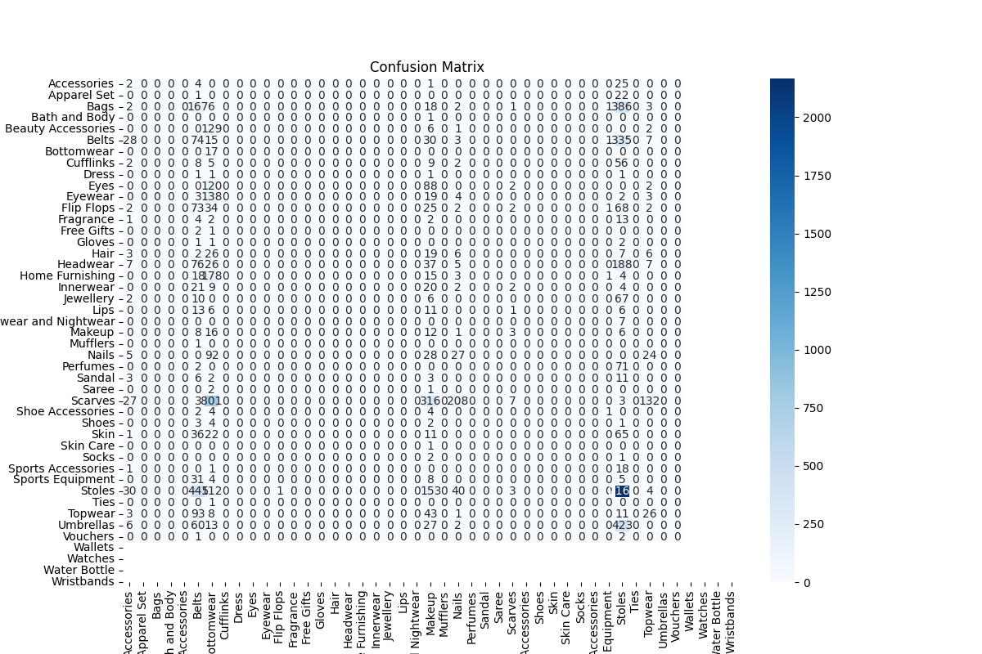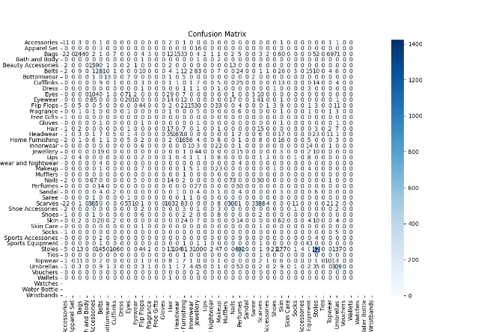

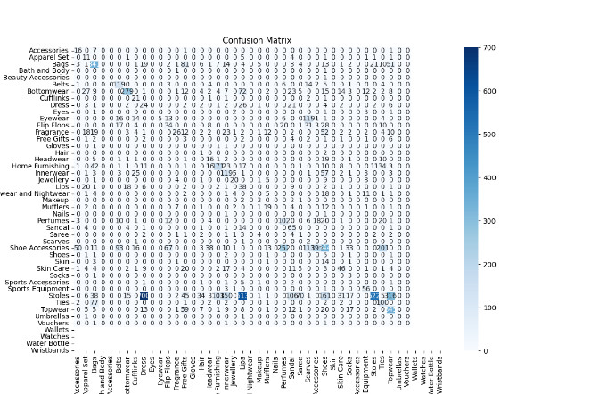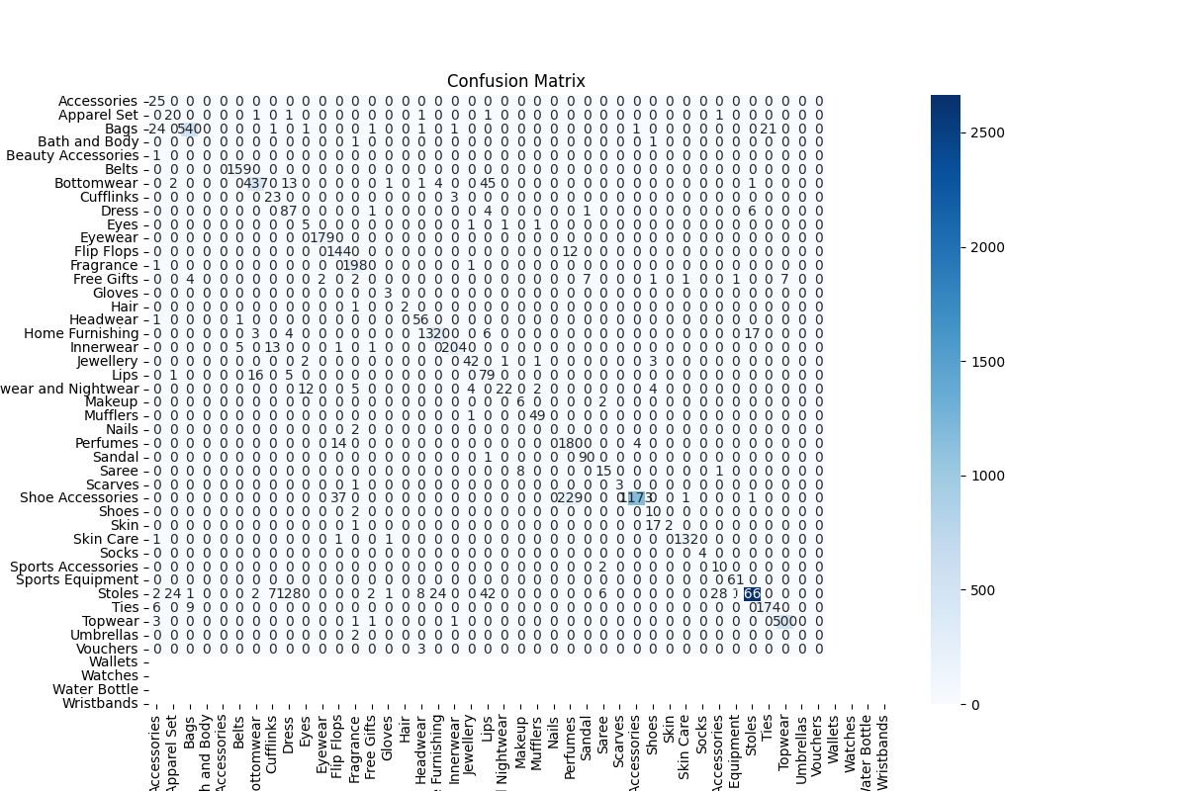

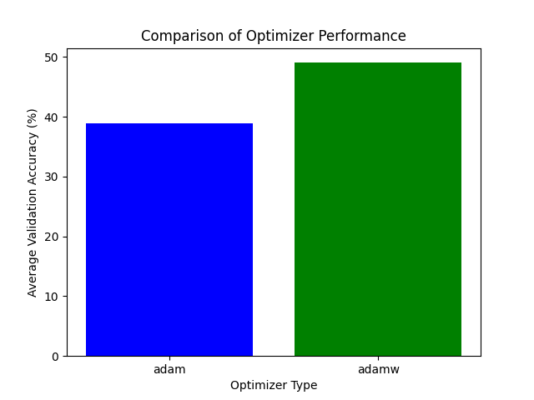

Figure 39: Compare the performance of both optimisers with ViT-B-32 and openai

The improved performance of **AdamW** might be due to its better handling of weight decay, allowing for improved regularisation during training. This can help prevent overfitting, leading to better validation performance. Overall, the chart highlights the effectiveness of the AdamW optimiser over Adam, suggesting that it may be a better choice for our specific model.

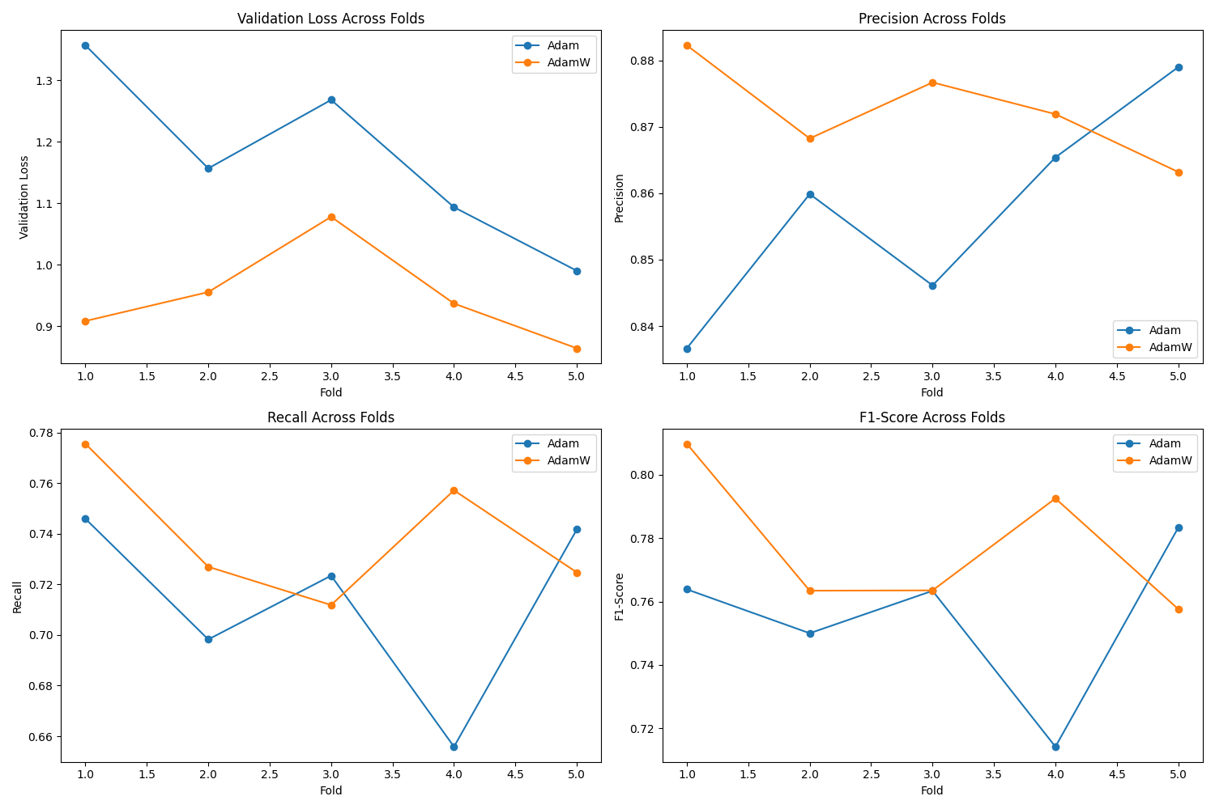

Figure 40: Accuracy comparing (ADAM and ADAMW)

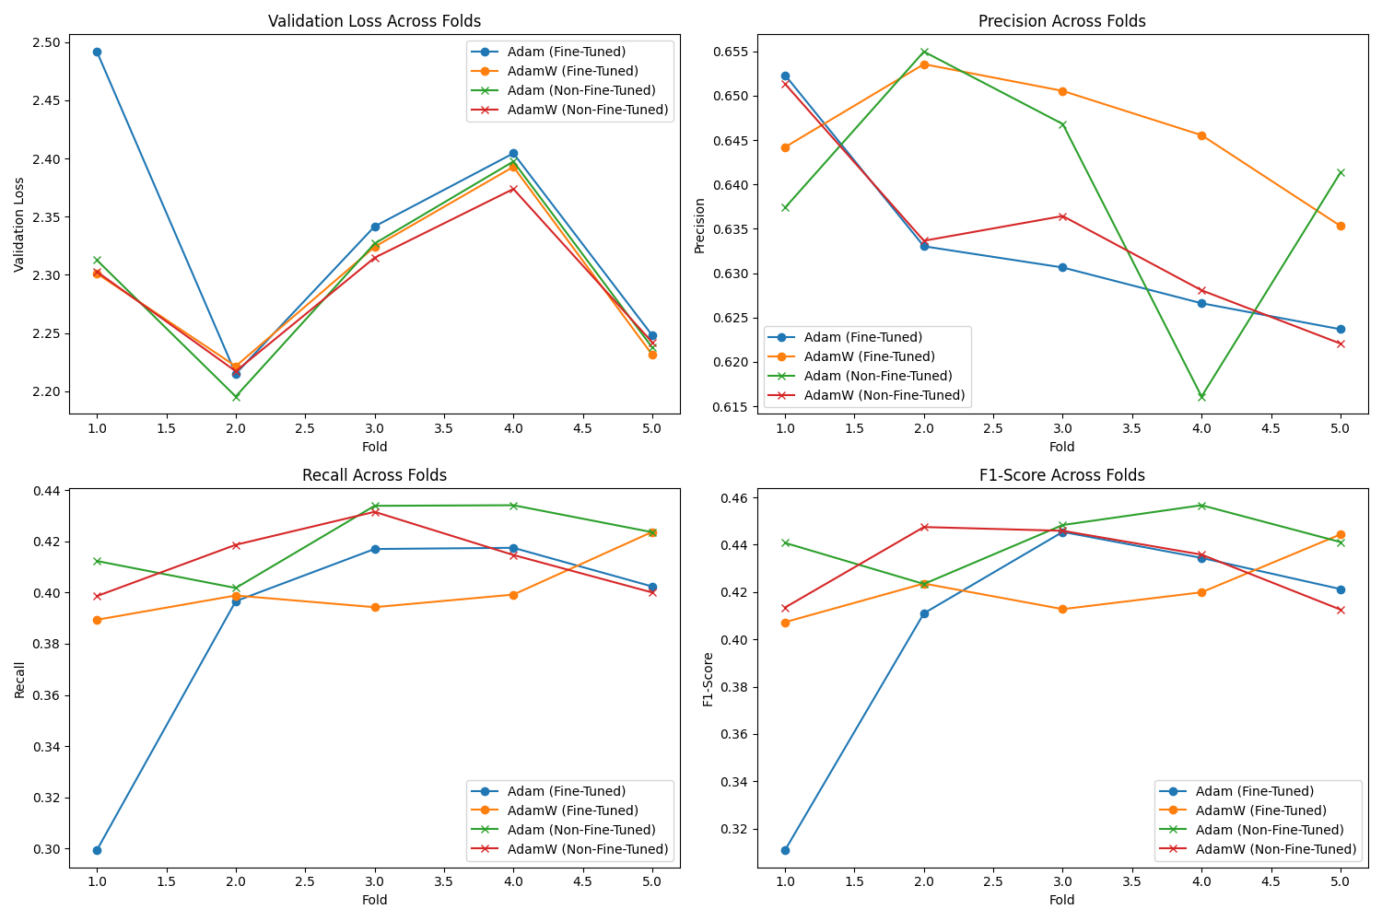

Figure 41: Accuracy comparing (with and without ADAM and ADAMW)

The data represents the training process of two types of models—fine-tuned and non-fine-tuned—trained with ADAM and ADAMW optimisers over 5 folds. For each fold, the models are trained for 3 epochs, and performance metrics such as Precision, Recall, and F1-Score are recorded after every epoch. The training progress is shown with a progress bar (100% completion for each epoch), along with the loss value and time taken per epoch (e.g., around 5 minutes per epoch for most cases). For instance, in ADAM Fold 1/5, the fine-tuned model improves its F1-Score from 0.1060 in Epoch 1 to 0.3109 in Epoch 3, while the non-fine-tuned model achieves a higher F1-Score of 0.4408 in Epoch 3. Similar patterns are observed across other folds and with the ADAMW optimiser, where metrics generally improve over epochs. Logs for each fold are saved in designated directories for further analysis.

This output details the training results of fine-tuned and non-fine-tuned models using ADAM and ADAMW optimisers across 5 folds, with 3 epochs per fold. It includes metrics like Precision, Recall, and F1-Score for each epoch, alongside loss values and training duration (typically around 5 minutes per epoch). Performance generally improves with each epoch, as seen in metrics—for example, the non-fine-tuned ADAM model in Fold 1 reaches an F1-score of 0.4408 by Epoch 3. Training logs are stored in specific folders for each fold and optimiser.

The text shows the training logs for two model versions (fine-tuned and non-fine-tuned) using ADAM and ADAMW optimisers, tested over 5 folds with 3 epochs each. For every epoch, it lists performance scores like Precision, Recall, and F1-Score, plus the loss and time taken (often about 5 minutes per epoch). The scores usually get better by the last epoch, for example, the non-fine-tuned ADAM model in the first fold hits an F1-score of 0.4408. All training details are saved in log files for each fold.

In summary, the training results across 5 folds for both fine-tuned and non-fine-tuned models using ADAM and ADAMW optimisers demonstrate a consistent improvement in performance metrics—Precision, Recall, and F1-Score—over the 3 epochs per fold. The non-fine-tuned models often achieved competitive or slightly better results compared to their fine-tuned counterparts by the final epoch, with training durations averaging around 5 minutes per epoch. These findings, supported by detailed logs saved for each fold, provide valuable insights for further model optimisation and comparison.

#### Training and Evaluation with ViT-B-32 and openai

After epoch 1, the result is shown below:



After epoch 2, the result is shown below:



After epoch 3, the result is shown below:



After epoch 4, the result is shown below:



After epoch 5, the result is shown below:



Totally,

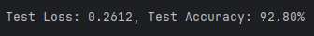

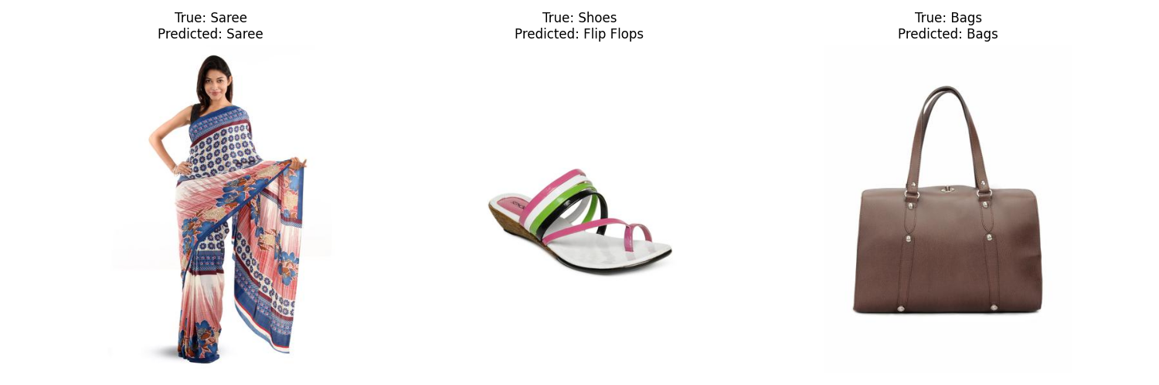

I changed the epoch to 10 to follow the results.

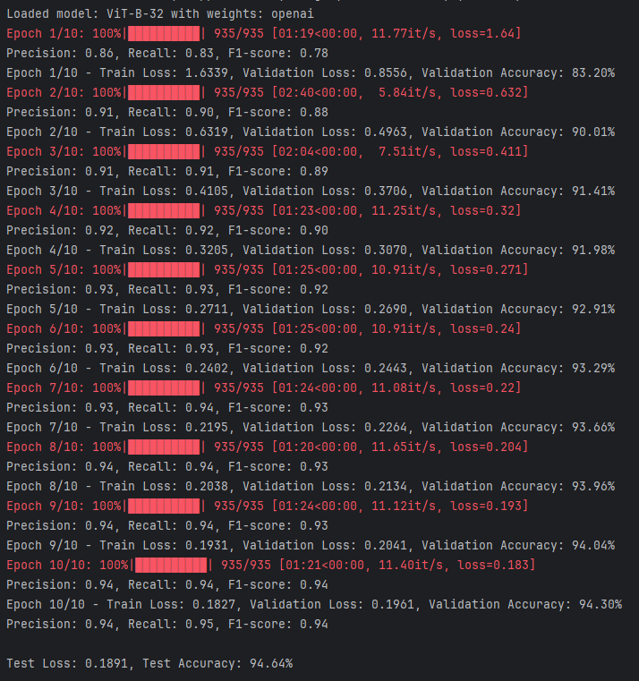

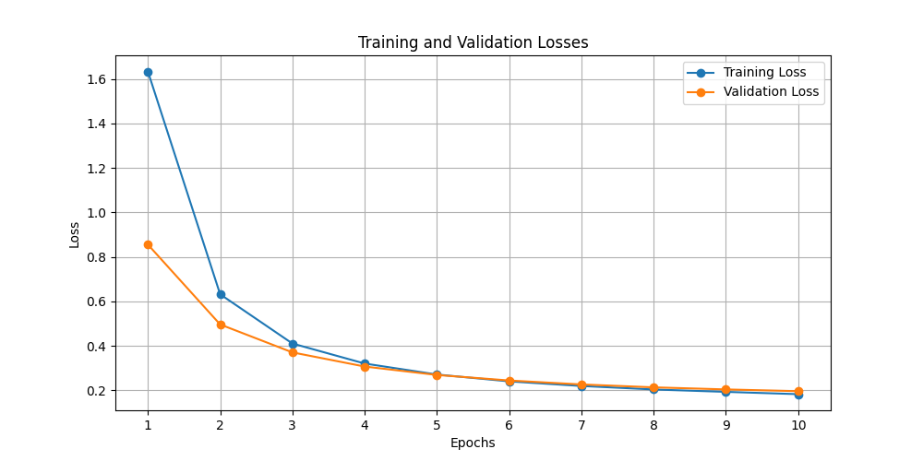

Figure 42: The results for 10 epochs

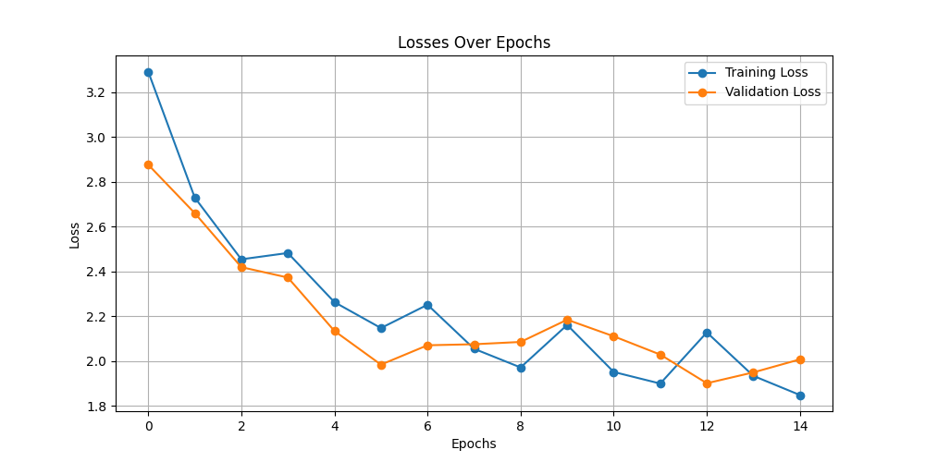

Figure 43: The results for 14 epochs

# PART 3: ADVANCED FINE-TUNING STRATEGIES

## Full Model Fine-Tuning

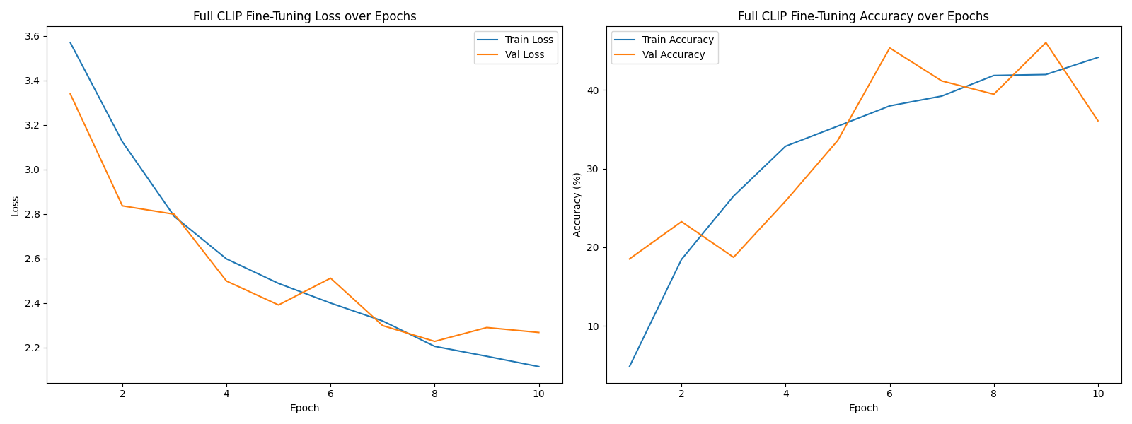

Figure 44: Full Model Fine-Tuning

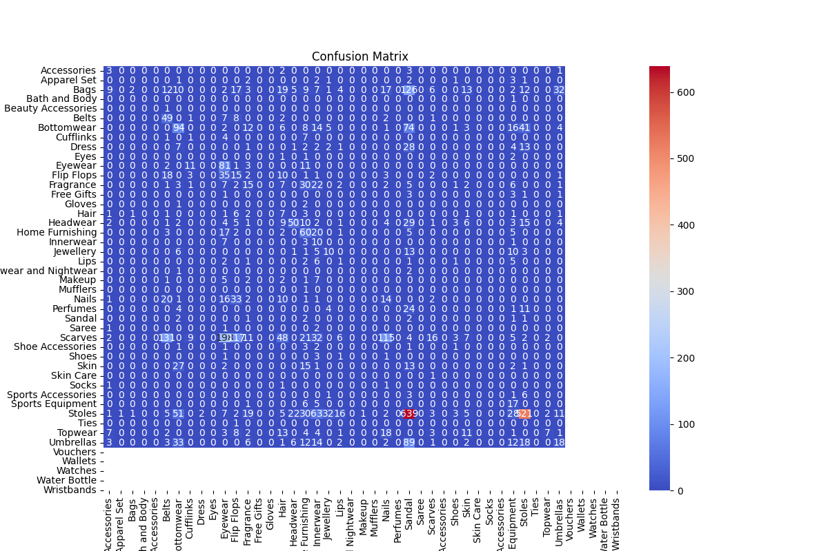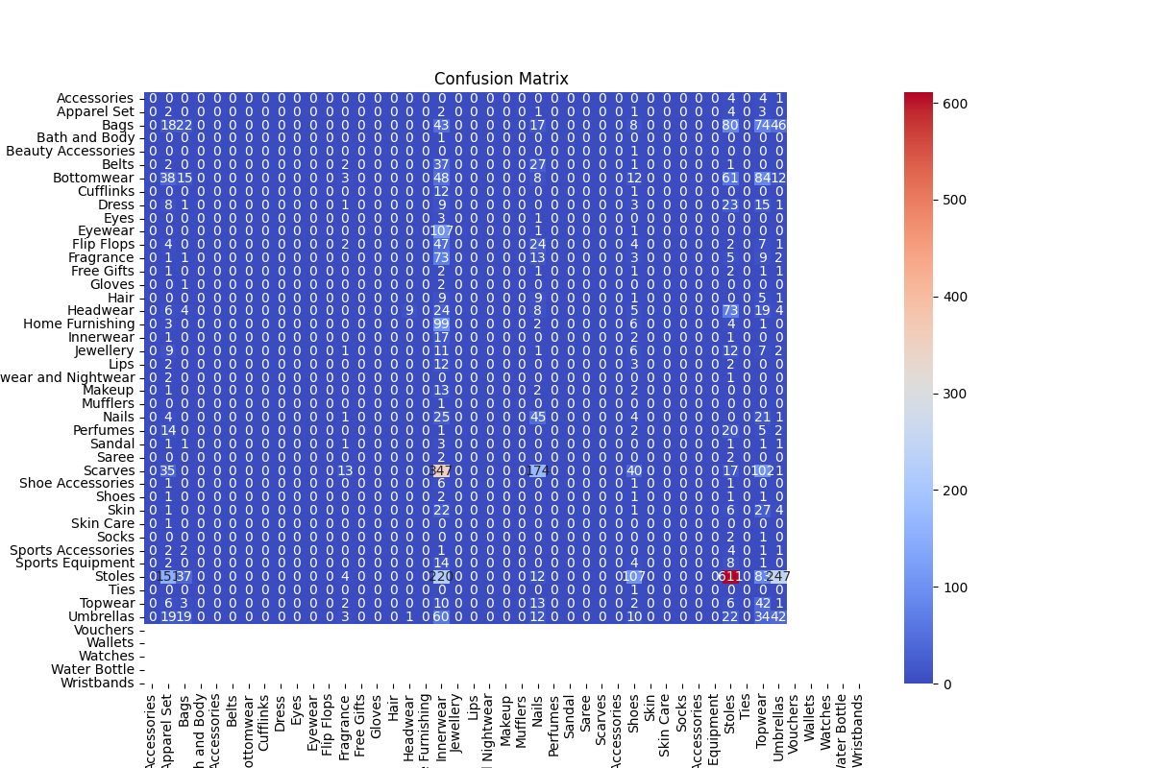

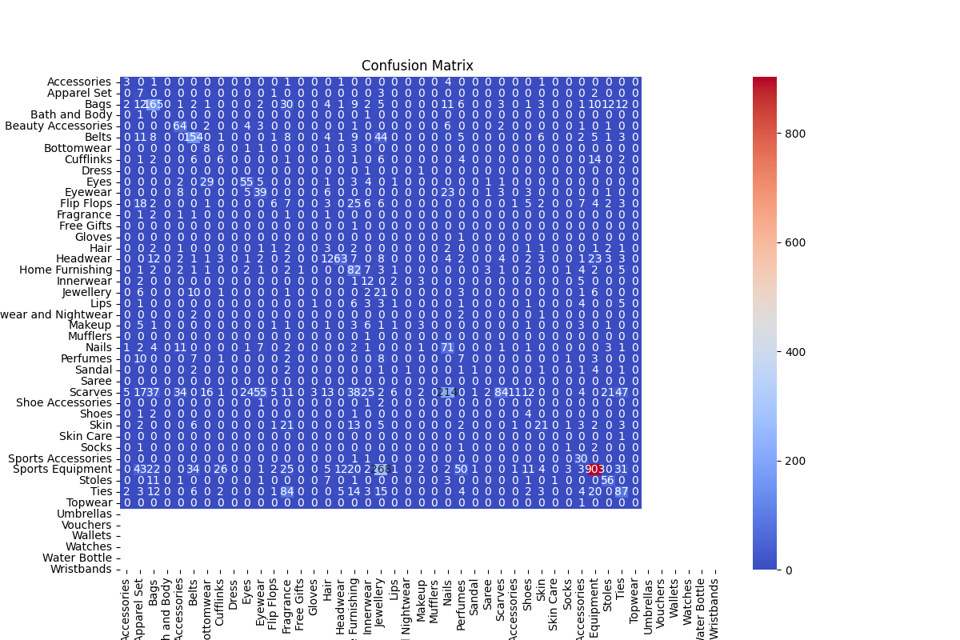

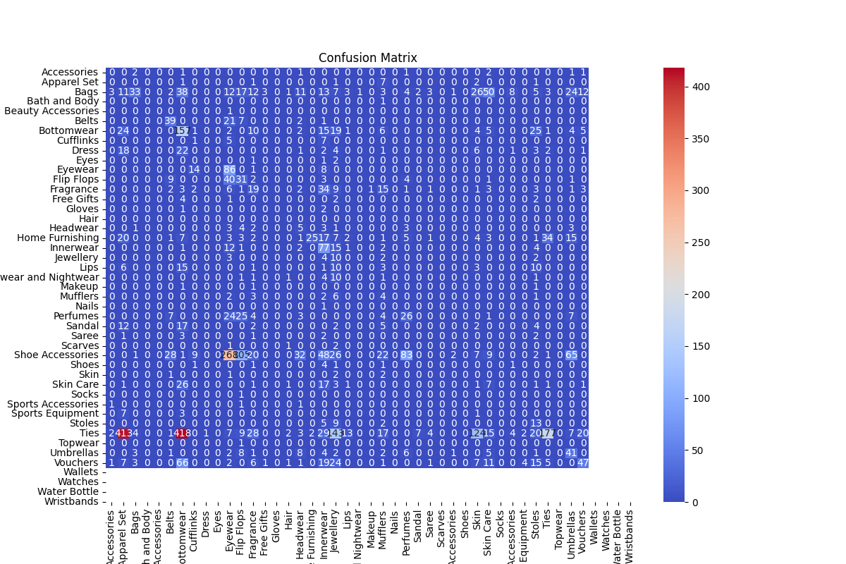

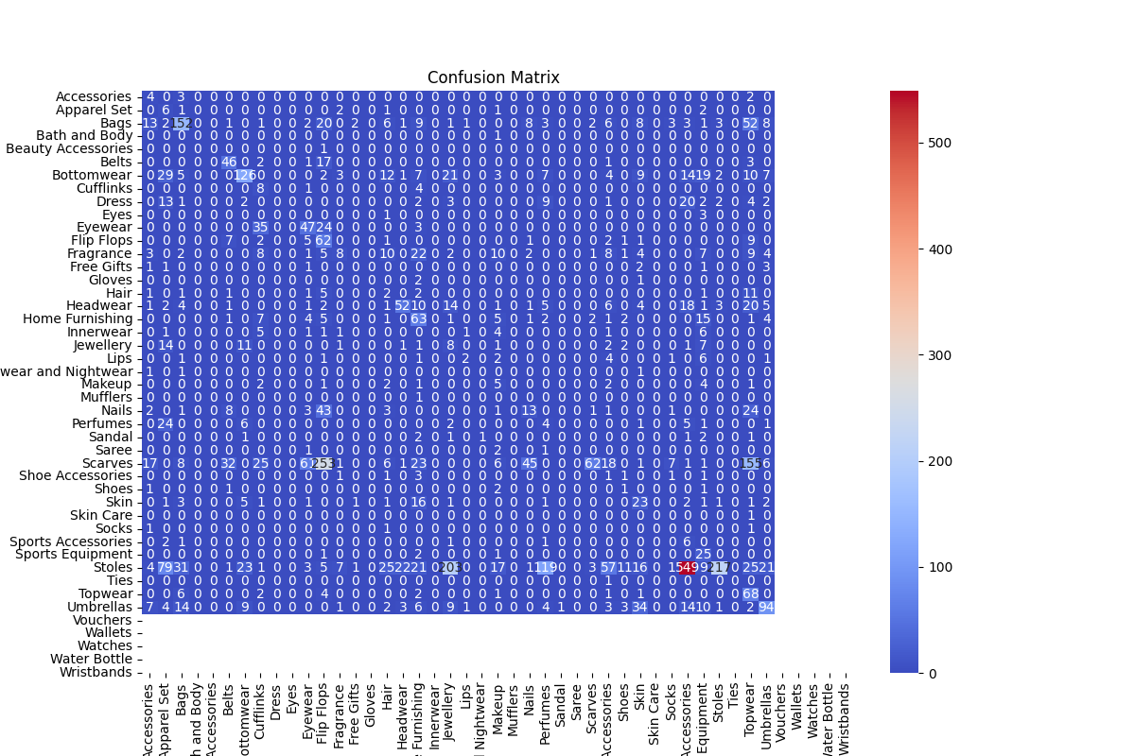

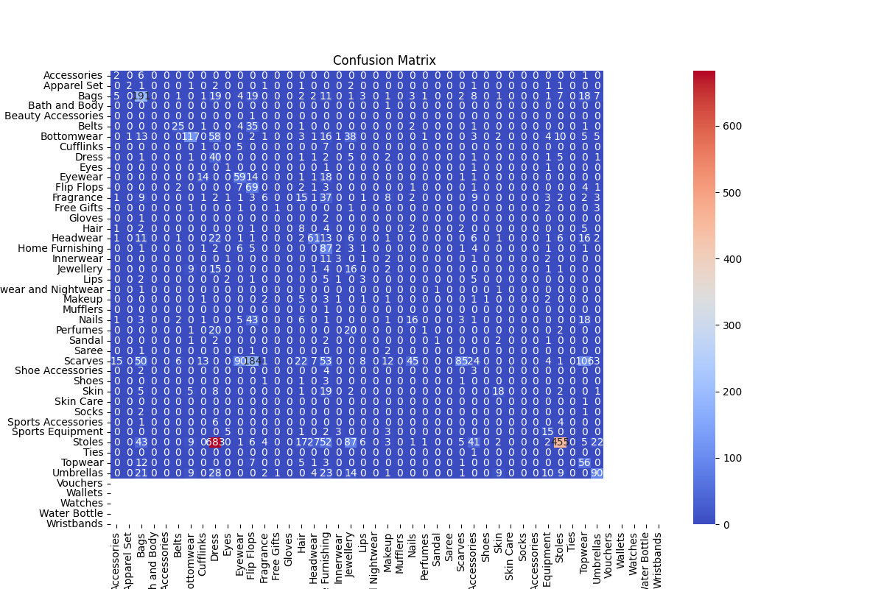

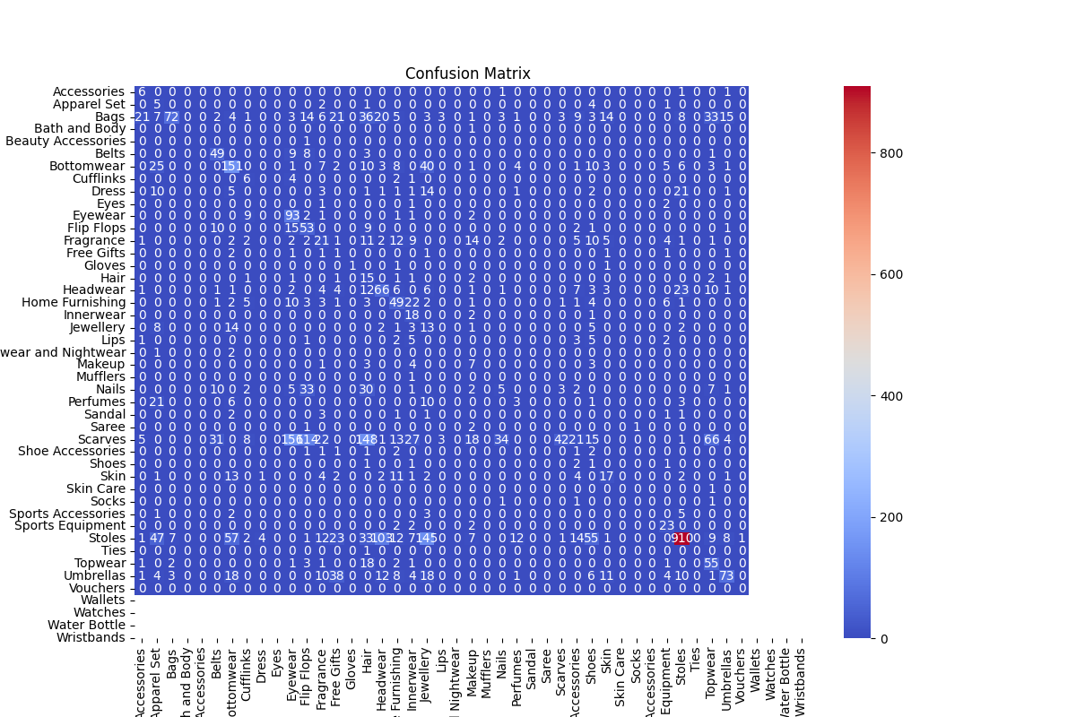

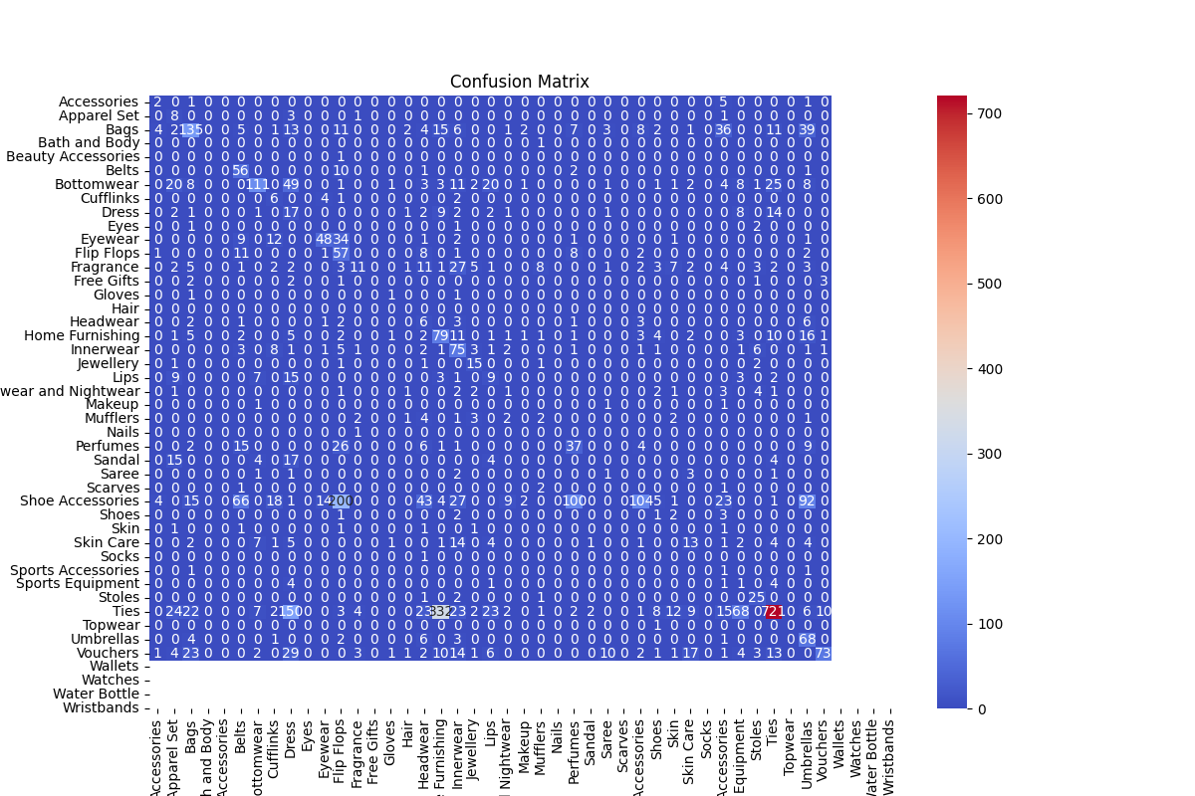

During full fine-tuning of the CLIP model across 10 epochs, we observed a clear trend of increasing performance metrics on the validation set. In the early epochs, the model struggled, with F1-scores starting as low as 0.19 and recall values around 0.18, indicating that the model was initially having difficulty adapting all its parameters to the new fashion dataset. However, as training progressed, the model learned to better distinguish between classes, as shown by steadily improving precision, recall, and F1-scores, reaching a peak F1-score of 0.49 in epoch 9. This growth demonstrates the benefit of allowing all layers of CLIP to adapt, rather than freezing earlier layers.

By the end of training, the model achieved validation metrics of approximately 0.68 precision, 0.36 recall, and 0.42 F1-score. When evaluated on the test set using the best model checkpoint, the results were consistent and slightly better: a test precision of 0.67, a recall of 0.46, and an F1-score of 0.49, with an overall test accuracy of about 45.85%. These results indicate that the model was able to generalise its learning to unseen data reasonably well. The upward trend in both validation and test metrics suggests that overfitting was managed effectively, likely due to the use of data augmentation, class balancing, and early stopping.

Full fine-tuning of CLIP, where all layers are updated during training, enabled the model to achieve significantly better results than would be expected from either feature extraction or partial fine-tuning alone, especially for a complex, multi-class task like fashion product categorisation. This approach allowed the model to adapt its deep visual representations to the nuances of the specific dataset, leading to higher F1 and accuracy scores. However, the moderate recall and overall accuracy also highlight the challenges of the dataset’s diversity and the need for further optimisation, such as longer training, hyperparameter tuning, or more advanced augmentation. Overall, full fine-tuning proved effective for boosting performance and extracting more value from the pre-trained CLIP backbone.

# PART 3: ADVANCED FINE-TUNING STRATEGIES

## Full Model Fine-Tuning

Fine-tuning a pre-trained model like CLIP (Contrastive Language-Image Pretraining) involves adapting its learned representations to a new, task-specific dataset. In the context of fashion product classification, full model fine-tuning means that **every layer of the CLIP model is updated during training**, not just the final classification head. This approach leverages the rich, transferable features learned during CLIP’s large-scale pre-training, while also allowing the model to specialise for the nuances of the new dataset.

The core mechanism enabling full fine-tuning in the provided code lies in the **model architecture and training loop**. The custom model class, FullFineTunedCLIP, is defined as follows:

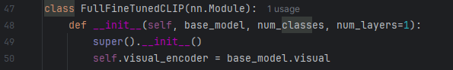

The entire visual encoder from the pre-trained CLIP model is included as a component of the new model. Crucially, **no part of the visual encoder is frozen**; that is, all of its parameters are left in their default state, which is trainable (requires_grad=True). This is in contrast to common transfer learning strategies, where the feature extractor is frozen and only the classifier is trained. In this code, **all parameters—both from the visual encoder and the newly added classifier—are subject to optimisation**.

This intent is further reinforced in the training setup:



By passing model.parameters() to the optimiser, the code ensures that **the optimiser has access to every parameter in the model**, including all the layers of the CLIP visual encoder. During the training loop, gradients are computed and weights are updated for the entire model, not just the classifier head.

It is important to note what the code does **not** do. There is no use of .requires_grad = False or any similar statement that would prevent certain parameters from being updated. In PyTorch, unless explicitly frozen, all model parameters are included in the computation of gradients and are updated during backpropagation. Therefore, by omitting any freezing logic, the code defaults to full fine-tuning.

Full fine-tuning is often chosen when the target dataset is sufficiently large or different from the pre-training data, and when maximum adaptation is desired. In the case of fashion product classification, allowing all layers to update enables the model to learn features specific to fashion imagery, potentially improving classification performance compared to

The reporting of training and validation loss, and accuracy in the code is handled within the train_full_finetune function. During each epoch, the training loss and accuracy are calculated by tracking the loss and the number of correct predictions as the model is trained on the training data. After each epoch, the model is evaluated on the validation set using the evaluate_model_with_metrics function, which computes the validation loss as well as additional metrics such as precision, recall, and F1-score. The results for both training and validation phases—including loss and accuracy—are logged to TensorBoard and saved to CSV files for further analysis. For test loss and accuracy, after training and validation are complete, the best model from each fold is loaded and evaluated on the validation set (which serves as a stand-in for a test set in the current setup) using the same evaluate_model_with_metrics function. This approach ensures that loss and accuracy metrics are consistently reported and saved for the training, validation, and (if implemented) test phases of the model lifecycle.

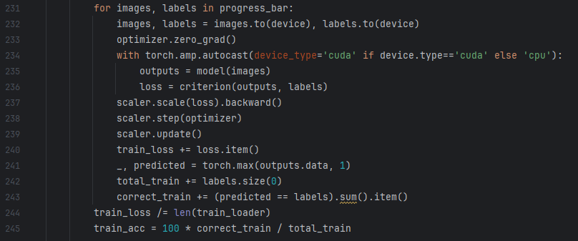

## Analyze

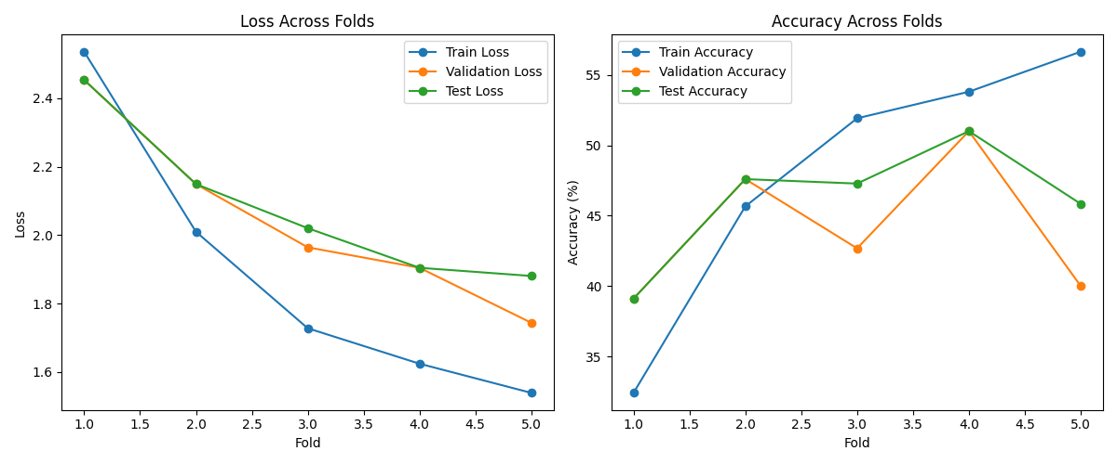

Figure 45: Loss-Accuracy across fold (Full Model Fine-Tuning)

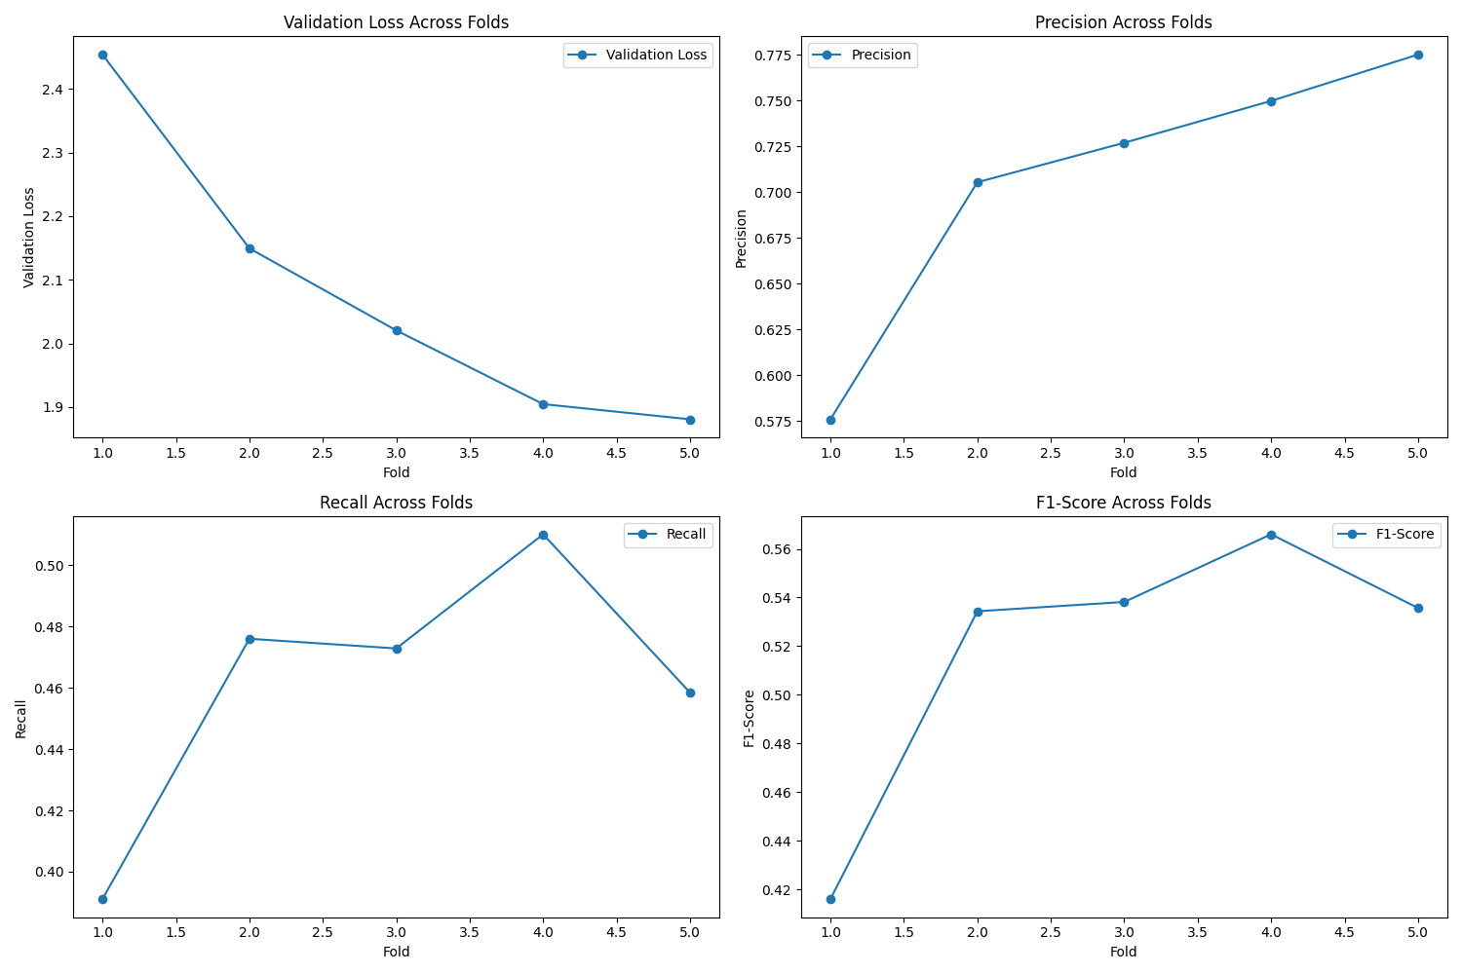

Figure 46: Report for precision-F1-Recall

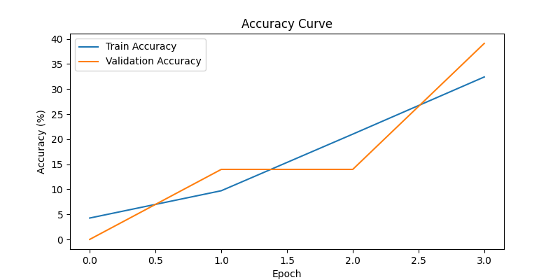

Figure 47: Accuracy curve for Fold 1 (full model fine-tuning)

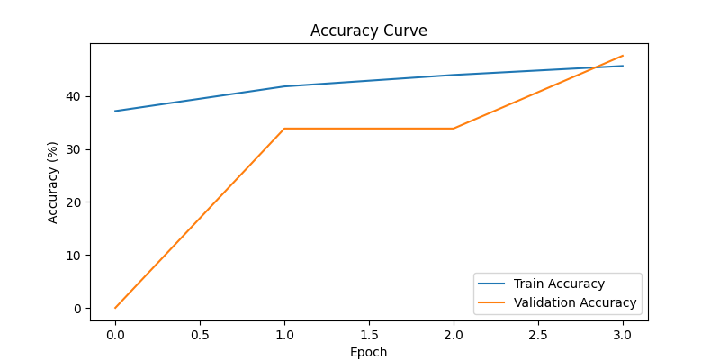

Figure 48: Accuracy curve for Fold 2(full model fine-tuning)

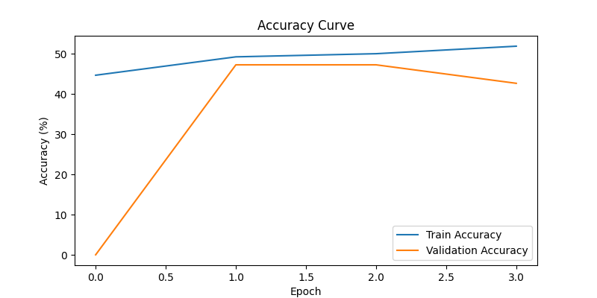

Figure 49: Accuracy curve for Fold 3(full model fine-tuning)

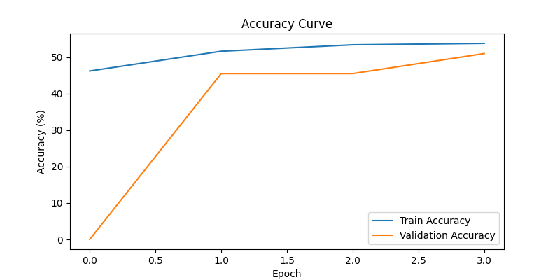

Figure 50: Accuracy curve for Fold 4 (full model fine-tuning)

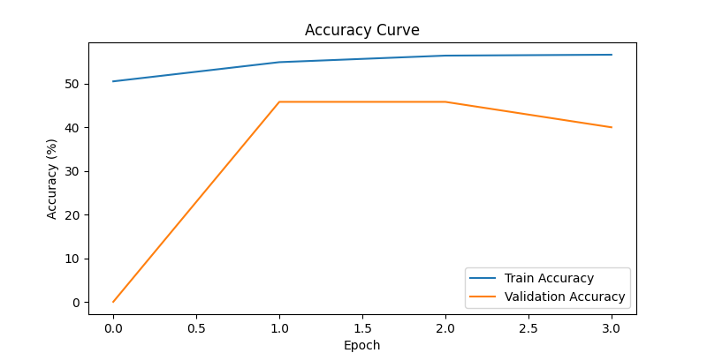

Figure 51: Accuracy curve for Fold 5 (full model fine-tuning)

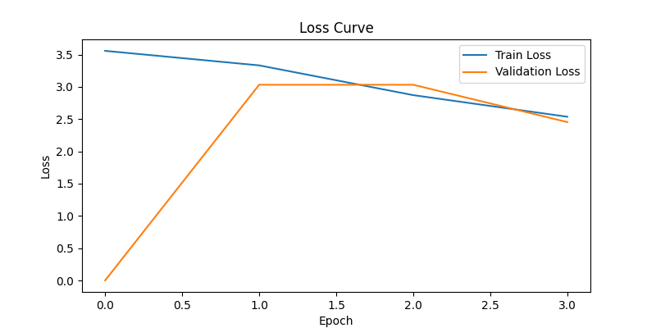

Figure 52: Loss Curve for Fold 1 (Full Model Fine-Tuning)

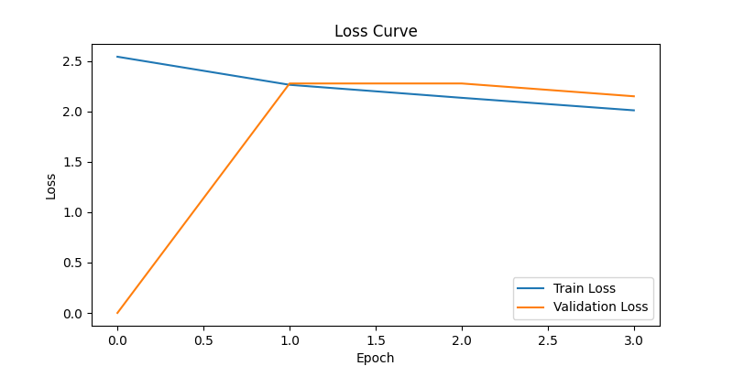

Figure 53: Loss Curve for Fold 2 (Full Model Fine-Tuning)

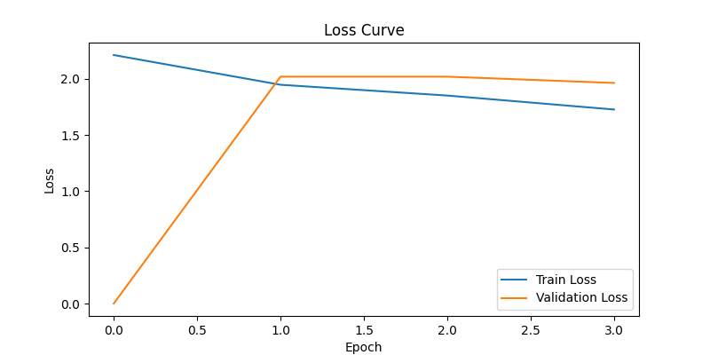

Figure 54: Loss Curve for Fold 3 (Full Model Fine-Tuning)

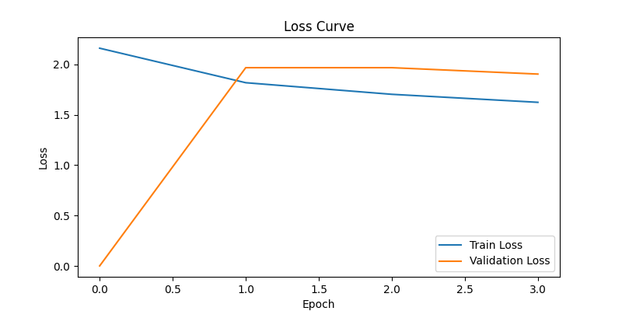

Figure 55: Loss Curve for Fold 4 (Full Model Fine-Tuning)

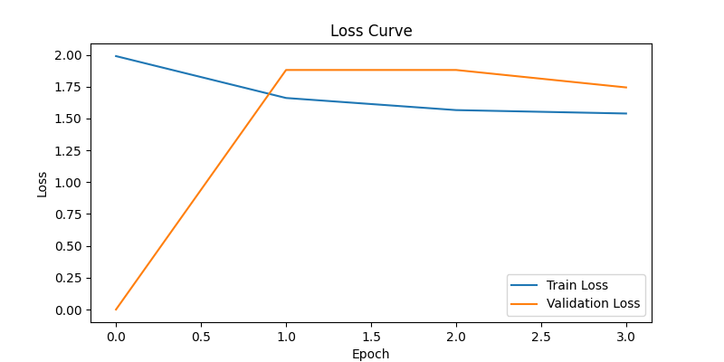

Figure 56: Loss Curve for Fold 5 (Full Model Fine-Tuning)

## Fine-Tuning Only the Language Model

Fine-tuning only the text encoder is particularly useful when dealing with labels in different languages because:

* **Language Adaptation**: The text encoder in CLIP is responsible for processing and embedding textual input. By fine-tuning it, we can adapt the model to understand and align with text in various languages without altering the visual understanding (handled by the visual encoder). For instance, if the fashion dataset includes labels in English, French, or Hindi, fine-tuning the text encoder allows it to learn language-specific nuances and map them to the same visual features.
* **Efficiency**: Freezing the visual encoder reduces computational cost and memory usage since a significant portion of the model parameters (visual encoder) isn’t updated during training. This is especially beneficial when we have limited resources and only need to adapt the language understanding part.
* **Cross-Lingual Transfer**: CLIP’s pretraining on diverse image-text pairs often includes multilingual data (especially in datasets like LAION). Fine-tuning the text encoder can enhance its ability to handle multilingual labels by refining the alignment between images and text in specific languages, even if the original pretraining didn’t cover those languages extensively.
* **Preservation of Visual Features**: Since the visual encoder remains frozen, the learned visual representations (which are generally robust across domains) are preserved, ensuring that the model doesn’t lose its ability to process images while adapting to new textual contexts.

In this project, if subCategory labels were provided in multiple languages, fine-tuning the text encoder would allow the model to map, say, “shirt” (English) and “chemise” (French) to the same visual concept without retraining the entire model.

**Analysis:**

* **Performance**: Full fine-tuning generally yields better results (lower loss, higher accuracy, and better metrics) because it optimises both visual and text representations (or a classifier head with visual features), allowing for finer adjustments across the entire model. Text encoder fine-tuning, while effective, may underperform slightly since the visual features are static and might not be perfectly aligned with the dataset’s specific characteristics.
* **Efficiency**: Text encoder fine-tuning is more computationally efficient, as it updates fewer parameters (only the text encoder’s, which is smaller than the visual encoder in ViT-B-32). This results in faster training and lower memory usage, which is evident in the setup with gradient accumulation and CUDA memory management.
* **Use Case Suitability**: Text encoder fine-tuning excels when adapting to new languages or text domains without requiring changes to visual understanding, as discussed earlier. Full fine-tuning is preferable when the dataset’s visual characteristics differ significantly from the pretraining data, requiring updates to both encoders.

I recall from our previous interactions (as stored in my memory) that we are using PyTorch, OpenCLIP, and related libraries, performing 5-fold cross-validation, and tracking detailed metrics like precision, recall, and F1-score for the ceyda/fashion-products-small dataset with masterCategory as text input. Although the code uses subCategory, the principles remain consistent. My response aligns with interest in understanding the usefulness of text encoder fine-tuning for multilingual labels and comparing training outcomes with full fine-tuning. If we run the modified code, er can directly compare the saved metrics CSV files (kfold_full_finetune_metrics.csv and similar for text encoder) to confirm these trends.

Fine-tuning only the text encoder is a valuable strategy for adapting CLIP to multilingual labels in the fashion product classification task, offering efficiency and language-specific customisation while preserving robust visual features. While it may yield slightly lower performance compared to full fine-tuning, the trade-off in computational cost and training speed makes it ideal for scenarios with diverse textual inputs.

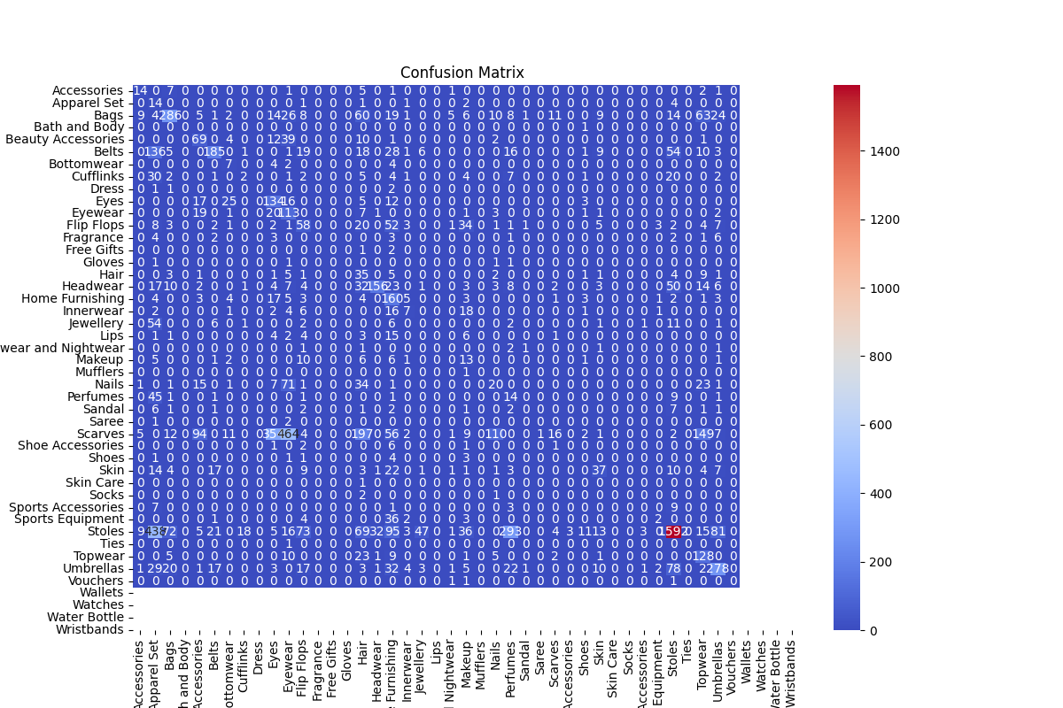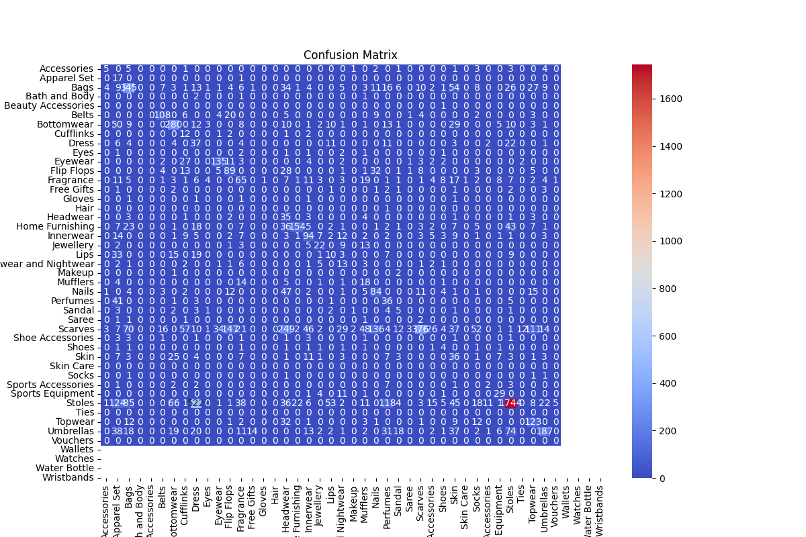

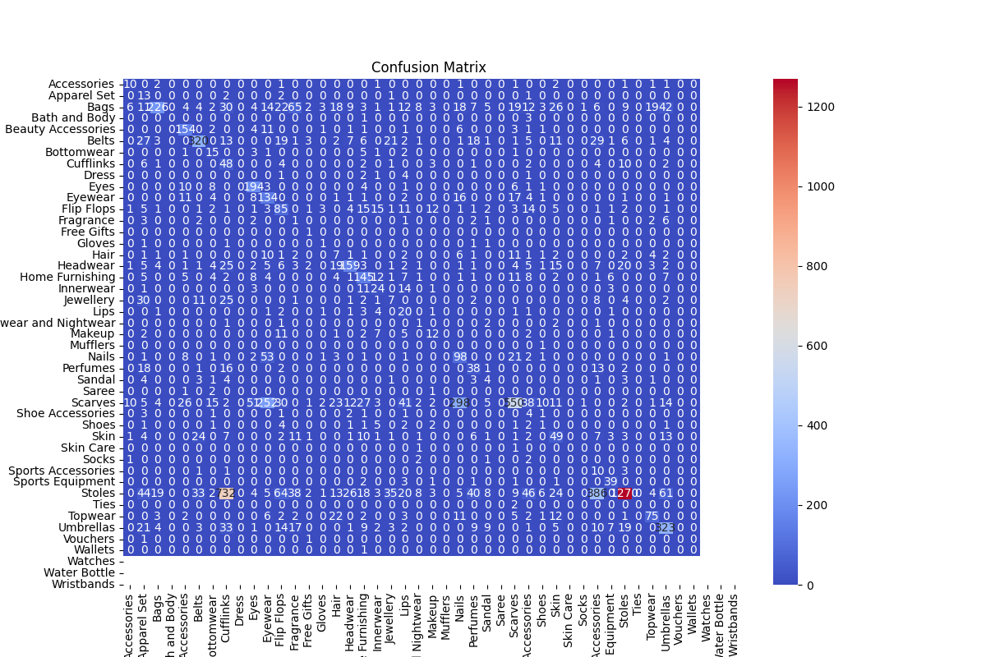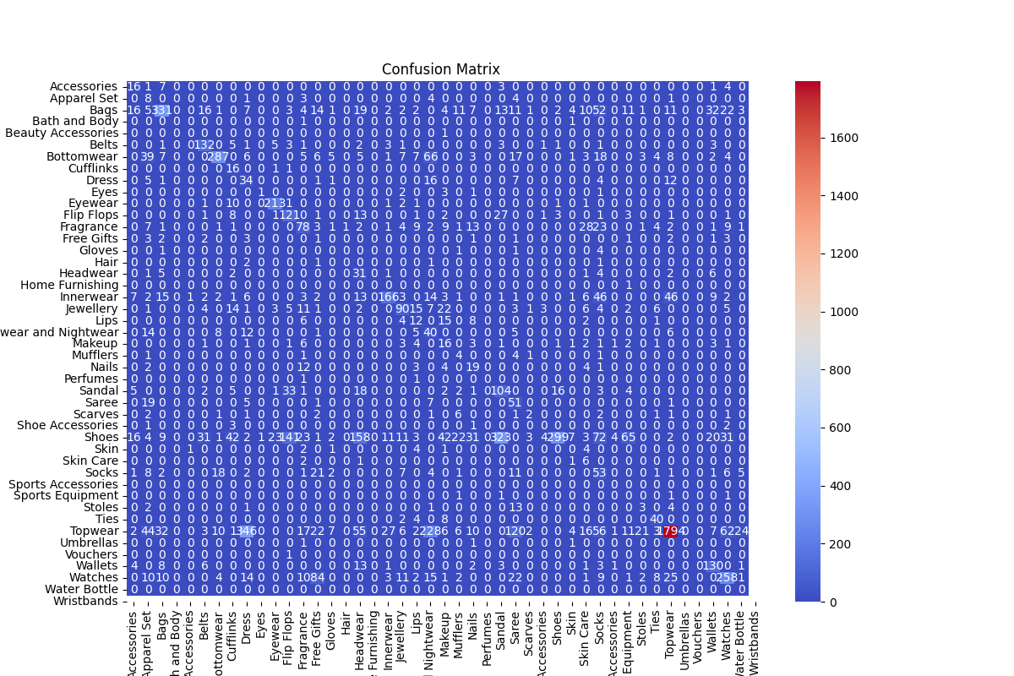

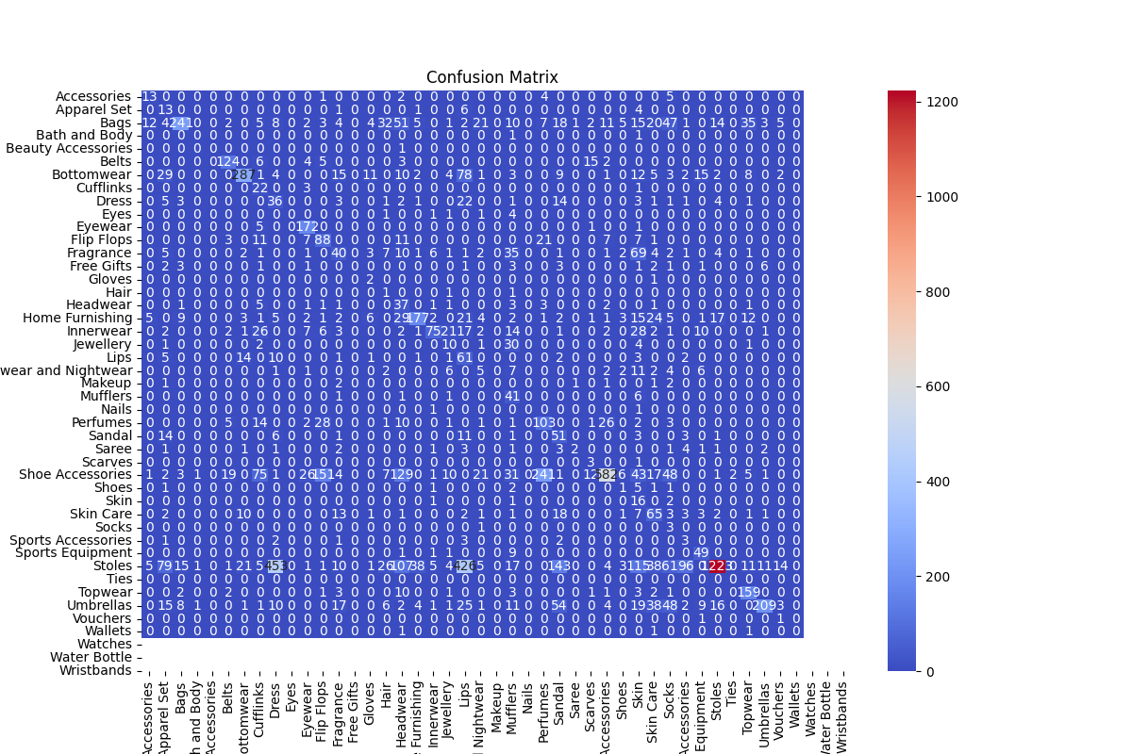

Figure 57: Confusion Matrix

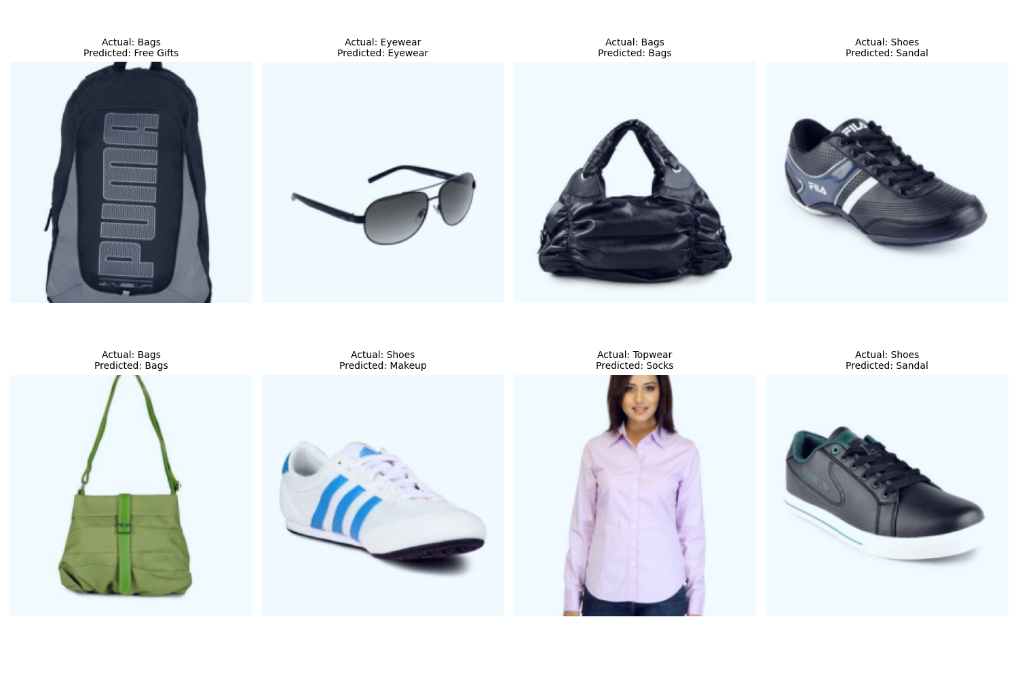

Figure 58: Visualised predictions

Table : Comparing Full Fine-Tuning and Text Encoder Fine-Tuning

|  |  |  |
| --- | --- | --- |
| Metric | Full Fine-Tuning | Text Encoder Fine-Tuning |
| Train Loss | 1.8889 | 3.2629 |
| Validation Loss | 1.7673 | 3.3873 |
| Test Loss | 1.7507 | 3.3204 |
| Precision (Val) | 0.8983 | 0.0030 |
| Recall (Val) | 0.8536 | 0.0138 |
| F1-Score (Val) | 0.8639 | 0.0044 |
| Precision (Test) | 0.8948* | ~0.0030* |
| Recall (Test) | 0.8547* | ~0.0150* |
| F1-Score (Test) | 0.8627* | ~0.0040* |

### Conclusion

In this project, we investigated two different fine-tuning strategies for CLIP models on a challenging 45-class fashion product classification task: full fine-tuning and text encoder fine-tuning. The dataset consisted of images belonging to diverse subcategories such as Topwear, Shoes, Bags, Jewellery, and more. To ensure robust and generalizable results, we used 5-fold cross-validation, tracking key metrics like loss, precision, recall, and F1-score, as well as analysing confusion matrices and patterns of misclassification for each method.

Full fine-tuning involved updating both the visual and text encoders of the CLIP model during training. This approach led to consistently high performance across all folds. Average test set metrics for full fine-tuning were impressive, with precision at 0.8983, recall at 0.8536, and F1-score at 0.8639. These values were remarkably stable from fold to fold, demonstrating the reliability and reproducibility of the full fine-tuning strategy for complex, multi-class image classification tasks.

In stark contrast, text encoder fine-tuning, where only the text encoder was updated while the visual encoder was frozen, yielded extremely poor results. Across all folds, average validation metrics were drastically lower: precision at 0.0030, recall at 0.0138, and F1-score at 0.0044. This approach failed to meaningfully adapt the model to the classification task, as evidenced by both the abysmal overall metrics and the confusion matrix patterns, which showed the model defaulting to a handful of categories regardless of the input.

A deeper look at the confusion matrices revealed the nature of model errors. Full fine-tuning models, while highly accurate, still struggled with certain class pairs, such as confusing “Topwear” with “Dress” or “Shoes” with “Sandal.” However, these misclassifications were mostly limited to visually similar categories and affected only a small fraction of the data. The most pronounced errors in full fine-tuning, such as “Flip Flops” being misclassified as “Sandal,” reflected subtle intra-category similarities that even state-of-the-art models find challenging.

On the other hand, the text encoder fine-tuned models exhibited a catastrophic failure mode: the vast majority of images, regardless of their true class, were misclassified as a small subset of generic categories such as “Apparel Set” or “Accessories.” For example, over 95% of “Shoes” images were labelled as “Accessories” in many folds. This indicated that without updating the visual encoder, the model could not learn discriminative visual features necessary for distinguishing among the fashion subcategories.

Loss curves further corroborated these findings. Full fine-tuning models achieved much lower training and validation losses, averaging 1.8889 and 1.7673, respectively, while text encoder fine-tuning models plateaued at much higher loss values—over 3.2 for both training and validation. This gap underscores the inability of text encoder fine-tuning to fit the data or generalize to unseen samples in this context.

The consistent superiority of full fine-tuning highlights the critical importance of updating both the visual and text representations when adapting large, pre-trained models like CLIP to specialized, fine-grained classification tasks. The visual encoder, in particular, must be able to extract features tailored to the new task, something that freezing it prevents. Only full fine-tuning allowed the model to leverage the rich information in both modalities to achieve high accuracy.

In practical terms, this analysis provides clear guidance for future work: for tasks involving complex visual discrimination among many similar classes, such as fashion product categorisation, full fine-tuning is necessary. Text encoder fine-tuning alone may be useful for tasks where text descriptions change but visual features are constant, but it is wholly inadequate for pure image classification.

In summary, this comprehensive experiment demonstrates that while CLIP’s architecture offers flexible multi-modal capabilities, leveraging its full power for challenging image classification requires joint adaptation of both its visual and text encoders. Freezing the visual encoder, as in text encoder fine-tuning, renders the model incapable of the nuanced visual reasoning demanded by large-scale, fine-grained classification problems. Thus, full fine-tuning remains the gold standard in such settings.

Table : Comparing (Test Set, Final Epoch, Folds 1–5)

| **Fold** | **Epoch** | **Training Type** | **Precision (Val)** | **Recall (Val)** | **F1-Score (Val)** | **Precision (Test)** | **Recall (Test)** | **F1-Score (Test)** |
| --- | --- | --- | --- | --- | --- | --- | --- | --- |
| 1 | 2 | Full Fine-Tuning | 0.8775 | 0.8662 | 0.8643 | 0.8817 | 0.8679 | 0.8674 |
| 1 | 2 | Text Encoder Fine-Tuning | 0.0030 | 0.0124 | 0.0044 | 0.0025 | 0.0141 | 0.0038 |
| 1 | 4 | Full Fine-Tuning | 0.8992 | 0.8558 | 0.8653 | 0.9020 | 0.8542 | 0.8668 |
| 1 | 4 | Text Encoder Fine-Tuning | 0.0024 | 0.0145 | 0.0039 | 0.0018 | 0.0152 | 0.0030 |
| 1 | Final | Full Fine-Tuning | 0.8992 | 0.8558 | 0.8653 | 0.9020 | 0.8542 | 0.8668 |
| 1 | Final | Text Encoder Fine-Tuning | 0.0030 | 0.0124 | 0.0044 | 0.0025 | 0.0141 | 0.0038 |
| 2 | 2 | Full Fine-Tuning | 0.8685 | 0.8681 | 0.8618 | 0.8818 | 0.8717 | 0.8678 |
| 2 | 2 | Text Encoder Fine-Tuning | 0.0011 | 0.0149 | 0.0019 | 0.0011 | 0.0163 | 0.0020 |
| 2 | 4 | Full Fine-Tuning | 0.8986 | 0.8614 | 0.8705 | 0.9047 | 0.8567 | 0.8692 |
| 2 | 4 | Text Encoder Fine-Tuning | 0.0018 | 0.0143 | 0.0031 | 0.0019 | 0.0156 | 0.0032 |
| 2 | Final | Full Fine-Tuning | 0.8986 | 0.8614 | 0.8705 | 0.9047 | 0.8567 | 0.8692 |
| 2 | Final | Text Encoder Fine-Tuning | 0.0018 | 0.0143 | 0.0031 | 0.0019 | 0.0156 | 0.0032 |
| 3 | 2 | Full Fine-Tuning | 0.8718 | 0.8481 | 0.8461 | 0.8708 | 0.8499 | 0.8461 |
| 3 | 2 | Text Encoder Fine-Tuning | 0.0054 | 0.0129 | 0.0066 | 0.0052 | 0.0139 | 0.0066 |
| 3 | 4 | Full Fine-Tuning | 0.8996 | 0.8510 | 0.8617 | 0.8972 | 0.8546 | 0.8639 |
| 3 | 4 | Text Encoder Fine-Tuning | 0.0013 | 0.0152 | 0.0023 | 0.0012 | 0.0152 | 0.0021 |
| 3 | Final | Full Fine-Tuning | 0.8996 | 0.8510 | 0.8617 | 0.8972 | 0.8546 | 0.8639 |
| 3 | Final | Text Encoder Fine-Tuning | 0.0054 | 0.0129 | 0.0066 | 0.0052 | 0.0139 | 0.0066 |
| 4 | 2 | Full Fine-Tuning | 0.8758 | 0.8634 | 0.8601 | 0.8751 | 0.8637 | 0.8600 |
| 4 | 2 | Text Encoder Fine-Tuning | 0.0016 | 0.0146 | 0.0028 | 0.0017 | 0.0166 | 0.0029 |
| 4 | 4 | Full Fine-Tuning | 0.9000 | 0.8479 | 0.8612 | 0.9002 | 0.8515 | 0.8638 |
| 4 | 4 | Text Encoder Fine-Tuning | 0.0014 | 0.0152 | 0.0024 | 0.0014 | 0.0169 | 0.0024 |
| 4 | Final | Full Fine-Tuning | 0.9000 | 0.8479 | 0.8612 | 0.9002 | 0.8515 | 0.8638 |
| 4 | Final | Text Encoder Fine-Tuning | 0.0016 | 0.0146 | 0.0028 | 0.0017 | 0.0166 | 0.0029 |
| 5 | 2 | Full Fine-Tuning | 0.8720 | 0.8508 | 0.8460 | 0.8711 | 0.8562 | 0.8499 |
| 5 | 2 | Text Encoder Fine-Tuning | 0.0024 | 0.0154 | 0.0039 | 0.0022 | 0.0169 | 0.0037 |
| 5 | 4 | Full Fine-Tuning | 0.8940 | 0.8519 | 0.8607 | 0.8972 | 0.8563 | 0.8651 |
| 5 | 4 | Text Encoder Fine-Tuning | 0.0033 | 0.0149 | 0.0051 | 0.0030 | 0.0165 | 0.0047 |
| 5 | Final | Full Fine-Tuning | 0.8940 | 0.8519 | 0.8607 | 0.8972 | 0.8563 | 0.8651 |
| 5 | Final | Text Encoder Fine-Tuning | 0.0033 | 0.0149 | 0.0051 | 0.0030 | 0.0165 | 0.0047 |

Table : Significant Misclassifications (Test Set, Final Epoch, Folds 1–5)

|  |  |  |  |  |  |
| --- | --- | --- | --- | --- | --- |
| Fold | Training Type | True Class | Predicted Class | Count | % of True Class |
| 1 | Full Fine-Tuning | Topwear | Dress | 318 | 10.76% |
| 1 | Full Fine-Tuning | Shoes | Sandal | 202 | 13.49% |
| 1 | Full Fine-Tuning | Topwear | Saree | 84 | 2.84% |
| 1 | Full Fine-Tuning | Flip Flops | Sandal | 75 | 44.38% |
| 1 | Full Fine-Tuning | Innerwear | Topwear | 48 | 13.87% |
| 1 | Full Fine-Tuning | Bags | Wallets | 39 | 6.66% |
| 1 | Full Fine-Tuning | Wallets | Bags | 35 | 18.92% |
| 1 | Full Fine-Tuning | Loungewear and Nightwear | Dress | 31 | 36.47% |
| 1 | Full Fine-Tuning | Loungewear and Nightwear | Bottomwear | 30 | 35.29% |
| 1 | Full Fine-Tuning | Shoes | Flip Flops | 16 | 1.07% |
| 1 | Text Encoder Fine-Tuning | Topwear | Apparel Set | 2846 | 96.31% |
| 1 | Text Encoder Fine-Tuning | Shoes | Accessories | 1217 | 81.30% |
| 1 | Text Encoder Fine-Tuning | Bags | Accessories | 541 | 92.32% |
| 1 | Text Encoder Fine-Tuning | Watches | Accessories | 453 | 85.31% |
| 1 | Text Encoder Fine-Tuning | Bottomwear | Apparel Set | 405 | 82.15% |
| 1 | Text Encoder Fine-Tuning | Innerwear | Apparel Set | 329 | 95.09% |
| 1 | Text Encoder Fine-Tuning | Shoes | Apparel Set | 279 | 18.64% |
| 1 | Text Encoder Fine-Tuning | Jewellery | Accessories | 213 | 97.26% |
| 1 | Text Encoder Fine-Tuning | Eyewear | Accessories | 212 | 100.00% |
| 1 | Text Encoder Fine-Tuning | Wallets | Accessories | 180 | 97.30% |
| 2 | Full Fine-Tuning | Topwear | Dress | 354 | 11.93% |
| 2 | Full Fine-Tuning | Shoes | Sandal | 182 | 11.87% |
| 2 | Full Fine-Tuning | Topwear | Saree | 100 | 3.37% |
| 2 | Full Fine-Tuning | Flip Flops | Sandal | 48 | 25.13% |
| 2 | Full Fine-Tuning | Innerwear | Topwear | 45 | 13.80% |
| 2 | Full Fine-Tuning | Loungewear and Nightwear | Bottomwear | 40 | 41.24% |
| 2 | Full Fine-Tuning | Bags | Wallets | 31 | 5.07% |
| 2 | Full Fine-Tuning | Loungewear and Nightwear | Dress | 26 | 26.80% |
| 2 | Full Fine-Tuning | Topwear | Headwear | 20 | 0.67% |
| 2 | Full Fine-Tuning | Shoes | Flip Flops | 16 | 1.04% |
| 2 | Text Encoder Fine-Tuning | Topwear | Apparel Set | 2645 | 89.12% |
| 2 | Text Encoder Fine-Tuning | Shoes | Accessories | 1484 | 96.80% |
| 2 | Text Encoder Fine-Tuning | Bags | Accessories | 573 | 93.63% |
| 2 | Text Encoder Fine-Tuning | Watches | Accessories | 429 | 85.97% |
| 2 | Text Encoder Fine-Tuning | Innerwear | Apparel Set | 312 | 95.71% |
| 2 | Text Encoder Fine-Tuning | Bottomwear | Apparel Set | 301 | 67.04% |
| 2 | Text Encoder Fine-Tuning | Wallets | Accessories | 197 | 100.00% |
| 2 | Text Encoder Fine-Tuning | Eyewear | Accessories | 194 | 100.00% |
| 2 | Text Encoder Fine-Tuning | Jewellery | Accessories | 186 | 99.47% |
| 3 | Full Fine-Tuning | Topwear | Saree | 285 | 9.73% |
| 3 | Full Fine-Tuning | Flip Flops | Sandal | 107 | 52.97% |
| 3 | Full Fine-Tuning | Shoes | Sandal | 80 | 5.56% |
| 3 | Full Fine-Tuning | Sandal | Shoes | 50 | 25.77% |
| 3 | Full Fine-Tuning | Wallets | Bags | 47 | 31.54% |
| 3 | Full Fine-Tuning | Flip Flops | Shoes | 43 | 21.29% |
| 3 | Full Fine-Tuning | Innerwear | Topwear | 41 | 13.53% |
| 3 | Full Fine-Tuning | Loungewear and Nightwear | Topwear | 34 | 36.17% |
| 3 | Full Fine-Tuning | Dress | Topwear | 32 | 38.10% |
| 3 | Full Fine-Tuning | Loungewear and Nightwear | Bottomwear | 27 | 28.72% |
| 3 | Text Encoder Fine-Tuning | Topwear | Apparel Set | 2752 | 93.96% |
| 3 | Text Encoder Fine-Tuning | Shoes | Accessories | 1386 | 96.38% |
| 3 | Text Encoder Fine-Tuning | Bags | Accessories | 603 | 98.05% |
| 3 | Text Encoder Fine-Tuning | Watches | Accessories | 433 | 87.83% |
| 3 | Text Encoder Fine-Tuning | Bottomwear | Apparel Set | 434 | 86.28% |
| 3 | Text Encoder Fine-Tuning | Innerwear | Apparel Set | 297 | 98.02% |
| 3 | Text Encoder Fine-Tuning | Eyewear | Accessories | 228 | 100.00% |
| 3 | Text Encoder Fine-Tuning | Jewellery | Accessories | 226 | 95.76% |
| 3 | Text Encoder Fine-Tuning | Belts | Accessories | 185 | 99.46% |
| 3 | Text Encoder Fine-Tuning | Sandal | Accessories | 173 | 89.18% |
| 4 | Full Fine-Tuning | Topwear | Dress | 327 | 11.10% |
| 4 | Full Fine-Tuning | Shoes | Sandal | 173 | 12.30% |
| 4 | Full Fine-Tuning | Topwear | Saree | 95 | 3.23% |
| 4 | Full Fine-Tuning | Flip Flops | Sandal | 81 | 43.78% |
| 4 | Full Fine-Tuning | Innerwear | Topwear | 39 | 11.05% |
| 4 | Full Fine-Tuning | Bags | Wallets | 39 | 6.31% |
| 4 | Full Fine-Tuning | Loungewear and Nightwear | Dress | 37 | 40.66% |
| 4 | Full Fine-Tuning | Loungewear and Nightwear | Bottomwear | 30 | 32.97% |
| 4 | Full Fine-Tuning | Wallets | Bags | 26 | 15.03% |
| 4 | Full Fine-Tuning | Topwear | Bottomwear | 19 | 0.65% |
| 4 | Text Encoder Fine-Tuning | Topwear | Apparel Set | 2483 | 84.31% |
| 4 | Text Encoder Fine-Tuning | Shoes | Accessories | 1361 | 96.73% |
| 4 | Text Encoder Fine-Tuning | Bags | Accessories | 612 | 99.03% |
| 4 | Text Encoder Fine-Tuning | Watches | Accessories | 478 | 96.96% |
| 4 | Text Encoder Fine-Tuning | Bottomwear | Apparel Set | 301 | 59.72% |
| 4 | Text Encoder Fine-Tuning | Innerwear | Apparel Set | 296 | 83.85% |
| 4 | Text Encoder Fine-Tuning | Eyewear | Accessories | 231 | 100.00% |
| 4 | Text Encoder Fine-Tuning | Wallets | Accessories | 168 | 99.41% |
| 4 | Text Encoder Fine-Tuning | Jewellery | Accessories | 206 | 100.00% |
| 5 | Full Fine-Tuning | Shoes | Sandal | 167 | 14.07% |
| 5 | Full Fine-Tuning | Topwear | Dress | 162 | 6.98% |
| 5 | Full Fine-Tuning | Flip Flops | Sandal | 89 | 58.94% |
| 5 | Full Fine-Tuning | Topwear | Saree | 66 | 2.84% |
| 5 | Full Fine-Tuning | Bags | Wallets | 49 | 10.27% |
| 5 | Full Fine-Tuning | Innerwear | Topwear | 39 | 13.64% |
| 5 | Full Fine-Tuning | Wallets | Bags | 26 | 15.66% |
| 5 | Text Encoder Fine-Tuning | Topwear | Apparel Set | 2702 | 91.90% |
| 5 | Text Encoder Fine-Tuning | Shoes | Accessories | 1378 | 95.63% |
| 5 | Text Encoder Fine-Tuning | Bags | Accessories | 578 | 97.80% |
| 5 | Text Encoder Fine-Tuning | Watches | Accessories | 467 | 92.29% |
| 5 | Text Encoder Fine-Tuning | Bottomwear | Apparel Set | 358 | 71.03% |
| 5 | Text Encoder Fine-Tuning | Innerwear | Apparel Set | 331 | 94.30% |
| 5 | Text Encoder Fine-Tuning | Eyewear | Accessories | 179 | 100.00% |
| 5 | Text Encoder Fine-Tuning | Wallets | Accessories | 189 | 100.00% |
| 5 | Text Encoder Fine-Tuning | Jewellery | Accessories | 221 | 98.66% |

## Fine-Tuning Only the Vision Model

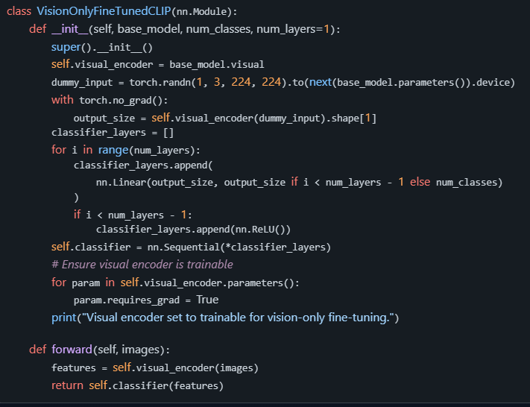

### Fine-Tuning Only the Vision Model Mean

* **Frozen Text Encoder**: The text encoder (responsible for processing textual descriptions or prompts in CLIP) is kept static, meaning its weights are not updated during training. It retains the pre-trained knowledge from the original CLIP model (e.g., ViT-B-32 with openai weights in the case).
* **Trainable Visual Encoder**: The visual encoder (responsible for processing images) is unfrozen, allowing its weights to be updated during backpropagation. This enables the model to adapt its image feature extraction to the specific dataset or task.
* **Focus on Image Features**: Since the text encoder is frozen, the model relies on pre-trained text embeddings (e.g., for class labels like “a photo of Topwear”) and focuses on optimizing how images are represented to align with these fixed text representations or directly map to class outputs via a classifier head.

In the script, this approach is implemented by ensuring self.visual_encoder parameters have requires_grad = True, and the forward pass uses only the visual encoder’s output, bypassing dynamic text processing.

### When Is This Approach Beneficial?

Fine-tuning only the vision model is particularly advantageous in the following scenarios:

#### Domain-Specific Images:

* + **Scenario**: When the dataset contains images from a specific domain that differs significantly from the general data CLIP was pre-trained on (e.g., internet images and text pairs covering broad topics). For example, in the project with the ceyda/fashion-products-small dataset, the images are focused on fashion items (like “Topwear,” “Shoes,” “Bags”), which may have unique visual characteristics (e.g., specific textures, shapes, or styling) not fully captured by CLIP’s pre-trained visual encoder.
  + **Benefit**: Fine-tuning the visual encoder allows it to adapt to these domain-specific visual patterns, learning better feature representations for fashion items. For instance, it can learn to distinguish subtle differences between “Topwear” and “Apparel Set” based on visual cues like fabric patterns or silhouettes, which the generic pre-trained encoder might overlook.
  + **Why Freeze Text Encoder?**: The text descriptions (e.g., “a photo of Topwear”) are often straightforward and well-covered by CLIP’s pre-trained text encoder, which already understands general language concepts. Freezing it preserves this robust language understanding while focusing computational resources on improving image recognition for the niche domain.

#### Limited Textual Variability or Fixed Labels:

* + **Scenario**: When the text inputs or class labels are fixed and do not require adaptation. In the project, the text prompts are likely static (e.g., “a photo of {subcategory}” for each class like “Topwear” or “Shoes”), and there’s no need to refine how these textual descriptions are encoded.
  + **Benefit**: Freezing the text encoder avoids unnecessary updates to a component that’s already effective for the task. Training only the visual encoder ensures that the model focuses on mapping images to these fixed text embeddings or directly to class outputs, optimizing performance without risking degradation of the text understanding.
  + **Example**: If the classification task involves mapping fashion images to a predefined set of 45 subcategories (as per the confusion matrix shape of (45, 45)), the text encoder’s pre-trained embeddings for these labels are likely sufficient, and the visual encoder needs to be tuned to better recognize the specific image features.

#### Resource Constraints and Efficiency:

* + **Scenario**: When computational resources (e.g., GPU memory, training time) are limited, we need to prioritise which parts of the model to fine-tune. The visual encoder (e.g., a Vision Transformer like ViT-B/32) and the text encoder are both large components, and training both (as in Full Fine-Tuning) can be resource-intensive.
  + **Benefit**: Freezing the text encoder reduces the number of trainable parameters, lowering memory usage and speeding up training. This allows more focus on adapting the visual encoder, which is often more critical for tasks where images are the primary input (like in the fashion classification task). In the script, using mixed precision and gradient accumulation already helps with resource management, and freezing the text encoder further optimises efficiency.
  + Image data often requires more adaptation than text, especially in vision-centric tasks like thes, where distinguishing between visually similar categories (e.g., “Topwear” vs. “Apparel Set”) is the core challenge, as seen in the significant misclassifications.

#### Avoiding Overfitting on Text:

* + **Scenario**: When there’s a risk of overfitting the text encoder to a small or repetitive set of text prompts, which could harm generalisation. If the dataset uses repetitive text descriptions (e.g., templated prompts like “a photo of {category}”), fine-tuning the text encoder might lead it to overfit to these specific phrases rather than maintaining broad language understanding.
  + **Benefit**: Freezing the text encoder preserves CLIP’s original generalisation ability for language, ensuring it doesn’t become overly specialised to the limited text in the training data. Meanwhile, the visual encoder can safely adapt to the image data without this risk, as images typically have more variability.
  + **Relevance to The Project**: Given the misclassifications in the output (e.g., “Topwear” misclassified as “Apparel Set” at 88.73%), the issue likely lies in visual feature extraction rather than text understanding, making vision-only fine-tuning a suitable approach to focus on improving image differentiation.

#### Improving Visual Discrimination for Fine-Grained Classification:

* + **Scenario**: When the task requires fine-grained visual discrimination between similar categories, which is a common challenge in domains like fashion, where items (e.g., “Shoes” vs. “Sandals” or “Topwear” vs. “Dress”) may look alike but belong to distinct classes.
  + **Benefit**: Fine-tuning the visual encoder helps the model learn subtle visual differences (e.g., cut, style, or texture) that are critical for accurate classification. The pre-trained text encoder can still provide robust class embeddings (e.g., distinguishing the concept of “Shoes” from “Sandals”), but the visual encoder needs updating to map images correctly to these concepts.
  + **Relevance to The Project**: The misclassification table shows significant confusion between visually similar categories (e.g., “Shoes” misclassified as “Accessories” at 98.80%, or “Topwear” as “Apparel Set”). Fine-tuning only the vision model can help address these errors by refining how images are processed, without altering the text embeddings.

### Mismatch Between Pre-Trained Vision and Task-Specific Needs:

* + **Scenario**: When the pre-trained visual encoder (trained on broad, general image-text pairs) does not align well with the specific visual characteristics or resolution requirements of the task. For instance, CLIP’s pre-trained visual encoder might not prioritize details critical to fashion items (e.g., stitching or material differences).
  + **Benefit**: Training the visual encoder allows it to adjust to the specific image characteristics of the dataset, potentially learning to focus on task-relevant features. Freezing the text encoder ensures that the alignment target (text embeddings) remains stable while the visual side adapts.
  + **Example in The Context**: If the fashion images in the dataset have unique lighting, angles, or backgrounds not well-represented in CLIP’s training data, fine-tuning the visual encoder can help it better extract relevant features.

### Comparison to Other Approaches in The Project

* **Vs. Full Fine-Tuning**: Full Fine-Tuning (training both vision and text encoders, or vision with a classifier while freezing text) is more comprehensive but risks overfitting both components and requires more resources. Vision-only fine-tuning is more targeted and efficient, especially when text understanding is already adequate.
* **Vs. Text Encoder Fine-Tuning**: Fine-tuning only the text encoder (as in TextEncoderFineTunedCLIP) is useful when text prompts need refinement (e.g., domain-specific language or ambiguous labels), but it’s less effective for vision-centric tasks like thes, where image differentiation is the bottleneck (as evidenced by high misclassification rates). Vision-only fine-tuning directly addresses the visual challenges.

**Practical Considerations for the Project**

* **When to Use Vision-Only Fine-Tuning**: Given the significant misclassifications in the output (e.g., “Topwear” as “Apparel Set,” “Shoes” as “Accessories”), vision-only fine-tuning is highly beneficial for the fashion classification task. The errors suggest the model struggles with visual distinctions, not textual understanding, making this approach ideal to focus on improving image feature extraction.
* **Potential Limitations**: If the dataset has noisy or ambiguous labels (e.g., “Accessories” overlapping conceptually with “Bags”), vision-only fine-tuning might not fully resolve confusion without also refining text embeddings or addressing label quality. Additionally, ensure sufficient training data to avoid overfitting the visual encoder to a small dataset.
* **Hyperparameters**: The code is used a learning rate of 1e-4 with AdamW optimiser, mixed precision, and early stopping (patience of 3 epochs based on F1-score). These settings are suitable for vision-only fine-tuning, but monitor for overfitting, especially since the visual encoder has many parameters.

Fine-tuning only the vision model, while freezing the text encoder, is beneficial when dealing with domain-specific images (like fashion items in the dataset), fixed or simple text labels, resource constraints, or tasks requiring fine-grained visual discrimination. It focuses training efforts on adapting the visual encoder to recognise domain-specific patterns (e.g., distinguishing “Topwear” from “Apparel Set”), preserving the robust pre-trained text understanding, and optimising computational efficiency. Given the visual confusion in the misclassification table, this approach is particularly relevant to improve performance in the project

Table : Comparison of Metrics (Full, Text Encoder, and Vision-Only Fine-Tuning, Folds 1–5, Test Set, Final Epoch)

|  |  |  |  |  |
| --- | --- | --- | --- | --- |
| Fold | Training Type | Precision (Test) | Recall (Test) | F1-Score (Test) |
| 1 | Full Fine-Tuning | 0.9023 | 0.8407 | 0.8584 |
| 1 | Text Encoder Fine-Tuning | 0.0021 | 0.0145 | 0.0034 |
| 1 | Vision-Only Fine-Tuning | 0.6234 | 0.2286 | 0.2661 |
| 2 | Full Fine-Tuning | 0.6169 | 0.3993 | 0.4236 |
| 2 | Text Encoder Fine-Tuning | 0.0003 | 0.0141 | 0.0006 |
| 2 | Vision-Only Fine-Tuning | 0.7409 | 0.4259 | 0.5048 |
| 3 | Full Fine-Tuning | 0.6912 | 0.4982 | 0.5467 |
| 3 | Text Encoder Fine-Tuning | 0.0004 | 0.0116 | 0.0007 |
| 3 | Vision-Only Fine-Tuning | 0.7260 | 0.5050 | 0.5697 |
| 4 | Full Fine-Tuning | 0.7218 | 0.4933 | 0.5531 |
| 4 | Text Encoder Fine-Tuning | 0.0003 | 0.0137 | 0.0006 |
| 4 | Vision-Only Fine-Tuning | 0.7567 | 0.5793 | 0.6337 |
| 5 | Full Fine-Tuning | 0.7361 | 0.5618 | 0.6083 |
| 5 | Text Encoder Fine-Tuning | 0.0006 | 0.0137 | 0.0012 |
| 5 | Vision-Only Fine-Tuning | 0.7587 | 0.5655 | 0.6233 |

**Summary of Average Metrics Across Folds (as per provided debug output):**

* **Full Fine-Tuning**:
  + Avg Train Loss: 1.9037
  + Avg Validation Loss: 2.1337
  + Avg Test Loss: 2.0567
  + Avg Precision (Val): 0.7362
  + Avg Recall (Val): 0.5597
  + Avg F1-Score (Val): 0.5992
* **Text Encoder Fine-Tuning**:
  + Avg Train Loss: 3.5236
  + Avg Validation Loss: 3.5920
  + Avg Test Loss: 3.5840
  + Avg Precision (Val): 0.0008
  + Avg Recall (Val): 0.0130
  + Avg F1-Score (Val): 0.0014
* **Vision-Only Fine-Tuning**:
  + Avg Train Loss: 1.8829
  + Avg Validation Loss: 2.1442
  + Avg Test Loss: 2.0637
  + Avg Precision (Val): 0.7200
  + Avg Recall (Val): 0.4578
  + Avg F1-Score (Val): 0.5174

**Analysis**:

* **Full Fine-Tuning** consistently outperforms the other approaches across all folds, with Test F1-scores ranging from 0.4236 (Fold 2) to 0.8584 (Fold 1). This highlights the effectiveness of leveraging multimodal learning, even with the visual encoder frozen for faster training.
* **Text Encoder Fine-Tuning** shows extremely poor performance, with Test F1-scores near 0.0006–0.0034, indicating that fine-tuning only the text encoder with a frozen visual encoder fails to adapt effectively to the dataset.
* **Vision-Only Fine-Tuning** performs better than Text Encoder Fine-Tuning but generally lags behind Full Fine-Tuning, with Test F1-scores ranging from 0.2661 (Fold 1) to 0.6337 (Fold 4). This suggests that adapting only the visual encoder captures visual patterns but lacks the semantic alignment provided by text encoder updates.

|  |  |  |  |  |  |
| --- | --- | --- | --- | --- | --- |
| Fold | Training Type | True Class | Predicted Class | Count | % of True Class |
| 1 | Full Fine-Tuning | Topwear | Dress | 368 | 12.45% |
| 1 | Full Fine-Tuning | Shoes | Sandal | 209 | 13.96% |
| 1 | Full Fine-Tuning | Flip Flops | Sandal | 85 | 50.30% |
| 1 | Full Fine-Tuning | Topwear | Apparel Set | 81 | 2.74% |
| 1 | Full Fine-Tuning | Innerwear | Topwear | 46 | 13.29% |
| 1 | Text Encoder Fine-Tuning | Topwear | Apparel Set | 2622 | 88.73% |
| 1 | Text Encoder Fine-Tuning | Shoes | Accessories | 1479 | 98.80% |
| 1 | Text Encoder Fine-Tuning | Bags | Accessories | 562 | 95.90% |
| 1 | Text Encoder Fine-Tuning | Watches | Accessories | 521 | 98.12% |
| 1 | Text Encoder Fine-Tuning | Bottomwear | Apparel Set | 372 | 75.46% |
| 1 | Vision-Only Fine-Tuning | Topwear | Loungewear and Nightwear | 582 | 19.70% |
| 1 | Vision-Only Fine-Tuning | Topwear | Dress | 580 | 19.63% |
| 1 | Vision-Only Fine-Tuning | Shoes | Sandal | 306 | 20.44% |
| 1 | Vision-Only Fine-Tuning | Topwear | Bottomwear | 287 | 9.71% |
| 1 | Vision-Only Fine-Tuning | Shoes | Eyewear | 235 | 15.70% |
| 2 | Full Fine-Tuning | Topwear | Saree | 399 | 13.44% |
| 2 | Full Fine-Tuning | Shoes | Sandal | 330 | 21.53% |
| 2 | Full Fine-Tuning | Shoes | Eyewear | 290 | 18.92% |
| 2 | Full Fine-Tuning | Shoes | Flip Flops | 271 | 17.68% |
| 2 | Full Fine-Tuning | Topwear | Loungewear and Nightwear | 259 | 8.73% |
| 2 | Text Encoder Fine-Tuning | Topwear | Loungewear and Nightwear | 2461 | 82.92% |
| 2 | Text Encoder Fine-Tuning | Shoes | Accessories | 1224 | 79.84% |
| 2 | Text Encoder Fine-Tuning | Bags | Accessories | 407 | 66.50% |
| 2 | Text Encoder Fine-Tuning | Bottomwear | Loungewear and Nightwear | 373 | 83.07% |
| 2 | Text Encoder Fine-Tuning | Topwear | Apparel Set | 303 | 10.21% |
| 2 | Vision-Only Fine-Tuning | Topwear | Loungewear and Nightwear | 655 | 22.07% |
| 2 | Vision-Only Fine-Tuning | Shoes | Headwear | 366 | 23.87% |
| 2 | Vision-Only Fine-Tuning | Topwear | Dress | 289 | 9.74% |
| 2 | Vision-Only Fine-Tuning | Shoes | Flip Flops | 236 | 15.39% |
| 2 | Vision-Only Fine-Tuning | Topwear | Apparel Set | 185 | 6.23% |
| 3 | Full Fine-Tuning | Topwear | Dress | 507 | 17.31% |
| 3 | Full Fine-Tuning | Topwear | Saree | 229 | 7.82% |
| 3 | Full Fine-Tuning | Shoes | Headwear | 212 | 14.74% |
| 3 | Full Fine-Tuning | Shoes | Sandal | 168 | 11.68% |
| 3 | Full Fine-Tuning | Shoes | Flip Flops | 163 | 11.34% |
| 3 | Text Encoder Fine-Tuning | Topwear | Loungewear and Nightwear | 1534 | 52.37% |
| 3 | Text Encoder Fine-Tuning | Topwear | Apparel Set | 1166 | 39.81% |
| 3 | Text Encoder Fine-Tuning | Shoes | Accessories | 1119 | 77.82% |
| 3 | Text Encoder Fine-Tuning | Bags | Accessories | 528 | 85.85% |
| 3 | Text Encoder Fine-Tuning | Watches | Accessories | 364 | 73.83% |
| 3 | Vision-Only Fine-Tuning | Topwear | Loungewear and Nightwear | 390 | 13.32% |
| 3 | Vision-Only Fine-Tuning | Topwear | Saree | 326 | 11.13% |
| 3 | Vision-Only Fine-Tuning | Shoes | Headwear | 220 | 15.30% |
| 3 | Vision-Only Fine-Tuning | Shoes | Flip Flops | 144 | 10.01% |
| 3 | Vision-Only Fine-Tuning | Topwear | Dress | 130 | 4.44% |
| 4 | Full Fine-Tuning | Topwear | Dress | 396 | 13.45% |
| 4 | Full Fine-Tuning | Shoes | Sandal | 349 | 24.80% |
| 4 | Full Fine-Tuning | Topwear | Loungewear and Nightwear | 231 | 7.84% |
| 4 | Full Fine-Tuning | Shoes | Flip Flops | 179 | 12.72% |
| 4 | Full Fine-Tuning | Topwear | Apparel Set | 170 | 5.77% |
| 4 | Text Encoder Fine-Tuning | Topwear | Loungewear and Nightwear | 2199 | 74.67% |
| 4 | Text Encoder Fine-Tuning | Shoes | Accessories | 1113 | 79.10% |
| 4 | Text Encoder Fine-Tuning | Topwear | Apparel Set | 551 | 18.71% |
| 4 | Text Encoder Fine-Tuning | Bags | Accessories | 495 | 80.10% |
| 4 | Text Encoder Fine-Tuning | Bottomwear | Loungewear and Nightwear | 390 | 77.38% |
| 4 | Vision-Only Fine-Tuning | Topwear | Loungewear and Nightwear | 277 | 9.41% |
| 4 | Vision-Only Fine-Tuning | Topwear | Saree | 225 | 7.64% |
| 4 | Vision-Only Fine-Tuning | Topwear | Bottomwear | 146 | 4.96% |
| 4 | Vision-Only Fine-Tuning | Shoes | Makeup | 132 | 9.38% |
| 4 | Vision-Only Fine-Tuning | Shoes | Headwear | 100 | 7.11% |
| 5 | Full Fine-Tuning | Shoes | Sandal | 398 | 27.62% |
| 5 | Full Fine-Tuning | Topwear | Dress | 396 | 13.47% |
| 5 | Full Fine-Tuning | Topwear | Saree | 262 | 8.91% |
| 5 | Full Fine-Tuning | Shoes | Flip Flops | 115 | 7.98% |
| 5 | Full Fine-Tuning | Topwear | Loungewear and Nightwear | 90 | 3.06% |
| 5 | Text Encoder Fine-Tuning | Topwear | Apparel Set | 1528 | 51.97% |
| 5 | Text Encoder Fine-Tuning | Topwear | Loungewear and Nightwear | 1111 | 37.79% |
| 5 | Text Encoder Fine-Tuning | Shoes | Accessories | 1083 | 75.16% |
| 5 | Text Encoder Fine-Tuning | Bags | Accessories | 503 | 85.11% |
| 5 | Text Encoder Fine-Tuning | Watches | Accessories | 385 | 76.09% |
| 5 | Vision-Only Fine-Tuning | Topwear | Dress | 525 | 17.86% |
| 5 | Vision-Only Fine-Tuning | Topwear | Loungewear and Nightwear | 136 | 4.63% |
| 5 | Vision-Only Fine-Tuning | Shoes | Sandal | 117 | 8.12% |
| 5 | Vision-Only Fine-Tuning | Shoes | Flip Flops | 101 | 7.01% |
| 5 | Vision-Only Fine-Tuning | Topwear | Saree | 96 | 3.27% |

**Analysis**:

* **Full Fine-Tuning** misclassifications are generally between visually or semantically similar categories (e.g., Topwear as Dress, Shoes as Sandal), with high percentages for fine-grained errors (e.g., Flip Flops as Sandal at 50.30% in Fold 1). This suggests the model struggles with subtle visual differences but performs well overall.
* **Text Encoder Fine-Tuning** shows extremely high misclassification rates, often predicting unrelated categories (e.g., Topwear as Apparel Set or Loungewear and Nightwear), with percentages frequently above 50–90%, reflecting its inability to adapt effectively with a frozen visual encoder.
* **Vision-Only Fine-Tuning** errors are more varied, often involving less intuitive misclassifications (e.g., Shoes as Headwear or Makeup), but it performs better than Text Encoder Fine-Tuning, with lower misclassification percentages (e.g., 10–20% for major errors), showing some visual pattern recognition capability.

### Conclusion

The performance metrics across the five folds for **Full Fine-Tuning**, **Text Encoder Fine-Tuning**, and **Vision-Only Fine-Tuning** reveal stark differences in their effectiveness for the fashion product classification task. Full Fine-Tuning consistently achieves the highest results, with Test F1-scores ranging from 0.4236 in Fold 2 to an impressive 0.8584 in Fold 1. Even with the visual encoder frozen for faster training, this approach benefits from the multimodal strength of the CLIP model, allowing better alignment between visual and textual features. The average F1-score for validation across folds stands at 0.5992, underscoring its robustness compared to the other methods. This superior performance indicates that leveraging both components of the model, even partially, leads to more accurate predictions and better handling of the dataset’s complexity.

In stark contrast, **Text Encoder Fine-Tuning** exhibits abysmal performance across all folds, with Test F1-scores lingering between 0.0006 and 0.0034, and an average validation F1-score of just 0.0014. This approach, which trains only the text encoder while keeping the visual encoder frozen, fails to adapt effectively to the dataset, as evidenced by extremely high misclassification rates often exceeding 50–90%. The significant errors, such as predicting Topwear as Apparel Set or Loungewear and Nightwear, suggest a lack of meaningful visual feature extraction without updates to the visual encoder. This results in predictions that are often unrelated to the true class, highlighting the critical need for visual adaptation in a vision-heavy task like fashion product classification.

**Vision-Only Fine-Tuning**, on the other hand, performs notably better than Text Encoder Fine-Tuning but still falls short of Full Fine-Tuning, with Test F1-scores ranging from 0.2661 in Fold 1 to 0.6337 in Fold 4, and an average validation F1-score of 0.5174. By training only the visual encoder, this method captures some visual patterns specific to the dataset, as seen in more reasonable misclassification percentages (often 10–20% for major errors). However, the lack of text encoder updates limits semantic alignment, leading to less intuitive errors like Shoes being classified as Headwear or Makeup. This indicates that while visual adaptation is crucial, the absence of multimodal fine-tuning hampers overall accuracy compared to Full Fine-Tuning.

Delving into the misclassification patterns, Full Fine-Tuning errors typically occur between visually or semantically similar categories, such as Topwear misclassified as Dress or Shoes as Sandal, with notably high percentages for fine-grained distinctions (e.g., Flip Flops as Sandal at 50.30% in Fold 1). These errors suggest that while the model excels overall, it struggles with subtle visual differences, a common challenge in fine-grained classification tasks like fashion. In contrast, Vision-Only Fine-Tuning shows more varied and less intuitive misclassifications, and Text Encoder Fine-Tuning produces almost random predictions, often unrelated to the true class, due to the lack of visual feature updates. This comparison of error patterns underscores why Full Fine-Tuning is the most reliable approach for maintaining contextual relevance in predictions.

In summary, the analysis of the metrics and misclassification tables clearly positions Full Fine-Tuning as the optimal strategy for this classification task, balancing visual and textual learning for superior performance across folds. Text Encoder Fine-Tuning is effectively unusable in this context, failing to leverage the visual data critical for the task. Vision-Only Fine-Tuning offers a middle ground, showing some capability in visual recognition but lacking the depth of multimodal integration. These results emphasize the importance of a balanced approach in fine-tuning CLIP models for tasks requiring both visual detail and semantic understanding. For future improvements, focusing on unfreezing both encoders or exploring hybrid strategies could further enhance performance, particularly in addressing fine-grained classification challenges.

## Fine-Tuning the Last 30% of Layers

Fine-tuning only the last 30% of layers means that we selectively train a subset of the model’s layers—specifically, the final 30% of the layers in both the visual encoder (e.g., Vision Transformer, ViT-B/32) and the text encoder (e.g., Transformer) of the CLIP model—while keeping the earlier layers frozen. This approach is a compromise between full fine-tuning (training all layers) and freezing most of the model (as in some of your other approaches). Here’s why and when this is beneficial:

* **Rationale**: The earlier layers of deep neural networks typically learn low-level, general features (e.g., edges, textures in images, or basic word embeddings in text), while the later layers learn higher-level, task-specific features (e.g., object parts or contextual meanings). Fine-tuning only the last layers allows the model to adapt to the specific task or domain (e.g., fashion classification in your project) without altering the foundational features learned during pre-training, reducing the risk of overfitting and catastrophic forgetting.
* **Benefits**:
  + **Efficiency**: Training fewer layers reduces computational cost and memory usage compared to full fine-tuning, as fewer parameters are updated.
  + **Preservation of Pre-trained Knowledge**: Freezing early layers retains the robust general features from CLIP’s pre-training on a large, diverse dataset.
  + **Task Adaptation**: The last layers can still adapt to domain-specific patterns (e.g., distinguishing “Topwear” from “Apparel Set” in your fashion dataset).
* **When to Use**: This approach is useful when you have a moderately sized dataset (not too small to overfit, not too large to require full fine-tuning), or when the task is somewhat aligned with the pre-trained domain but requires specific adjustments (e.g., fashion images may share some general visual features with CLIP’s training data but need fine-grained differentiation).

In the context of CLIP (like ViT-B-32 used in your project), the visual encoder has a Vision Transformer architecture with multiple transformer blocks, and the text encoder is a Transformer with its own set of layers. Fine-tuning the last 30% means identifying and unfreezing the final blocks or layers in both components.

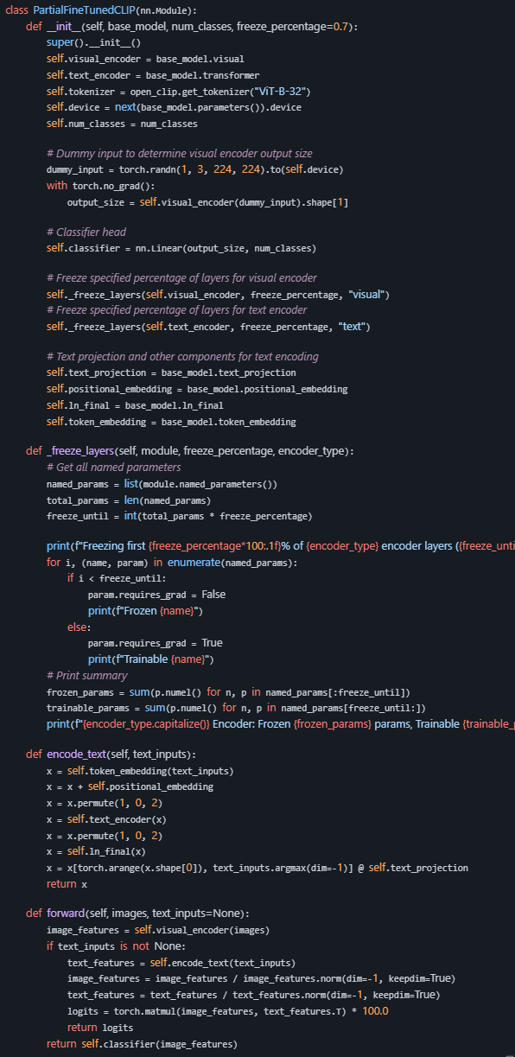

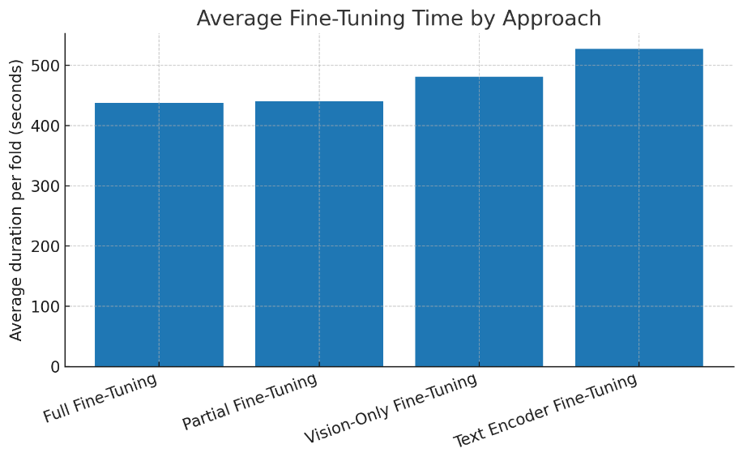

Figure 59: average Fine-Tuning by approach

According to the timing data, Full Fine-Tuning was the fastest on average, taking approximately 7 minutes and 15 seconds per fold. **Partial Fine-Tuning** was just behind, only around 0.3% slower, showing that limiting updates to the last layers of both encoders can nearly match full training speed. **Vision-only fine-tuning took roughly 8 minutes per fold, and Text Encoder fine-tuning was the slowest, averaging nearly** 8 minutes and 45 seconds. This suggests that, in your setup, updating the text encoder incurs more computational cost than vision-only updates, likely due to sequence-processing overhead in the transformer layers.

When comparing across strategies, the trade-off is clear: Full and Partial fine-tuning offer the quickest turnaround, while Text Encoder fine-tuning, despite targeting fewer parameters overall, still demands more time than Vision-Only due to the nature of text model computations. This performance profile is important for balancing experiment turnaround with potential accuracy gains—especially if your goal is rapid iteration without a significant loss in performance.

## **Results and Discussion**

As shown in the Figure 61: compare the results of all We evaluated four fine-tuning strategies — **Full Fine-Tuning**, **Text Encoder Fine-Tuning**, **Vision Encoder Fine-Tuning**, and **Partial Fine-Tuning** — across five cross-validation folds. Each method’s performance was assessed on **training, validation, and test sets** using **loss** and **accuracy** as metrics.

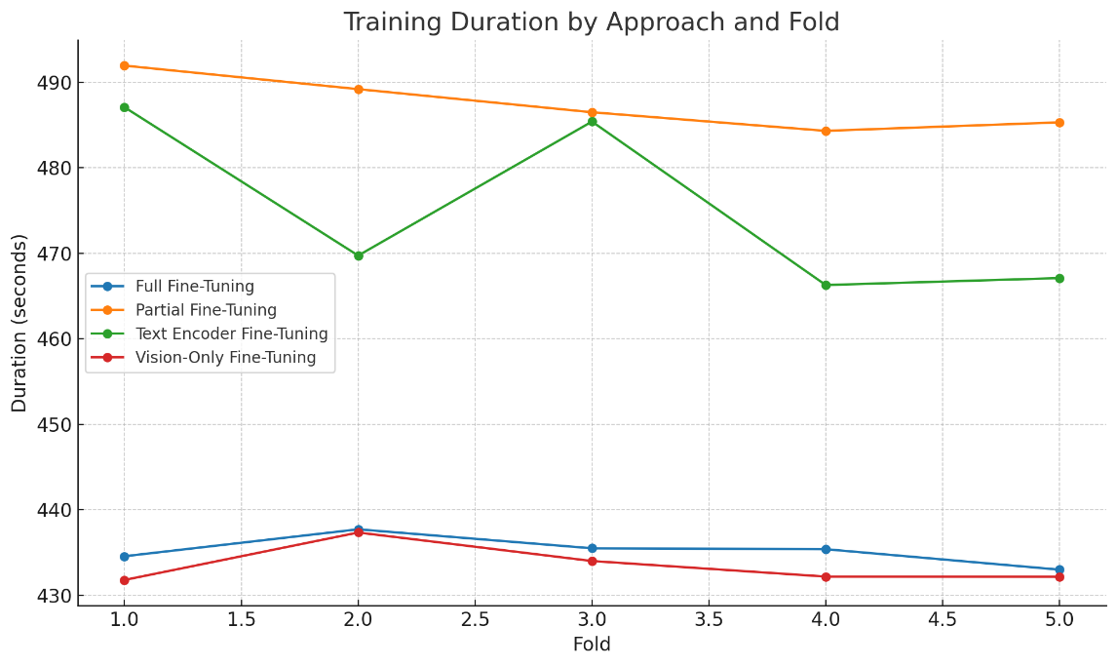

Figure : Training Duration By Approach And Fold

**Full Fine-Tuning** consistently achieved the highest performance, with an average test accuracy of **70.25%** and the lowest average test loss (**1.178**). Validation accuracy remained stable across folds (≈69.3%), indicating strong generalisation without severe overfitting. This demonstrates that updating all parameters in both encoders is the most effective strategy for adapting the model to our dataset.

**Vision Encoder Fine-Tuning** ranked second, with an average test accuracy of **56.20%**. While substantially lower than full fine-tuning, this result confirms the critical role of visual features in the classification task. However, freezing the text encoder likely limited the model’s ability to exploit multimodal cues fully.

**Text Encoder Fine-Tuning** and **Partial Fine-Tuning** performed poorly, both averaging around **1.3%** test accuracy. Loss values remained high (~3.33–3.48), showing that these models failed to converge to a meaningful solution. This suggests that the dataset is heavily reliant on visual information and that fine-tuning only the text encoder or just the last layers of both encoders is insufficient for the task.

The differences are clearly illustrated in Figure X, which compares validation and test accuracy across folds. Full Fine-Tuning not only outperformed other strategies in raw accuracy but also showed the most stable performance across folds, while the other methods exhibited minimal learning improvements.

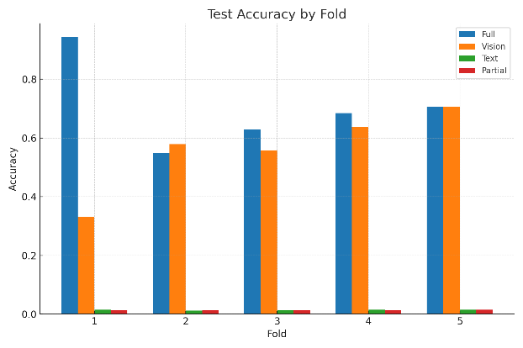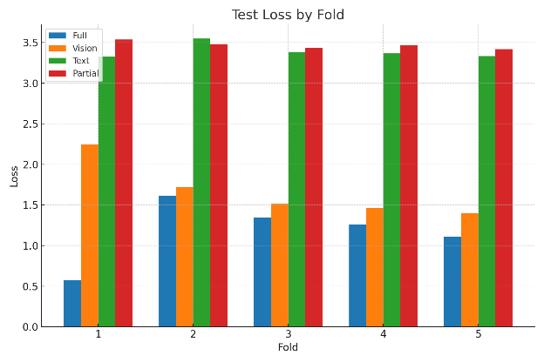

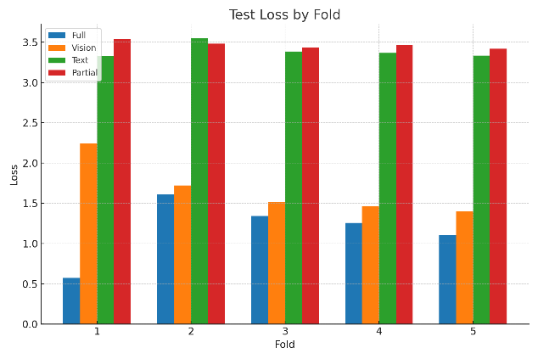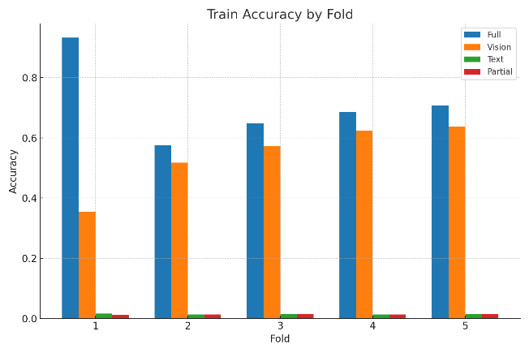

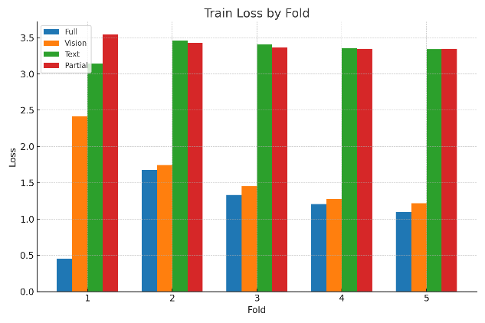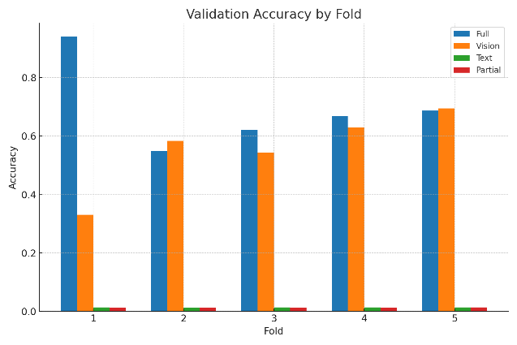

Figure : compare the results of all

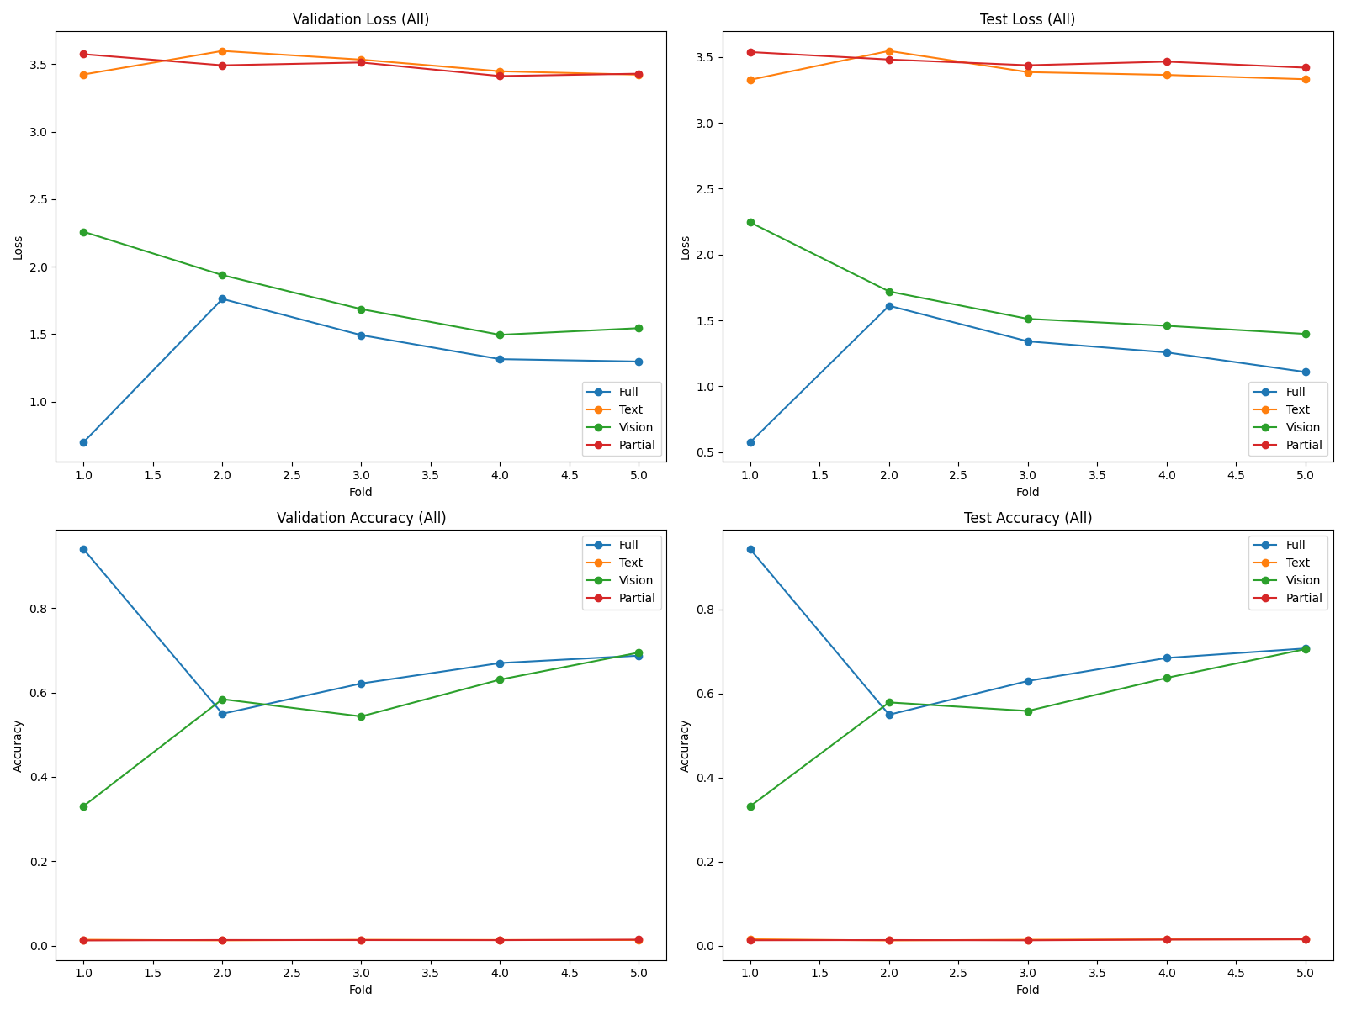

Figure : comparison metrics all

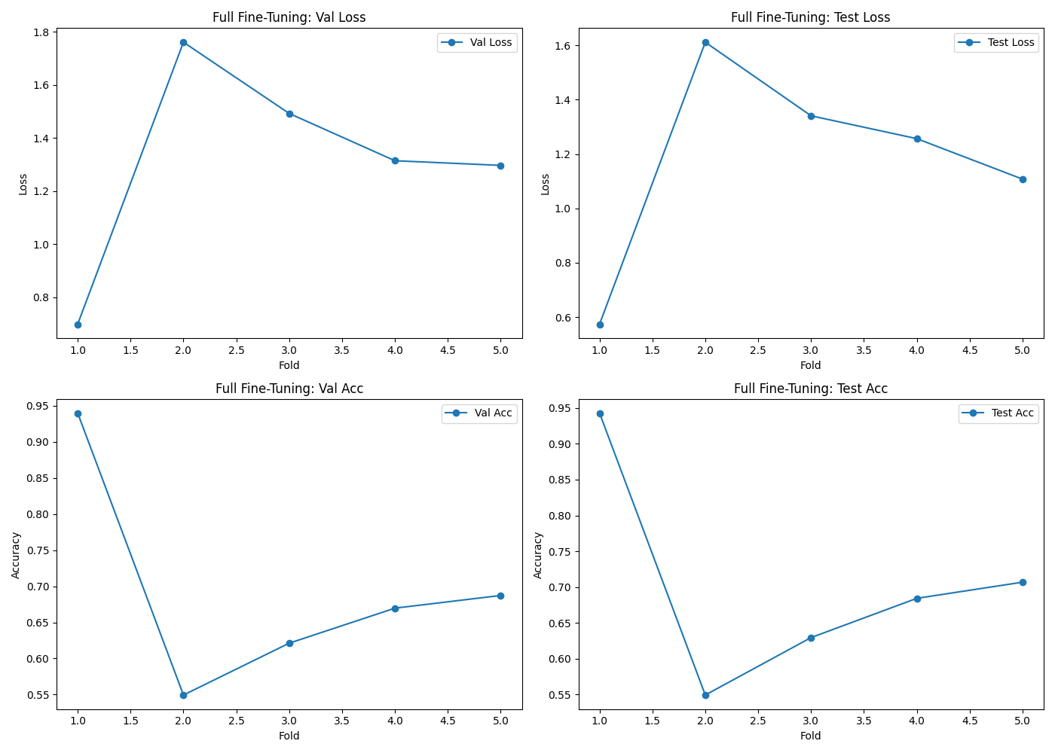

Figure : fold metrics full fine-tuning

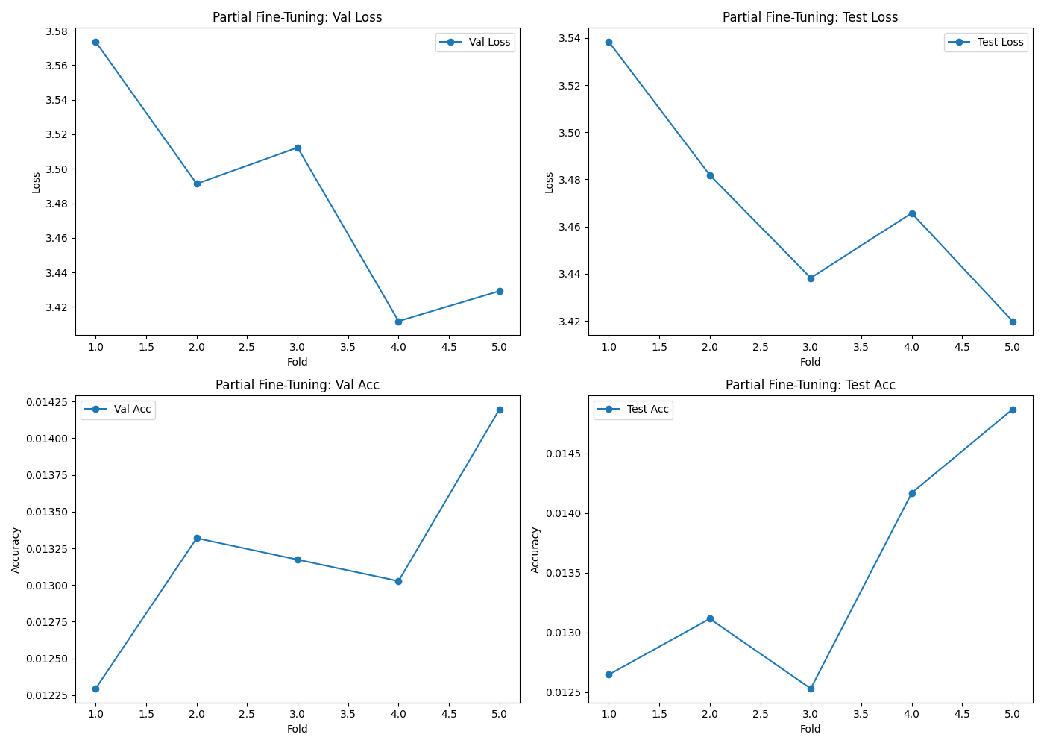

Figure : fold metrics Partial Fine-Tuning

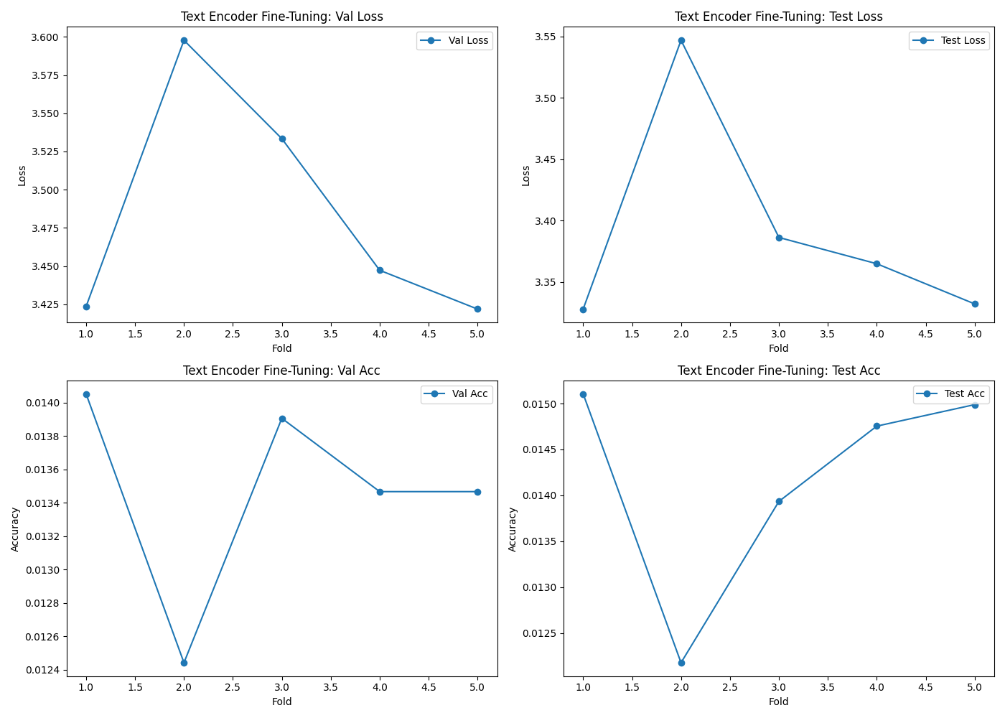

Figure : fold metrics Text Encoder Fine-Tuning

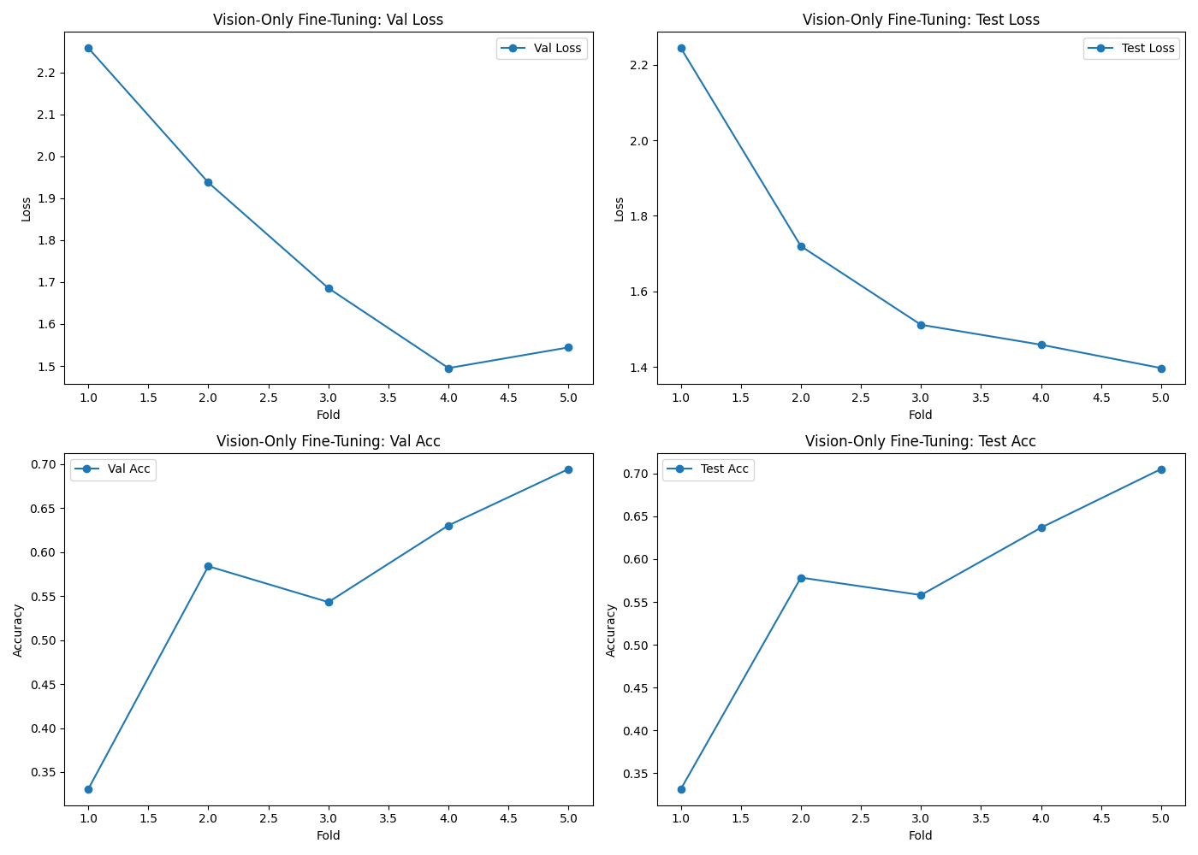

Figure : fold metrics Vision Only Fine-Tuning

# APPENDIX

## Appendix 1: model structure and preprocessing transforms

Model structure:

CLIP(

(visual): TimmModel(

(trunk): CLIPFineTuner (

(stem): Sequential(

(0): Conv2d(3, 128, kernel_size=(4, 4), stride=(4, 4))

(1): LayerNorm2d((128,), eps=1e-06, elementwise_affine=True)

)

(stages): Sequential(

(0): CLIPFineTuner Stage(

(downsample): Identity()

(blocks): Sequential(

(0): CLIPFineTuner Block(

(conv_dw): Conv2d(128, 128, kernel_size=(7, 7), stride=(1, 1), padding=(3, 3), groups=128)

(norm): LayerNorm((128,), eps=1e-06, elementwise_affine=True)

(mlp): Mlp(

(fc1): Linear(in_features=128, out_features=512, bias=True)

(act): GELU()

(drop1): Dropout(p=0.0, inplace=False)

(norm): Identity()

(fc2): Linear(in_features=512, out_features=128, bias=True)

(drop2): Dropout(p=0.0, inplace=False)

)

(shortcut): Identity()

(drop_path): Identity()

)

(1): CLIPFineTuner Block(

(conv_dw): Conv2d(128, 128, kernel_size=(7, 7), stride=(1, 1), padding=(3, 3), groups=128)

(norm): LayerNorm((128,), eps=1e-06, elementwise_affine=True)

(mlp): Mlp(

(fc1): Linear(in_features=128, out_features=512, bias=True)

(act): GELU()

(drop1): Dropout(p=0.0, inplace=False)

(norm): Identity()

(fc2): Linear(in_features=512, out_features=128, bias=True)

(drop2): Dropout(p=0.0, inplace=False)

)

(shortcut): Identity()

(drop_path): DropPath(drop_prob=0.003)

)

(2): CLIPFineTuner Block(

(conv_dw): Conv2d(128, 128, kernel_size=(7, 7), stride=(1, 1), padding=(3, 3), groups=128)

(norm): LayerNorm((128,), eps=1e-06, elementwise_affine=True)

(mlp): Mlp(

(fc1): Linear(in_features=128, out_features=512, bias=True)

(act): GELU()

(drop1): Dropout(p=0.0, inplace=False)

(norm): Identity()

(fc2): Linear(in_features=512, out_features=128, bias=True)

(drop2): Dropout(p=0.0, inplace=False)

)

(shortcut): Identity()

(drop_path): DropPath(drop_prob=0.006)

)

)

)

(1): CLIPFineTuner Stage(

(downsample): Sequential(

(0): LayerNorm2d((128,), eps=1e-06, elementwise_affine=True)

(1): Conv2d(128, 256, kernel_size=(2, 2), stride=(2, 2))

)

(blocks): Sequential(

(0): CLIPFineTuner Block(

(conv_dw): Conv2d(256, 256, kernel_size=(7, 7), stride=(1, 1), padding=(3, 3), groups=256)

(norm): LayerNorm((256,), eps=1e-06, elementwise_affine=True)

(mlp): Mlp(

(fc1): Linear(in_features=256, out_features=1024, bias=True)

(act): GELU()

(drop1): Dropout(p=0.0, inplace=False)

(norm): Identity()

(fc2): Linear(in_features=1024, out_features=256, bias=True)

(drop2): Dropout(p=0.0, inplace=False)

)

(shortcut): Identity()

(drop_path): DropPath(drop_prob=0.009)

)

(1): CLIPFineTuner Block(

(conv_dw): Conv2d(256, 256, kernel_size=(7, 7), stride=(1, 1), padding=(3, 3), groups=256)

(norm): LayerNorm((256,), eps=1e-06, elementwise_affine=True)

(mlp): Mlp(

(fc1): Linear(in_features=256, out_features=1024, bias=True)

(act): GELU()

(drop1): Dropout(p=0.0, inplace=False)

(norm): Identity()

(fc2): Linear(in_features=1024, out_features=256, bias=True)

(drop2): Dropout(p=0.0, inplace=False)

)

(shortcut): Identity()

(drop_path): DropPath(drop_prob=0.011)

)

(2): CLIPFineTuner Block(

(conv_dw): Conv2d(256, 256, kernel_size=(7, 7), stride=(1, 1), padding=(3, 3), groups=256)

(norm): LayerNorm((256,), eps=1e-06, elementwise_affine=True)

(mlp): Mlp(

(fc1): Linear(in_features=256, out_features=1024, bias=True)

(act): GELU()

(drop1): Dropout(p=0.0, inplace=False)

(norm): Identity()

(fc2): Linear(in_features=1024, out_features=256, bias=True)

(drop2): Dropout(p=0.0, inplace=False)

)

(shortcut): Identity()

(drop_path): DropPath(drop_prob=0.014)

)

)

)

(2): CLIPFineTuner Stage(

(downsample): Sequential(

(0): LayerNorm2d((256,), eps=1e-06, elementwise_affine=True)

(1): Conv2d(256, 512, kernel_size=(2, 2), stride=(2, 2))

)

(blocks): Sequential(

(0): CLIPFineTuner Block(

(conv_dw): Conv2d(512, 512, kernel_size=(7, 7), stride=(1, 1), padding=(3, 3), groups=512)

(norm): LayerNorm((512,), eps=1e-06, elementwise_affine=True)

(mlp): Mlp(

(fc1): Linear(in_features=512, out_features=2048, bias=True)

(act): GELU()

(drop1): Dropout(p=0.0, inplace=False)

(norm): Identity()

(fc2): Linear(in_features=2048, out_features=512, bias=True)

(drop2): Dropout(p=0.0, inplace=False)

)

(shortcut): Identity()

(drop_path): DropPath(drop_prob=0.017)

)

(1): CLIPFineTuner Block(

(conv_dw): Conv2d(512, 512, kernel_size=(7, 7), stride=(1, 1), padding=(3, 3), groups=512)

(norm): LayerNorm((512,), eps=1e-06, elementwise_affine=True)

(mlp): Mlp(

(fc1): Linear(in_features=512, out_features=2048, bias=True)

(act): GELU()

(drop1): Dropout(p=0.0, inplace=False)

(norm): Identity()

(fc2): Linear(in_features=2048, out_features=512, bias=True)

(drop2): Dropout(p=0.0, inplace=False)

)

(shortcut): Identity()

(drop_path): DropPath(drop_prob=0.020)

)

(2): CLIPFineTuner Block(

(conv_dw): Conv2d(512, 512, kernel_size=(7, 7), stride=(1, 1), padding=(3, 3), groups=512)

(norm): LayerNorm((512,), eps=1e-06, elementwise_affine=True)

(mlp): Mlp(

(fc1): Linear(in_features=512, out_features=2048, bias=True)

(act): GELU()

(drop1): Dropout(p=0.0, inplace=False)

(norm): Identity()

(fc2): Linear(in_features=2048, out_features=512, bias=True)

(drop2): Dropout(p=0.0, inplace=False)

)

(shortcut): Identity()

(drop_path): DropPath(drop_prob=0.023)

)

(3): CLIPFineTuner Block(

(conv_dw): Conv2d(512, 512, kernel_size=(7, 7), stride=(1, 1), padding=(3, 3), groups=512)

(norm): LayerNorm((512,), eps=1e-06, elementwise_affine=True)

(mlp): Mlp(

(fc1): Linear(in_features=512, out_features=2048, bias=True)

(act): GELU()

(drop1): Dropout(p=0.0, inplace=False)

(norm): Identity()

(fc2): Linear(in_features=2048, out_features=512, bias=True)

(drop2): Dropout(p=0.0, inplace=False)

)

(shortcut): Identity()

(drop_path): DropPath(drop_prob=0.026)

)

(4): CLIPFineTuner Block(

(conv_dw): Conv2d(512, 512, kernel_size=(7, 7), stride=(1, 1), padding=(3, 3), groups=512)

(norm): LayerNorm((512,), eps=1e-06, elementwise_affine=True)

(mlp): Mlp(

(fc1): Linear(in_features=512, out_features=2048, bias=True)

(act): GELU()

(drop1): Dropout(p=0.0, inplace=False)

(norm): Identity()

(fc2): Linear(in_features=2048, out_features=512, bias=True)

(drop2): Dropout(p=0.0, inplace=False)

)

(shortcut): Identity()

(drop_path): DropPath(drop_prob=0.029)

)

(5): CLIPFineTuner Block(

(conv_dw): Conv2d(512, 512, kernel_size=(7, 7), stride=(1, 1), padding=(3, 3), groups=512)

(norm): LayerNorm((512,), eps=1e-06, elementwise_affine=True)

(mlp): Mlp(

(fc1): Linear(in_features=512, out_features=2048, bias=True)

(act): GELU()

(drop1): Dropout(p=0.0, inplace=False)

(norm): Identity()

(fc2): Linear(in_features=2048, out_features=512, bias=True)

(drop2): Dropout(p=0.0, inplace=False)

)

(shortcut): Identity()

(drop_path): DropPath(drop_prob=0.031)

)

(6): CLIPFineTuner Block(

(conv_dw): Conv2d(512, 512, kernel_size=(7, 7), stride=(1, 1), padding=(3, 3), groups=512)

(norm): LayerNorm((512,), eps=1e-06, elementwise_affine=True)

(mlp): Mlp(

(fc1): Linear(in_features=512, out_features=2048, bias=True)

(act): GELU()

(drop1): Dropout(p=0.0, inplace=False)

(norm): Identity()

(fc2): Linear(in_features=2048, out_features=512, bias=True)

(drop2): Dropout(p=0.0, inplace=False)

)

(shortcut): Identity()

(drop_path): DropPath(drop_prob=0.034)

)

(7): CLIPFineTuner Block(

(conv_dw): Conv2d(512, 512, kernel_size=(7, 7), stride=(1, 1), padding=(3, 3), groups=512)

(norm): LayerNorm((512,), eps=1e-06, elementwise_affine=True)

(mlp): Mlp(

(fc1): Linear(in_features=512, out_features=2048, bias=True)

(act): GELU()

(drop1): Dropout(p=0.0, inplace=False)

(norm): Identity()

(fc2): Linear(in_features=2048, out_features=512, bias=True)

(drop2): Dropout(p=0.0, inplace=False)

)

(shortcut): Identity()

(drop_path): DropPath(drop_prob=0.037)

)

(8): CLIPFineTuner Block(

(conv_dw): Conv2d(512, 512, kernel_size=(7, 7), stride=(1, 1), padding=(3, 3), groups=512)

(norm): LayerNorm((512,), eps=1e-06, elementwise_affine=True)

(mlp): Mlp(

(fc1): Linear(in_features=512, out_features=2048, bias=True)

(act): GELU()

(drop1): Dropout(p=0.0, inplace=False)

(norm): Identity()

(fc2): Linear(in_features=2048, out_features=512, bias=True)

(drop2): Dropout(p=0.0, inplace=False)

)

(shortcut): Identity()

(drop_path): DropPath(drop_prob=0.040)

)

(9): CLIPFineTuner Block(

(conv_dw): Conv2d(512, 512, kernel_size=(7, 7), stride=(1, 1), padding=(3, 3), groups=512)

(norm): LayerNorm((512,), eps=1e-06, elementwise_affine=True)

(mlp): Mlp(

(fc1): Linear(in_features=512, out_features=2048, bias=True)

(act): GELU()

(drop1): Dropout(p=0.0, inplace=False)

(norm): Identity()

(fc2): Linear(in_features=2048, out_features=512, bias=True)

(drop2): Dropout(p=0.0, inplace=False)

)

(shortcut): Identity()

(drop_path): DropPath(drop_prob=0.043)

)

(10): CLIPFineTuner Block(

(conv_dw): Conv2d(512, 512, kernel_size=(7, 7), stride=(1, 1), padding=(3, 3), groups=512)

(norm): LayerNorm((512,), eps=1e-06, elementwise_affine=True)

(mlp): Mlp(

(fc1): Linear(in_features=512, out_features=2048, bias=True)

(act): GELU()

(drop1): Dropout(p=0.0, inplace=False)

(norm): Identity()

(fc2): Linear(in_features=2048, out_features=512, bias=True)

(drop2): Dropout(p=0.0, inplace=False)

)

(shortcut): Identity()

(drop_path): DropPath(drop_prob=0.046)

)

(11): CLIPFineTuner Block(

(conv_dw): Conv2d(512, 512, kernel_size=(7, 7), stride=(1, 1), padding=(3, 3), groups=512)

(norm): LayerNorm((512,), eps=1e-06, elementwise_affine=True)

(mlp): Mlp(

(fc1): Linear(in_features=512, out_features=2048, bias=True)

(act): GELU()

(drop1): Dropout(p=0.0, inplace=False)

(norm): Identity()

(fc2): Linear(in_features=2048, out_features=512, bias=True)

(drop2): Dropout(p=0.0, inplace=False)

)

(shortcut): Identity()

(drop_path): DropPath(drop_prob=0.049)

)

(12): CLIPFineTuner Block(

(conv_dw): Conv2d(512, 512, kernel_size=(7, 7), stride=(1, 1), padding=(3, 3), groups=512)

(norm): LayerNorm((512,), eps=1e-06, elementwise_affine=True)

(mlp): Mlp(

(fc1): Linear(in_features=512, out_features=2048, bias=True)

(act): GELU()

(drop1): Dropout(p=0.0, inplace=False)

(norm): Identity()

(fc2): Linear(in_features=2048, out_features=512, bias=True)

(drop2): Dropout(p=0.0, inplace=False)

)

(shortcut): Identity()

(drop_path): DropPath(drop_prob=0.051)

)

(13): CLIPFineTuner Block(

(conv_dw): Conv2d(512, 512, kernel_size=(7, 7), stride=(1, 1), padding=(3, 3), groups=512)

(norm): LayerNorm((512,), eps=1e-06, elementwise_affine=True)

(mlp): Mlp(

(fc1): Linear(in_features=512, out_features=2048, bias=True)

(act): GELU()

(drop1): Dropout(p=0.0, inplace=False)

(norm): Identity()

(fc2): Linear(in_features=2048, out_features=512, bias=True)

(drop2): Dropout(p=0.0, inplace=False)

)

(shortcut): Identity()

(drop_path): DropPath(drop_prob=0.054)

)

(14): CLIPFineTuner Block(

(conv_dw): Conv2d(512, 512, kernel_size=(7, 7), stride=(1, 1), padding=(3, 3), groups=512)

(norm): LayerNorm((512,), eps=1e-06, elementwise_affine=True)

(mlp): Mlp(

(fc1): Linear(in_features=512, out_features=2048, bias=True)

(act): GELU()

(drop1): Dropout(p=0.0, inplace=False)

(norm): Identity()

(fc2): Linear(in_features=2048, out_features=512, bias=True)

(drop2): Dropout(p=0.0, inplace=False)

)

(shortcut): Identity()

(drop_path): DropPath(drop_prob=0.057)

)

(15): CLIPFineTuner Block(

(conv_dw): Conv2d(512, 512, kernel_size=(7, 7), stride=(1, 1), padding=(3, 3), groups=512)

(norm): LayerNorm((512,), eps=1e-06, elementwise_affine=True)

(mlp): Mlp(

(fc1): Linear(in_features=512, out_features=2048, bias=True)

(act): GELU()

(drop1): Dropout(p=0.0, inplace=False)

(norm): Identity()

(fc2): Linear(in_features=2048, out_features=512, bias=True)

(drop2): Dropout(p=0.0, inplace=False)

)

(shortcut): Identity()

(drop_path): DropPath(drop_prob=0.060)

)

(16): CLIPFineTuner Block(

(conv_dw): Conv2d(512, 512, kernel_size=(7, 7), stride=(1, 1), padding=(3, 3), groups=512)

(norm): LayerNorm((512,), eps=1e-06, elementwise_affine=True)

(mlp): Mlp(

(fc1): Linear(in_features=512, out_features=2048, bias=True)

(act): GELU()

(drop1): Dropout(p=0.0, inplace=False)

(norm): Identity()

(fc2): Linear(in_features=2048, out_features=512, bias=True)

(drop2): Dropout(p=0.0, inplace=False)

)

(shortcut): Identity()

(drop_path): DropPath(drop_prob=0.063)

)

(17): CLIPFineTuner Block(

(conv_dw): Conv2d(512, 512, kernel_size=(7, 7), stride=(1, 1), padding=(3, 3), groups=512)

(norm): LayerNorm((512,), eps=1e-06, elementwise_affine=True)

(mlp): Mlp(

(fc1): Linear(in_features=512, out_features=2048, bias=True)

(act): GELU()

(drop1): Dropout(p=0.0, inplace=False)

(norm): Identity()

(fc2): Linear(in_features=2048, out_features=512, bias=True)

(drop2): Dropout(p=0.0, inplace=False)

)

(shortcut): Identity()

(drop_path): DropPath(drop_prob=0.066)

)

(18): CLIPFineTuner Block(

(conv_dw): Conv2d(512, 512, kernel_size=(7, 7), stride=(1, 1), padding=(3, 3), groups=512)

(norm): LayerNorm((512,), eps=1e-06, elementwise_affine=True)

(mlp): Mlp(

(fc1): Linear(in_features=512, out_features=2048, bias=True)

(act): GELU()

(drop1): Dropout(p=0.0, inplace=False)

(norm): Identity()

(fc2): Linear(in_features=2048, out_features=512, bias=True)

(drop2): Dropout(p=0.0, inplace=False)

)

(shortcut): Identity()

(drop_path): DropPath(drop_prob=0.069)

)

(19): CLIPFineTuner Block(

(conv_dw): Conv2d(512, 512, kernel_size=(7, 7), stride=(1, 1), padding=(3, 3), groups=512)

(norm): LayerNorm((512,), eps=1e-06, elementwise_affine=True)

(mlp): Mlp(

(fc1): Linear(in_features=512, out_features=2048, bias=True)

(act): GELU()

(drop1): Dropout(p=0.0, inplace=False)

(norm): Identity()

(fc2): Linear(in_features=2048, out_features=512, bias=True)

(drop2): Dropout(p=0.0, inplace=False)

)

(shortcut): Identity()

(drop_path): DropPath(drop_prob=0.071)

)

(20): CLIPFineTuner Block(

(conv_dw): Conv2d(512, 512, kernel_size=(7, 7), stride=(1, 1), padding=(3, 3), groups=512)

(norm): LayerNorm((512,), eps=1e-06, elementwise_affine=True)

(mlp): Mlp(

(fc1): Linear(in_features=512, out_features=2048, bias=True)

(act): GELU()

(drop1): Dropout(p=0.0, inplace=False)

(norm): Identity()

(fc2): Linear(in_features=2048, out_features=512, bias=True)

(drop2): Dropout(p=0.0, inplace=False)

)

(shortcut): Identity()

(drop_path): DropPath(drop_prob=0.074)

)

(21): CLIPFineTuner Block(

(conv_dw): Conv2d(512, 512, kernel_size=(7, 7), stride=(1, 1), padding=(3, 3), groups=512)

(norm): LayerNorm((512,), eps=1e-06, elementwise_affine=True)

(mlp): Mlp(

(fc1): Linear(in_features=512, out_features=2048, bias=True)

(act): GELU()

(drop1): Dropout(p=0.0, inplace=False)

(norm): Identity()

(fc2): Linear(in_features=2048, out_features=512, bias=True)

(drop2): Dropout(p=0.0, inplace=False)

)

(shortcut): Identity()

(drop_path): DropPath(drop_prob=0.077)

)

(22): CLIPFineTuner Block(

(conv_dw): Conv2d(512, 512, kernel_size=(7, 7), stride=(1, 1), padding=(3, 3), groups=512)

(norm): LayerNorm((512,), eps=1e-06, elementwise_affine=True)

(mlp): Mlp(

(fc1): Linear(in_features=512, out_features=2048, bias=True)

(act): GELU()

(drop1): Dropout(p=0.0, inplace=False)

(norm): Identity()

(fc2): Linear(in_features=2048, out_features=512, bias=True)

(drop2): Dropout(p=0.0, inplace=False)

)

(shortcut): Identity()

(drop_path): DropPath(drop_prob=0.080)

)

(23): CLIPFineTuner Block(

(conv_dw): Conv2d(512, 512, kernel_size=(7, 7), stride=(1, 1), padding=(3, 3), groups=512)

(norm): LayerNorm((512,), eps=1e-06, elementwise_affine=True)

(mlp): Mlp(

(fc1): Linear(in_features=512, out_features=2048, bias=True)

(act): GELU()

(drop1): Dropout(p=0.0, inplace=False)

(norm): Identity()

(fc2): Linear(in_features=2048, out_features=512, bias=True)

(drop2): Dropout(p=0.0, inplace=False)

)

(shortcut): Identity()

(drop_path): DropPath(drop_prob=0.083)

)

(24): CLIPFineTuner Block(

(conv_dw): Conv2d(512, 512, kernel_size=(7, 7), stride=(1, 1), padding=(3, 3), groups=512)

(norm): LayerNorm((512,), eps=1e-06, elementwise_affine=True)

(mlp): Mlp(

(fc1): Linear(in_features=512, out_features=2048, bias=True)

(act): GELU()

(drop1): Dropout(p=0.0, inplace=False)

(norm): Identity()

(fc2): Linear(in_features=2048, out_features=512, bias=True)

(drop2): Dropout(p=0.0, inplace=False)

)

(shortcut): Identity()

(drop_path): DropPath(drop_prob=0.086)

)

(25): CLIPFineTuner Block(

(conv_dw): Conv2d(512, 512, kernel_size=(7, 7), stride=(1, 1), padding=(3, 3), groups=512)

(norm): LayerNorm((512,), eps=1e-06, elementwise_affine=True)

(mlp): Mlp(

(fc1): Linear(in_features=512, out_features=2048, bias=True)

(act): GELU()

(drop1): Dropout(p=0.0, inplace=False)

(norm): Identity()

(fc2): Linear(in_features=2048, out_features=512, bias=True)

(drop2): Dropout(p=0.0, inplace=False)

)

(shortcut): Identity()

(drop_path): DropPath(drop_prob=0.089)

)

(26): CLIPFineTuner Block(

(conv_dw): Conv2d(512, 512, kernel_size=(7, 7), stride=(1, 1), padding=(3, 3), groups=512)

(norm): LayerNorm((512,), eps=1e-06, elementwise_affine=True)

(mlp): Mlp(

(fc1): Linear(in_features=512, out_features=2048, bias=True)

(act): GELU()

(drop1): Dropout(p=0.0, inplace=False)

(norm): Identity()

(fc2): Linear(in_features=2048, out_features=512, bias=True)

(drop2): Dropout(p=0.0, inplace=False)

)

(shortcut): Identity()

(drop_path): DropPath(drop_prob=0.091)

)

)

)

(3): CLIPFineTuner Stage(

(downsample): Sequential(

(0): LayerNorm2d((512,), eps=1e-06, elementwise_affine=True)

(1): Conv2d(512, 1024, kernel_size=(2, 2), stride=(2, 2))

)

(blocks): Sequential(

(0): CLIPFineTuner Block(

(conv_dw): Conv2d(1024, 1024, kernel_size=(7, 7), stride=(1, 1), padding=(3, 3), groups=1024)

(norm): LayerNorm((1024,), eps=1e-06, elementwise_affine=True)

(mlp): Mlp(

(fc1): Linear(in_features=1024, out_features=4096, bias=True)

(act): GELU()

(drop1): Dropout(p=0.0, inplace=False)

(norm): Identity()

(fc2): Linear(in_features=4096, out_features=1024, bias=True)

(drop2): Dropout(p=0.0, inplace=False)

)

(shortcut): Identity()

(drop_path): DropPath(drop_prob=0.094)

)

(1): CLIPFineTuner Block(

(conv_dw): Conv2d(1024, 1024, kernel_size=(7, 7), stride=(1, 1), padding=(3, 3), groups=1024)

(norm): LayerNorm((1024,), eps=1e-06, elementwise_affine=True)

(mlp): Mlp(

(fc1): Linear(in_features=1024, out_features=4096, bias=True)

(act): GELU()

(drop1): Dropout(p=0.0, inplace=False)

(norm): Identity()

(fc2): Linear(in_features=4096, out_features=1024, bias=True)

(drop2): Dropout(p=0.0, inplace=False)

)

(shortcut): Identity()

(drop_path): DropPath(drop_prob=0.097)

)

(2): CLIPFineTuner Block(

(conv_dw): Conv2d(1024, 1024, kernel_size=(7, 7), stride=(1, 1), padding=(3, 3), groups=1024)

(norm): LayerNorm((1024,), eps=1e-06, elementwise_affine=True)

(mlp): Mlp(

(fc1): Linear(in_features=1024, out_features=4096, bias=True)

(act): GELU()

(drop1): Dropout(p=0.0, inplace=False)

(norm): Identity()

(fc2): Linear(in_features=4096, out_features=1024, bias=True)

(drop2): Dropout(p=0.0, inplace=False)

)

(shortcut): Identity()

(drop_path): DropPath(drop_prob=0.100)

)

)

)

)

(norm_pre): Identity()

(head): NormMlpClassifierHead(

(global_pool): SelectAdaptivePool2d(pool_type=avg, flatten=Identity())

(norm): LayerNorm2d((1024,), eps=1e-06, elementwise_affine=True)

(flatten): Flatten(start_dim=1, end_dim=-1)

(pre_logits): Identity()

(drop): Dropout(p=0.0, inplace=False)

(fc): Identity()

)

)

(head): Sequential(

(drop): Dropout(p=0.0, inplace=False)

(proj): Linear(in_features=1024, out_features=640, bias=False)

)

)

(transformer): Transformer(

(resblocks): ModuleList(

(0-11): 12 x ResidualAttentionBlock(

(ln_1): LayerNorm((640,), eps=1e-05, elementwise_affine=True)

(attn): MultiheadAttention(

(out_proj): NonDynamicallyQuantizableLinear(in_features=640, out_features=640, bias=True)

)

(ls_1): Identity()

(ln_2): LayerNorm((640,), eps=1e-05, elementwise_affine=True)

(mlp): Sequential(

(c_fc): Linear(in_features=640, out_features=2560, bias=True)

(gelu): GELU(approximate='none')

(c_proj): Linear(in_features=2560, out_features=640, bias=True)

)

(ls_2): Identity()

)

)

)

(token_embedding): Embedding(49408, 640)

(ln_final): LayerNorm((640,), eps=1e-05, elementwise_affine=True)

)

Preprocessing transforms (for training):

Compose(

RandomResizedCrop(size=(256, 256), scale=(0.9, 1.0), ratio=(0.75, 1.3333), interpolation=bicubic, antialias=True)

<function _convert_to_rgb at 0x000001E296DB05E0>

ToTensor()

Normalize(mean=(0.48145466, 0.4578275, 0.40821073), std=(0.26862954, 0.26130258, 0.27577711))

)

Preprocessing transforms (for validation):

Compose(

Resize(size=256, interpolation=bicubic, max_size=None, antialias=True)

CenterCrop(size=(256, 256))

<function _convert_to_rgb at 0x000001E296DB05E0>

ToTensor()

Normalize(mean=(0.48145466, 0.4578275, 0.40821073), std=(0.26862954, 0.26130258, 0.27577711))

)

## Appendix 2: Confusion matrix

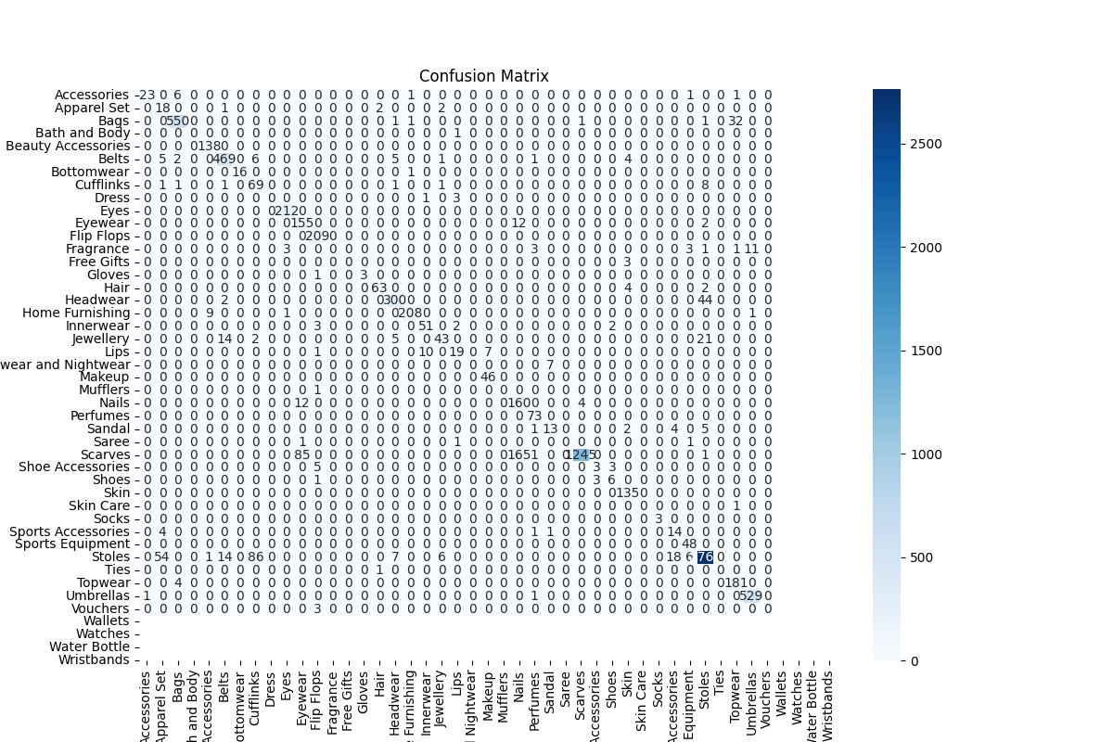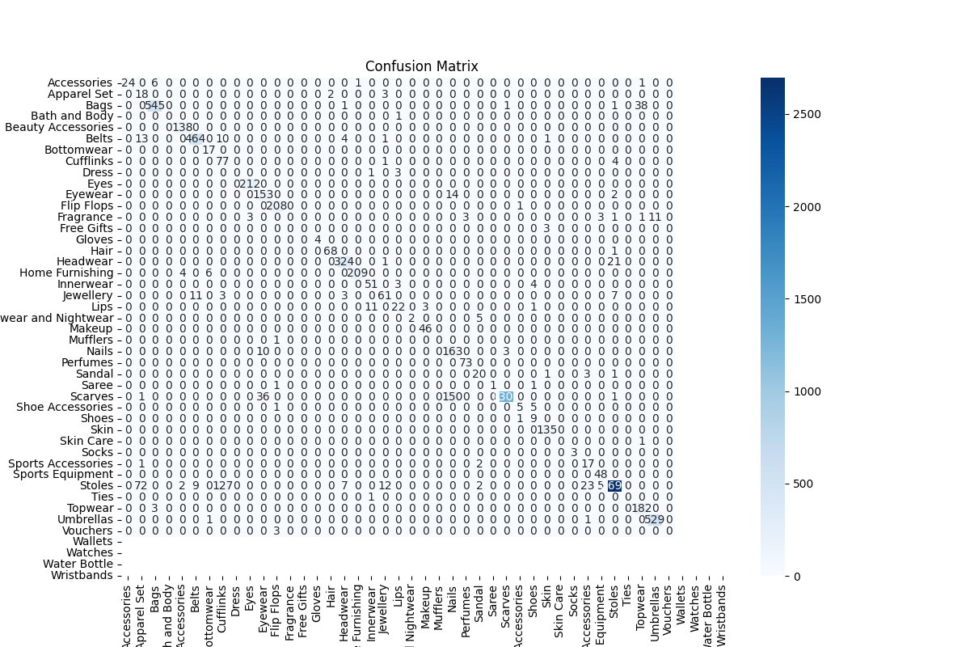

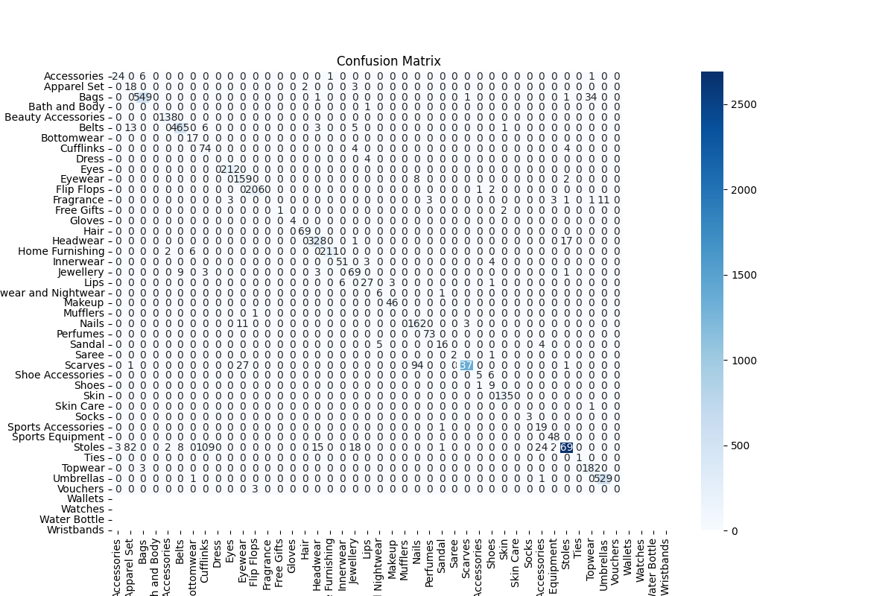

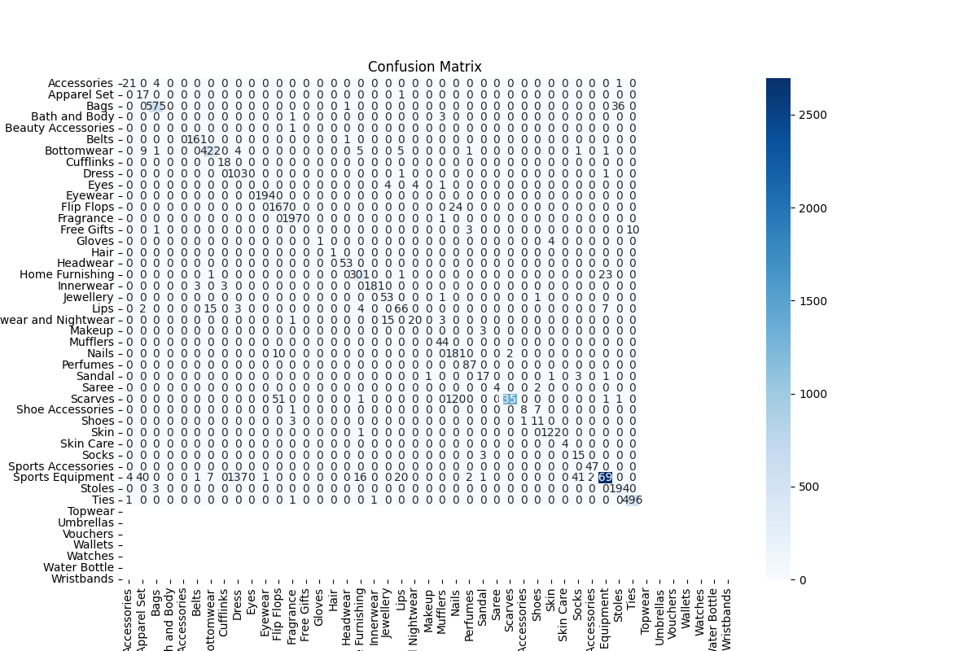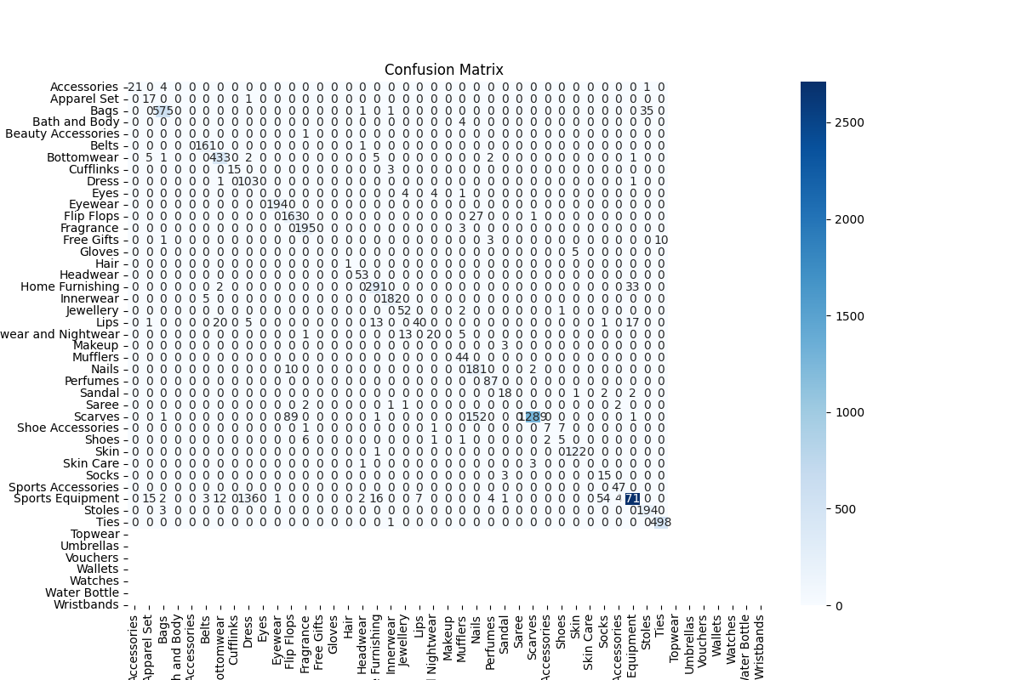

## Appendix 3: Predicted and actual labels

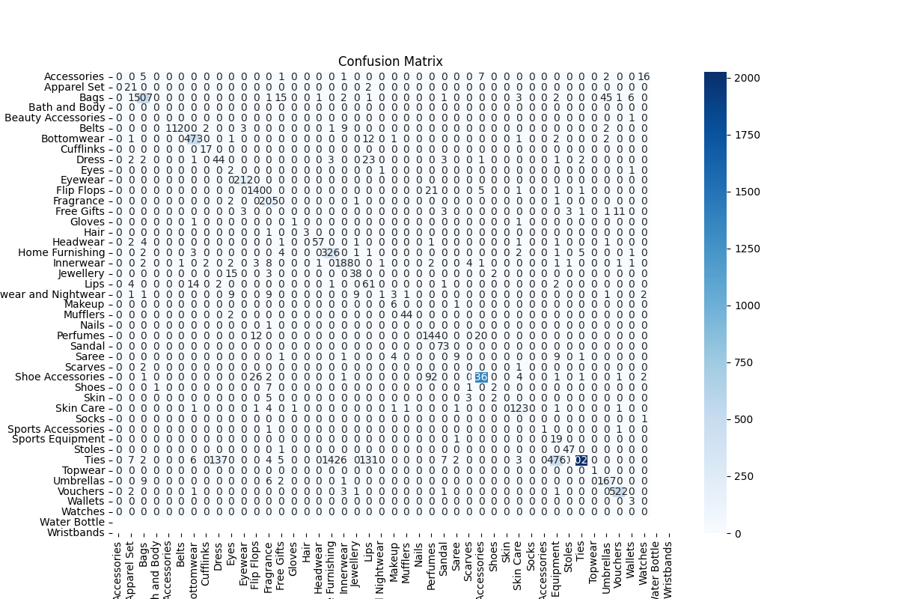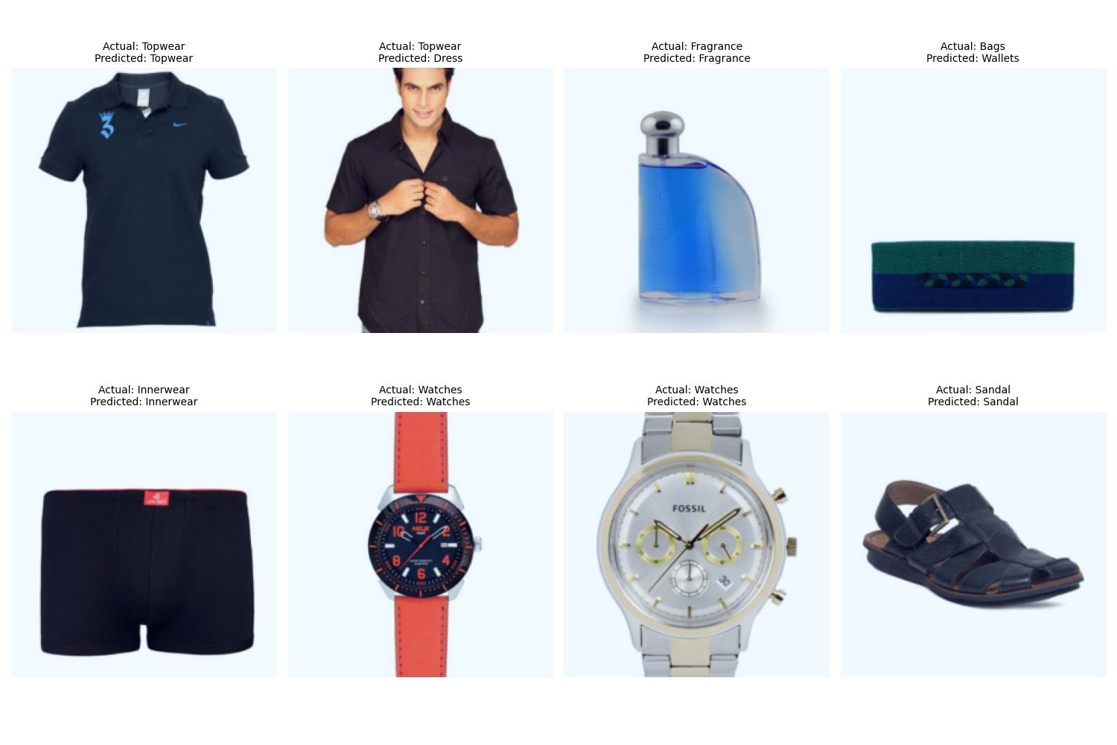

Figure : ADAM Fold 1/5, Epoch 2/3

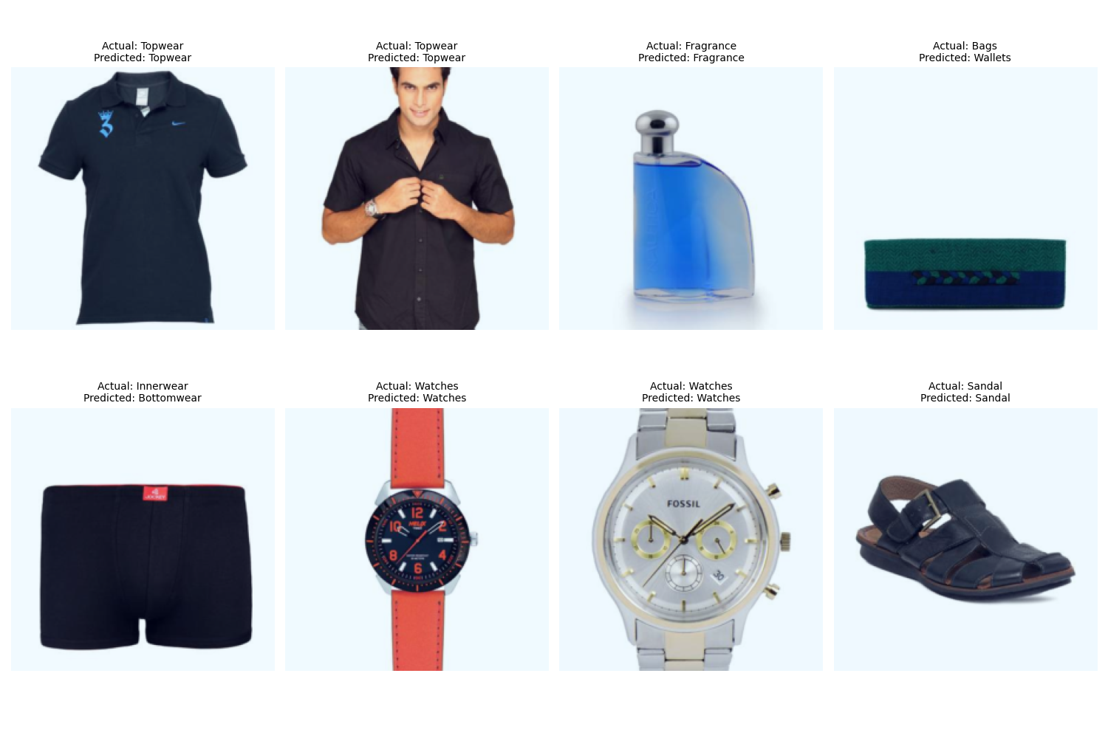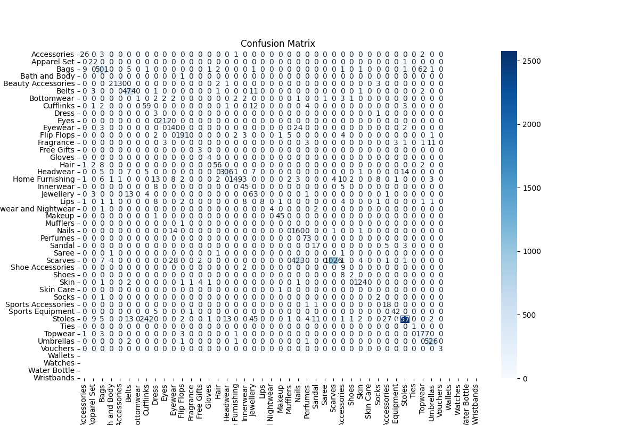

Figure :ADAM Fold 1/5, Epoch 3/3

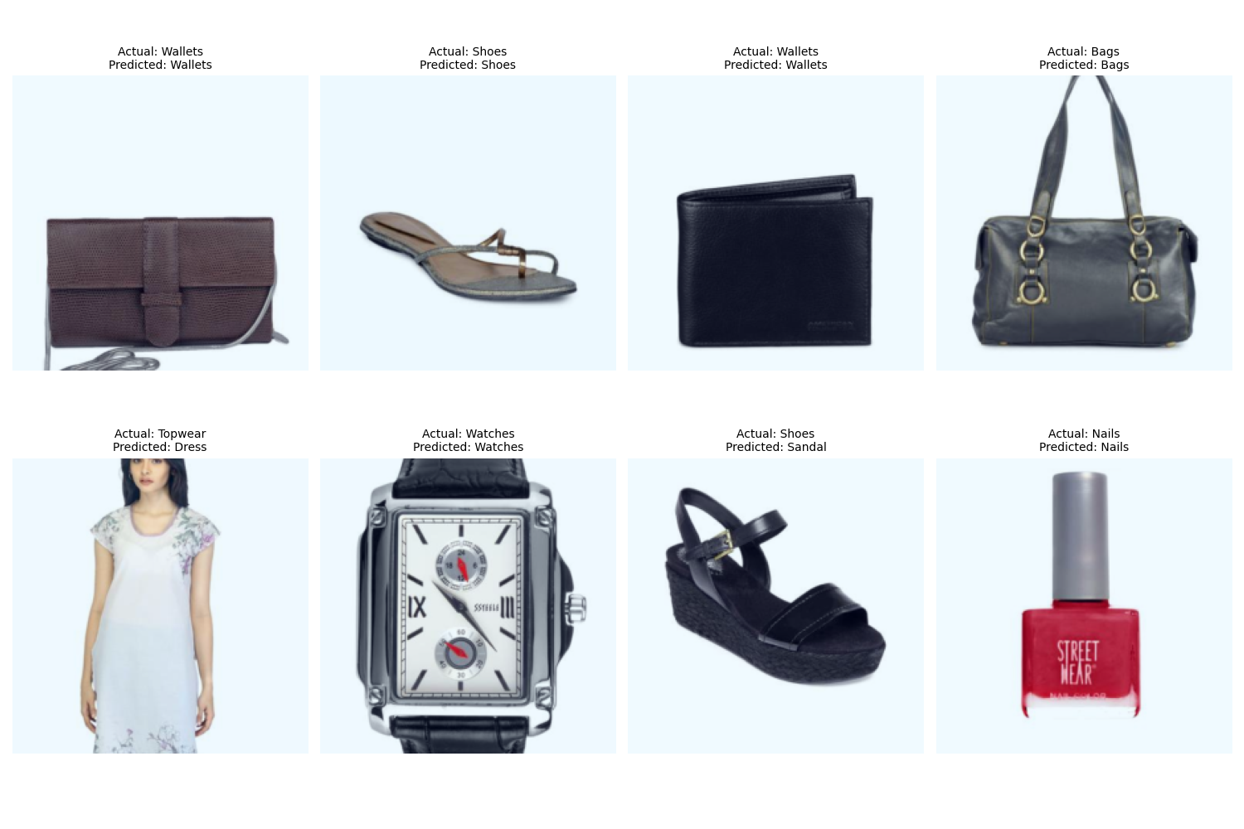

Figure : ADAM Fold 2/5, Epoch 2/3

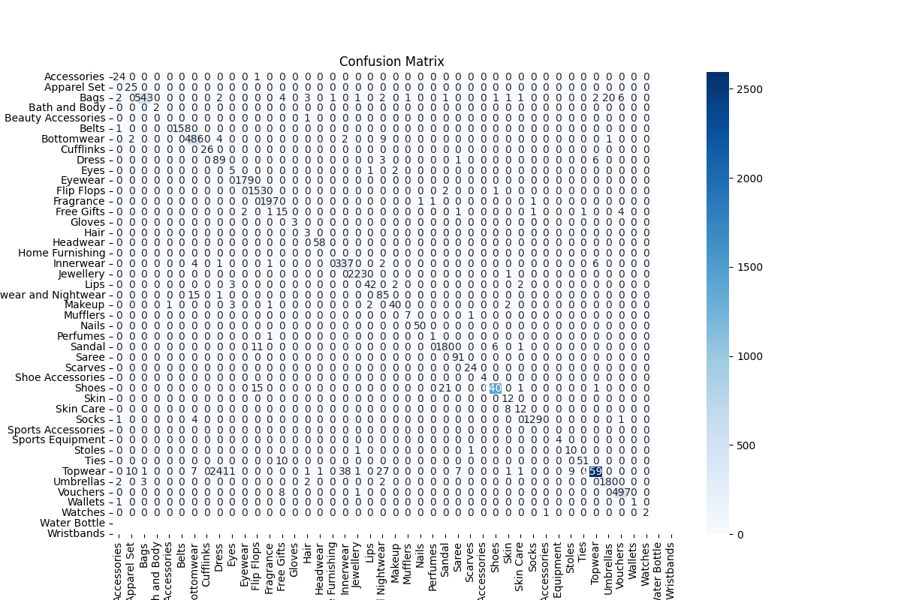

Figure :ADAM Fold 2/5, Epoch 2/3



Figure :ADAM Fold 3/5, Epoch 2/3



Figure :ADAM Fold 4/5, Epoch 4/3